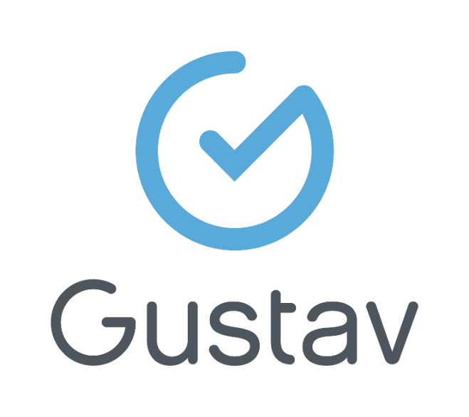

Propulsé par :

User guide

Gustav software

July 2025 2024

CONFIDENTIEL
DOCUMENT

Tables of contents

LOGING IN 7
Change password 8
Log out 8
WORKSPACE 9
Gustav Help Center 9
Self-assignment 10
File search 11
Recent files 12
Draft documents 14
My assignments 14
DAILY ROUTINE 16
Complete an activity 17
Not completed activities 17
Report an activity 18
Activities completed filter 18
Commun tasks filter 19
Access a colleague’s routine 20
FOLLOW UP 20
Complete a follow up 22
Report a folllow up 22
Not complete a follow up 23
Not applicable follow up 23
Reset a follow up 24
PROFESIONNAL REQUEST 24
Change or remove status 25
Approve a request 26
Reject a request 27
Take charge of a request 27
Transfer a request 28
Correct a request 29
Cancel a request 30
PRESCRIPTION 31
Complete a prescription 32
Correct a prescription 33
Cancel a prescription 33
OPEN A FILE 34
Add a picture 35
User identification section 36
Modify user identification 36
Print a legal 37
deactivate a file 38
merge a fille 38
Stays section 39
Modify a stay 39
Transfer 40
Departure 40
temporary leave 41
appointments 42
file number 42
Episode of care 43
Open an episode of care 43
Change clientele type 44
revise an episode 45
close an episode 45
Reopen a closed episode 46
RISK MANAGEMENT 47
REPORTS/MOVEMENTS 48
Inter-shift report 48
status update 50
Reschedule an activity 50
Movements 51
SUMMARY 52
DOCUMENTATION 53
Search a document 53
Search cancel document 54
View a document 55
Print a document 56
Batch printing 56
Fax a document 58
Moving a document to another file or episode 61
FLAG (Creating a report) 62
ÉVALUATIONS 63
Create an Evaluation 63
Navigate through the table of contents 64
Details and history 64
Previewing a document in draft mode 65
Importing a history 66
Import a section or an observation 67
Share a section 68
add a comment 68
Non applicable/Non evaluated 68
Reset 69
reset de value 71
save and Finalize 72
NOTES 73
Attach a document 74
FOLLOW-UPS 76
Create a follow-up 77
Continue a follow-up 80
Add an observation 81
Add a comment 81
Duplicate a column 82
Correct a data entry 83
Cancel a column 84
Edit a header title 84
Complete a follow up 85
Duplicate 85
Add a subtitle 86
Add an attachment 86
Add a signatory 87
Correct a finalized document 88
Cancel 89
Print 90
User digital signature 90
Care plan 91
Create a care plan 92
Activate a care/service 92
Deactivate a care /service 94
Revise the care plan 94
Correct a care plan 95
Finish and cancel the care plan 95
Therapeutic nursing plan (TNP) 96
Evaluation findings 96
Clinical follow up 97
Modifier les informations nominales lors d’un transfert de chambre 100
Finish or delete TNP 100
REQUEST 101
ORDONNANCE NON PHARMACOLOGIQUE 102
CORDINATION 103
Créer une trajectoire 104

LOGING IN
Gustav software is accessible through a desktop icon or a secure web link. Authentication credentials are provided by the organization’s IT department.
Depending on the configuration, multi-factor authentication using Microsoft Authenticator may be required.
To log in:
- Enter your username
- Enter your password
- Select the facility
The version number is displayed in the bottom-left corner, and a CAPTCHA icon is displayed in the bottom-right corner to ensure high security levels on the platform.
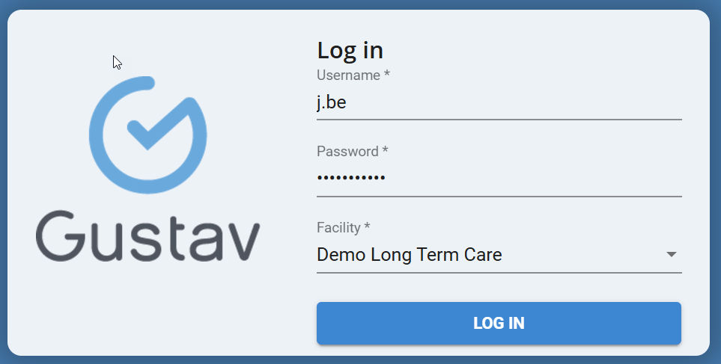
The username displayed in the top right-hand corner of the screen corresponds to the user's electronic signature.

Change password
For users with an account managed via Active Directory (Windows account), please refer to your organization's IT support.
To change your password:
- Click on username and select “Password”.
- Enter current password
- Enter new password
- Retype the new password for confirmation
- Confirm
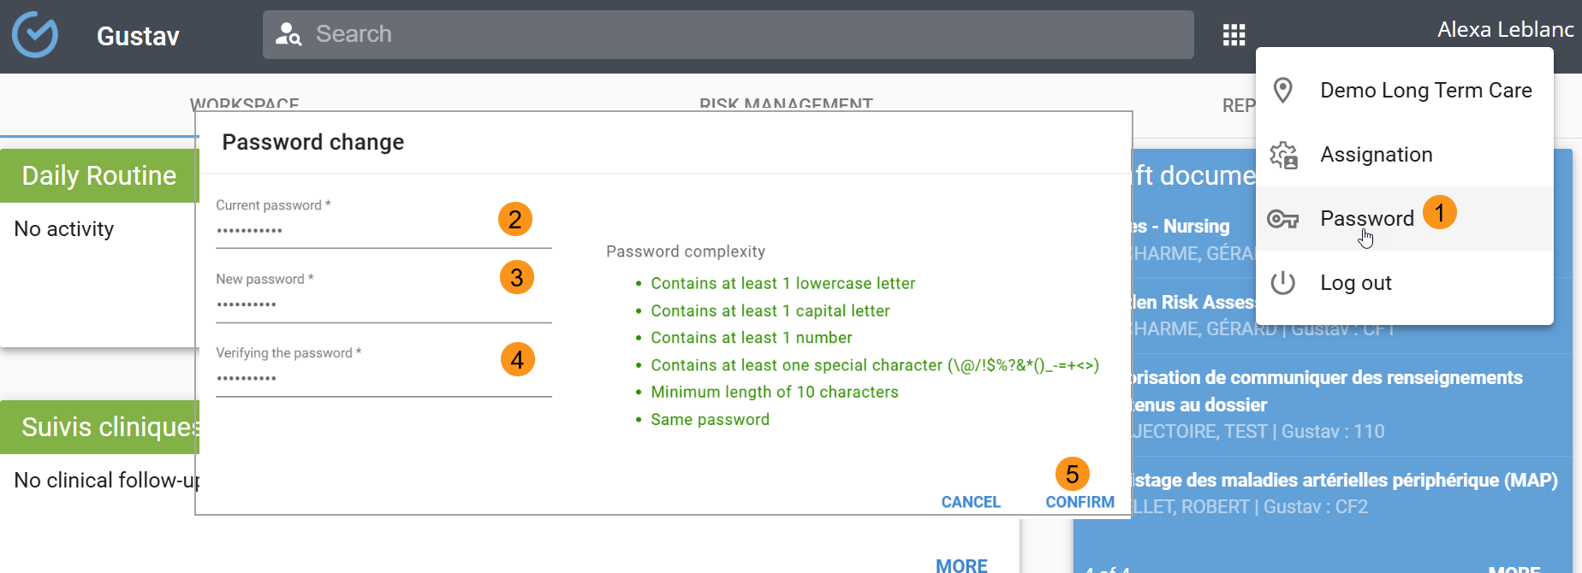

Log out
To log out :
- Click on your username
- Select Log out
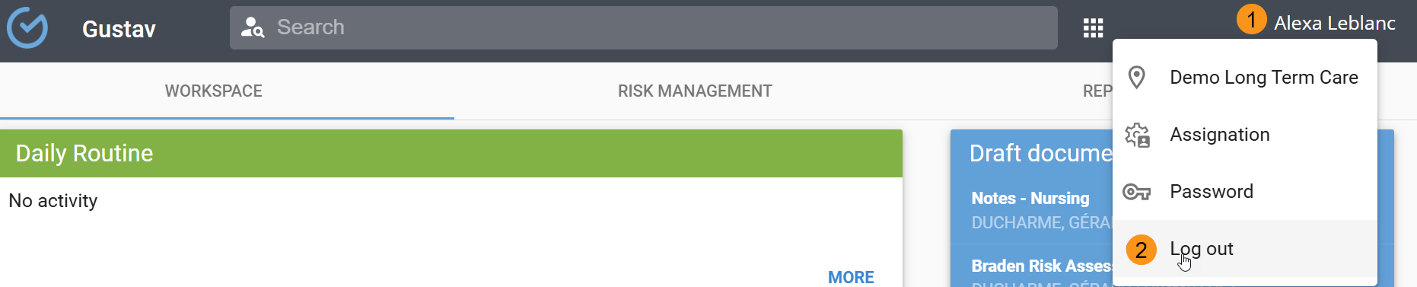

WORKSPACE
The configuration of the workspace tiles may vary depending on the user’s profession and the organization’s setup
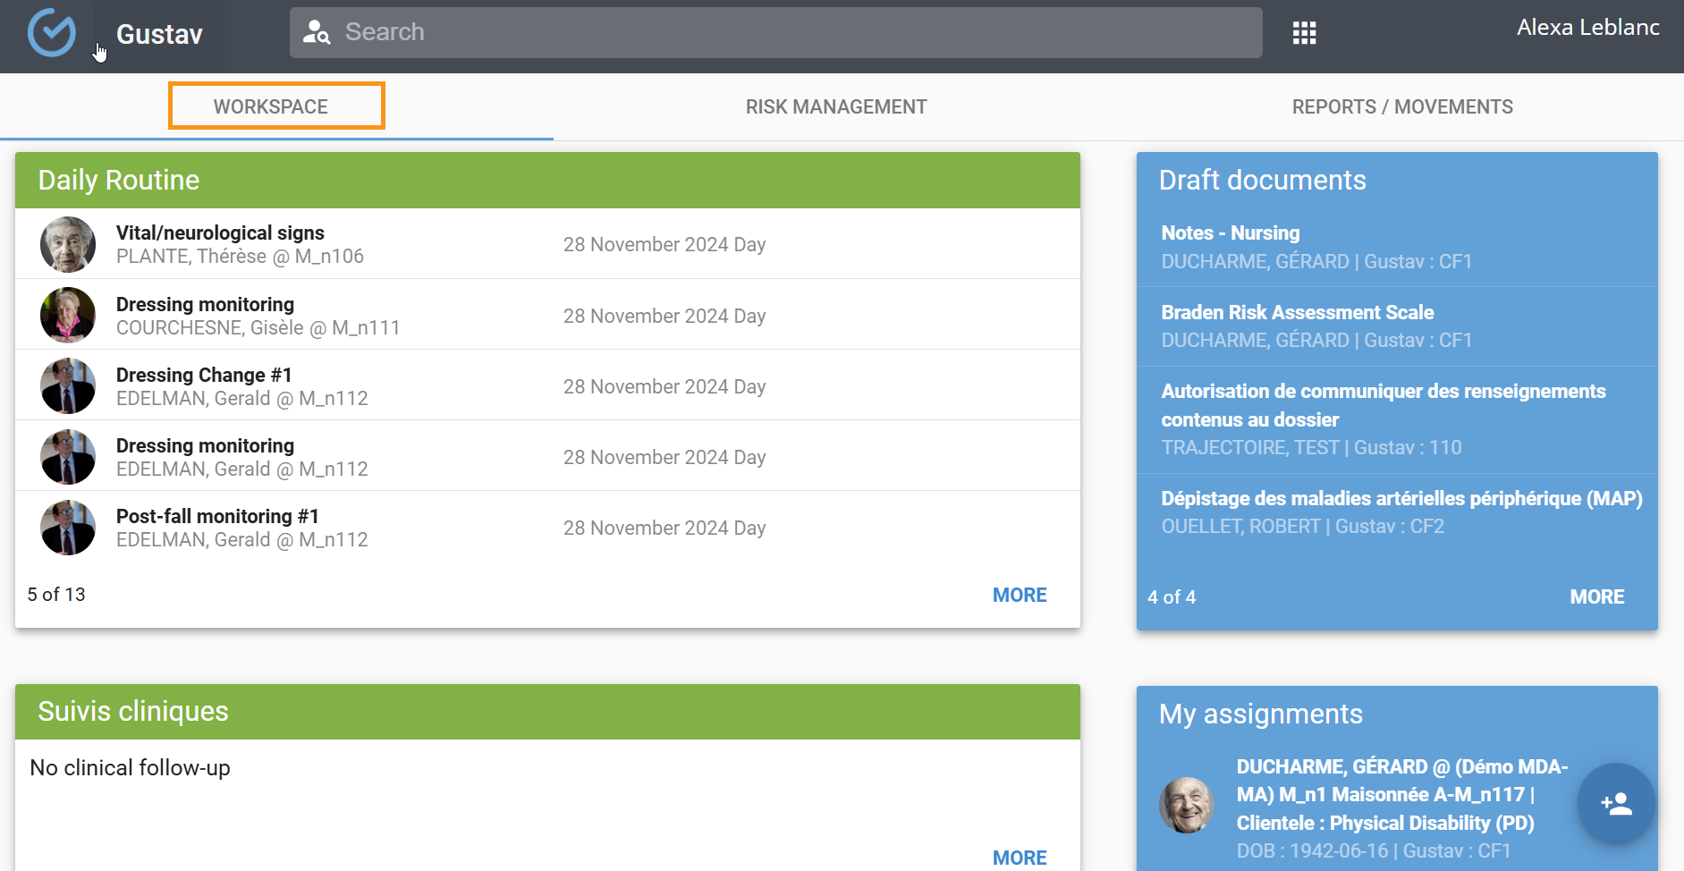

Gustav Help Center
Accessible via the workspace dashboard, the Gustav Help Centre provides access to documentation topics and training video capsules.
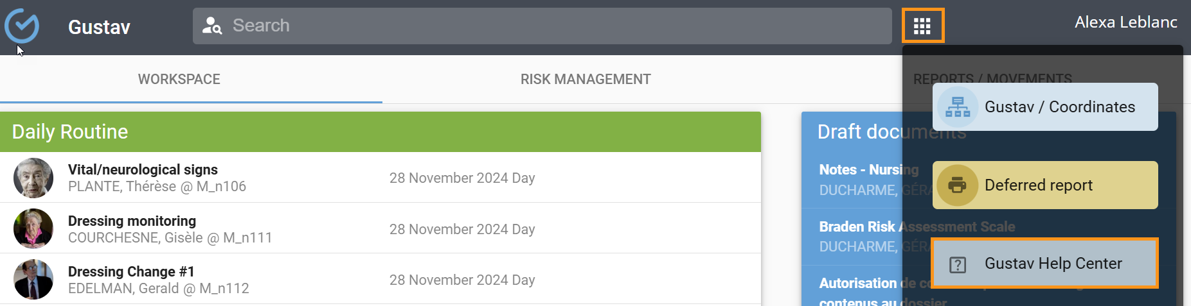

Self-assignment
This feature is designed for users with work routines derived from care plans. It allows users to assign themselves to one or more shifts to access their work routines for those shifts. The list of presences is displayed based on the user’s rights to complete activities for their profession. For exemple:
- A nurse can select both nurse auxiliary and PAB presences.
- A PAB can only select PAB presences
To use self-assignment:

- Select the shift (by default, the list displays presences for the current shift).
- Click "Add" and select a presence.
- Click "Confirm"
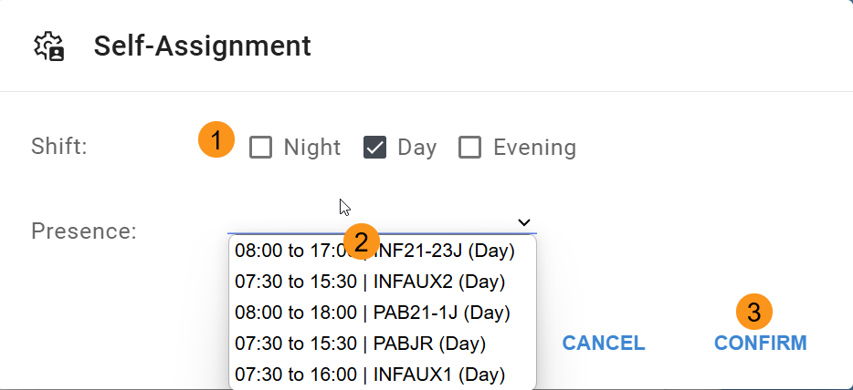

To remove a presence, click the (x)
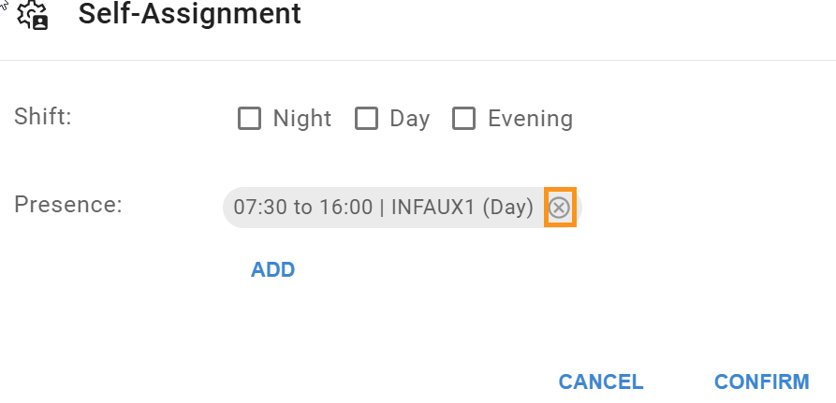
Self-assignment is only displayed when the shift is first logged in, but can be modified by performing the following steps:
- Click on username
- Select “Assignments “
- Make the change and “Confirm”
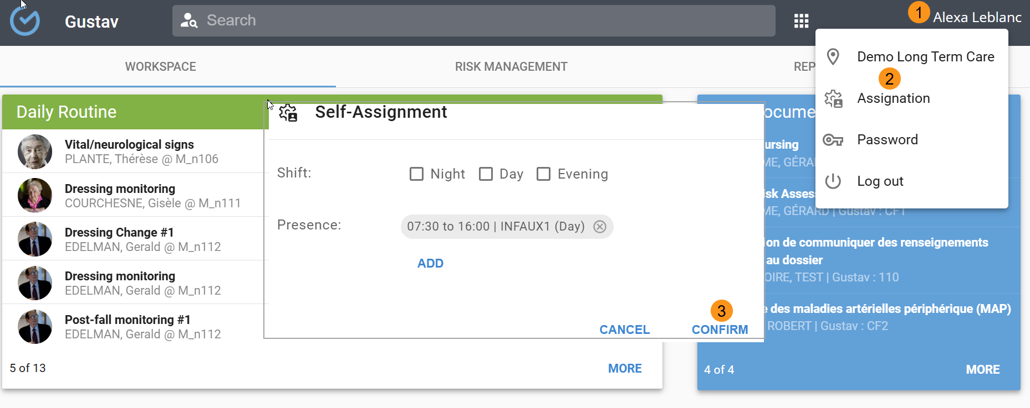

File search
A minimum of 3 characters must be entered to perform a file search. Accepted search criteria include:
- Search by first name and last name
- Search by file number
- Search by date of birth
- Search by room number preceded by the symbol @201
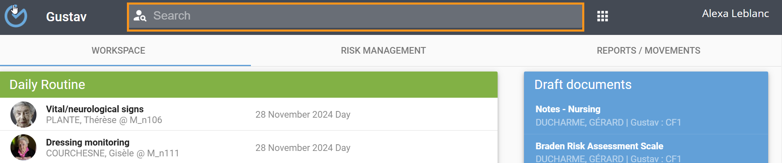
Search results will display the following information:

- (optional) photo
- First and last name
- Location
- Date of birth
- File number
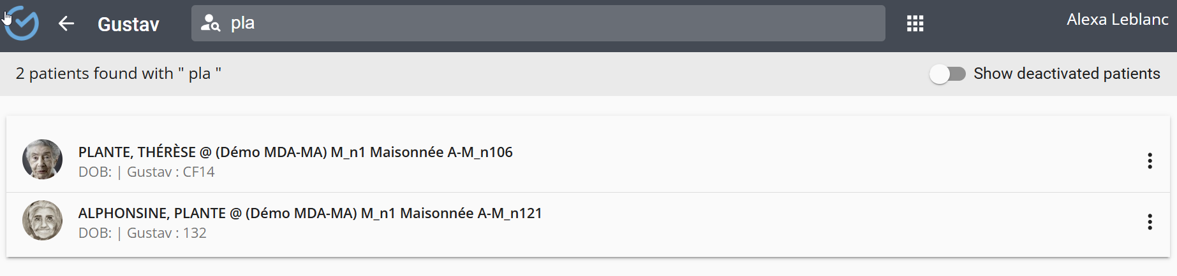

Recent files
This tile displays the last five (5) files accessed by the user. Selecting "MORE" provides access to a larger list of files. The tile will be empty upon the user’s first login.
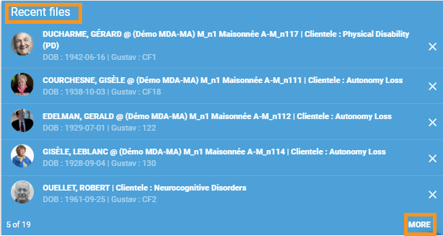
Available filters in the left-hand section facilitate file browsing:

- Files assigned during the current shift.
- Files currently in progress (documents authored by the user).
- Recently accessed files.
- Older files (files linked to prior episodes of care).
- Deactivated files previously accessed but without clinical data entries.

Files can be removed from the list using the three-dot menu. User information can also be accessed via this menu.
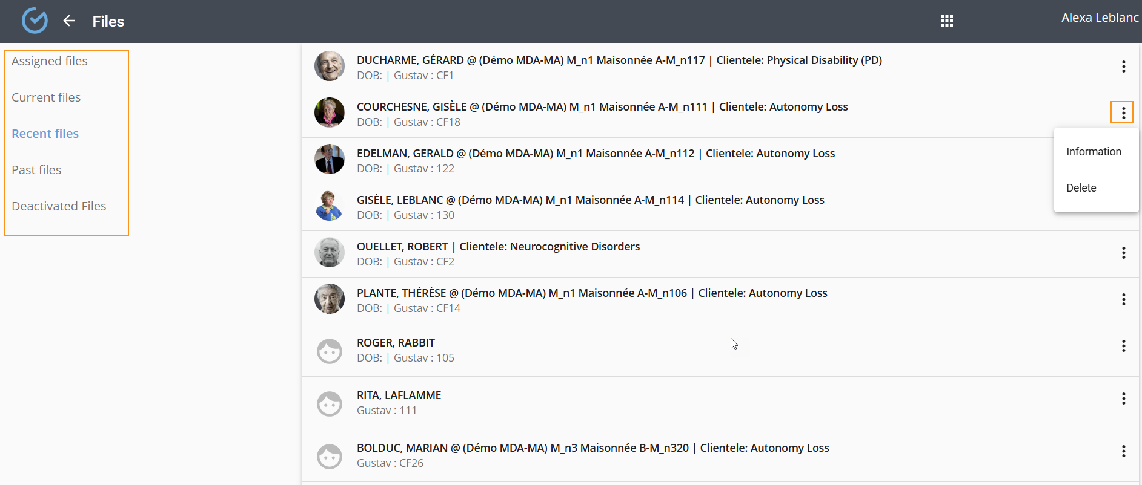

Draft documents
This tile displays the title, name, and file number of the last five (5) draft documents saved by the user. Selecting a document will open it in editing mode, allowing the user to continue or finalize it. Documents in draft mode will not be included in the contingency plan.
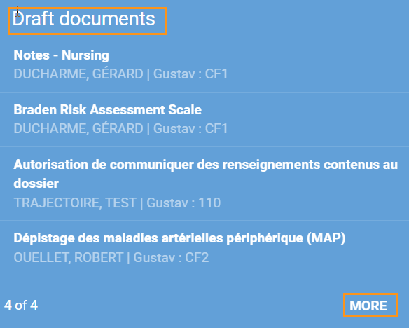
The " MORE" button allows detailed display, printing, and continued editing of documents.
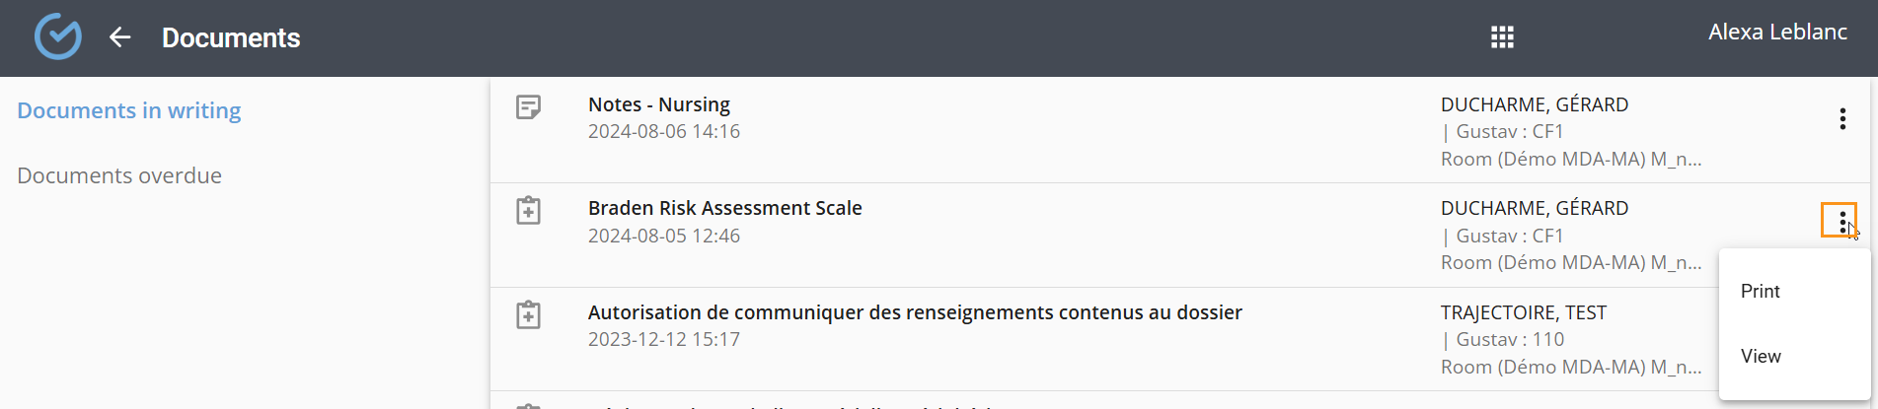

My assignments
This tile displays the list of users assigned to the logged-in user for their shift. Clicking the "MORE" button provides access to a detailed view.

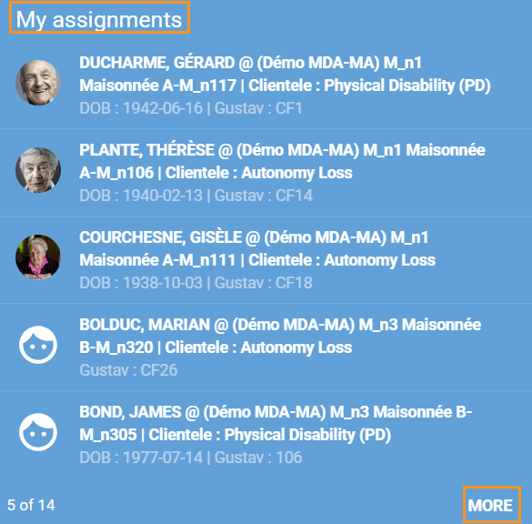
Filters available in the left-hand section facilitate file browsing:
- Files assigned during the current shift.
- Files currently in progress (documents authored by the user).
- Recently accessed files.
- Older files (linked to prior episodes of care).
- Deactivated files previously accessed but without clinical data entries.
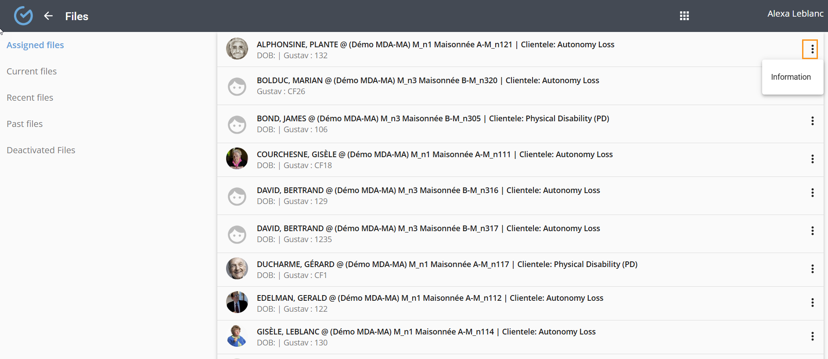

DAILY ROUTINE
This tile displays a chronological list of activities (care/services and common tasks) the user must complete during their shift. The displayed information includes:
- Photo.
- Usern name.
- Location.
- Date and time of activity completion.
Additional details and reference hyperlinks (forms, guides, MSI) may be displayed when an activity is selected. The " MORE" button provides a detailed view.
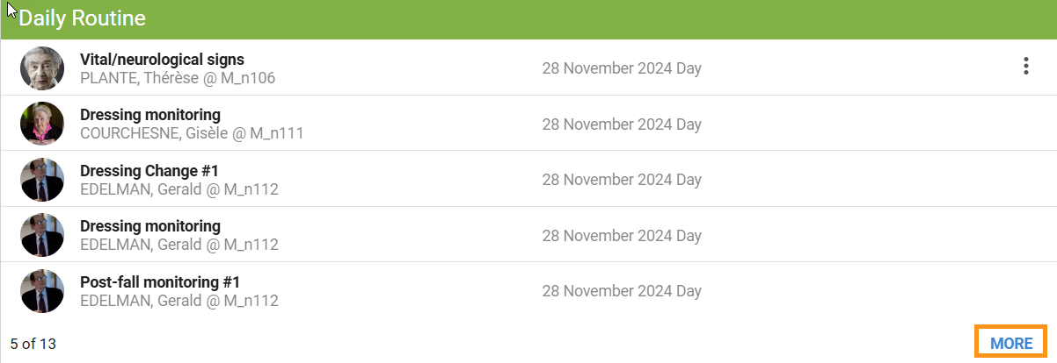
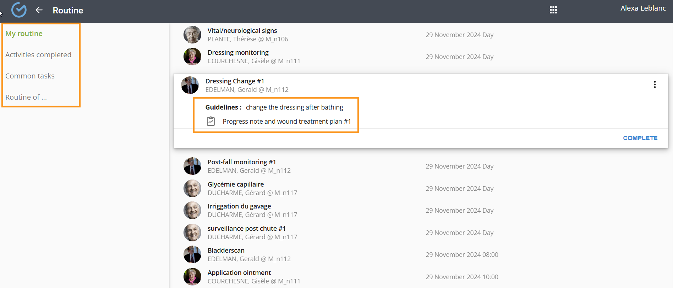

Complete an activity
Activity completion can also be performed via the coordination tab in the user’s file. To complete an activity:
- Select the activity and click "Complete".
- Enter the date/time.
- Click "Confirm".
Completion details, including the user’s information and the completion time, will appear in the "Activity completed" filter.
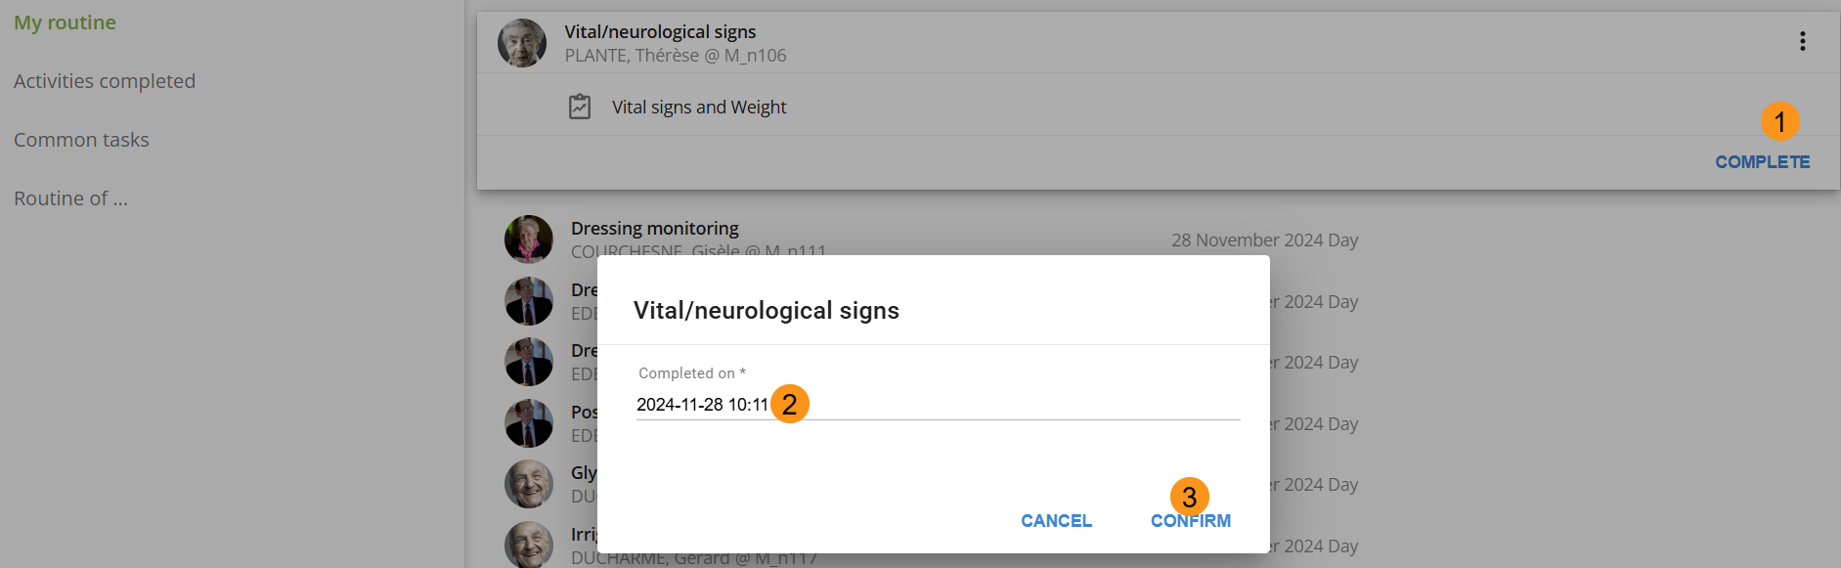

Not completed activities
An incomplete activity requires justification and will be displayed in the Inter-shift report. If needed, the activity can be rescheduled.
- Use the three-dot menu to select "Not completed".
- Select a reason.
- Click "Confirm".
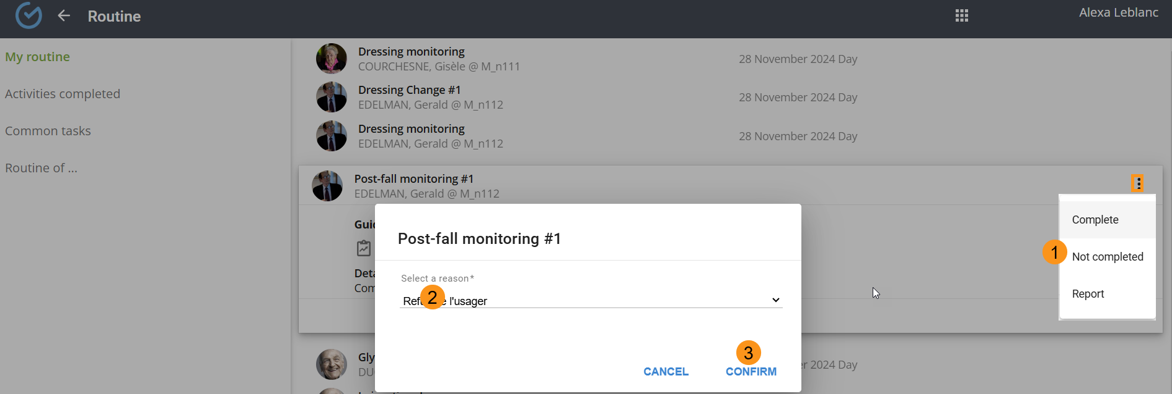

Report an activity
The user can postpone an activity to a later time or to the next shift. Justification is required for postponing to the next shift.
- Use the three-dot menu to select "Report".
- Select a time or the next shift.
- Click "Confirm".
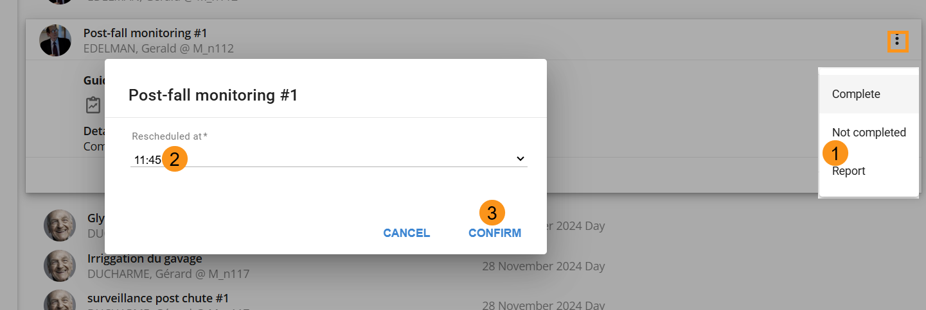

Activities completed filter
This filter displays the list of activities completed during the user’s shift. Completion details include:
- Activity name.
- User’s name and location.
- Date and time of completion.
- User’s signature.
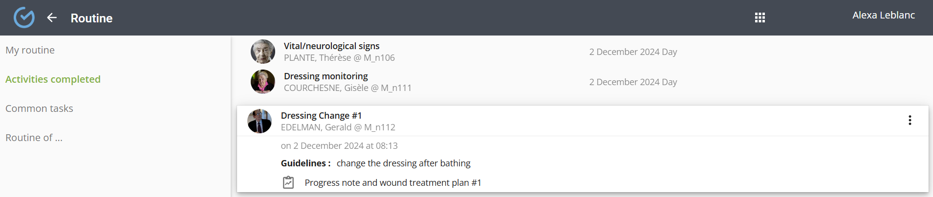

Commun tasks filter
This filter displays the list of common tasks to be completed during the shift. These tasks are not linked to a specific user.
- Select the task.
- Click "Complete".
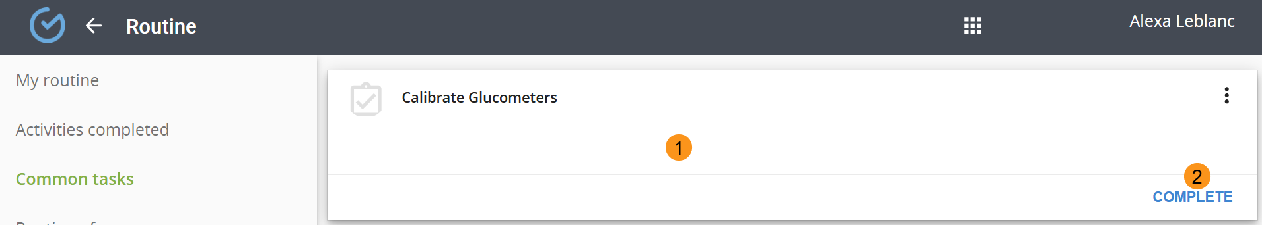
A common task marked as Incomplete requires justification and will be displayed in the Inter-shift report. It can be rescheduled if needed:
- Use the three-dot menu to select "Mark as Incomplete".
- From the dropdown menu, select a reason.
- Click "Confirm".
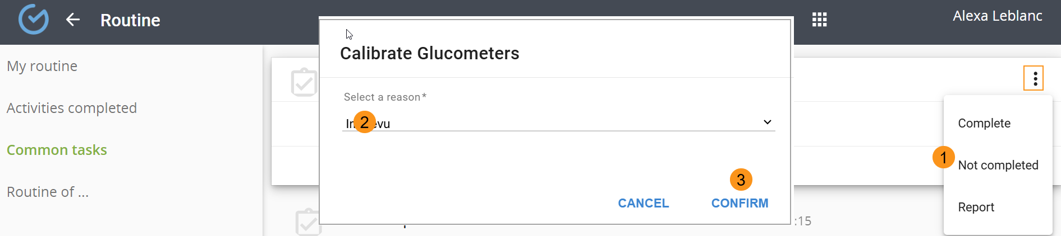

Access a colleague’s routine
This feature allows access to a colleague’s routine to collaborate on activity completion. The name of the user who completed the activity will be displayed in the activity details.
- Select "Routine of".
- Choose a colleague routine from the dropdown menu.
- Click "Confirm".
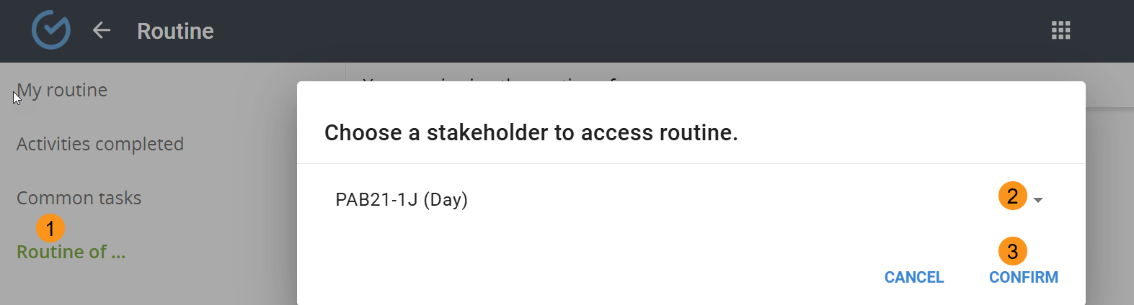

FOLLOW UP
To create a trajectory, refer to the "Create a Trajectory" section. Créer une trajectoire
Clinical follow-ups display the chronological list of trajectory activities to be performed over the next 72 hours. The following details are displayed:
- Activity title.
- User’s first and last name, and location.
- Scheduled date and time.
- A red warning appears for overdue activities.
Selecting an activity may display additional details, such as a form to complete or a reference guide.
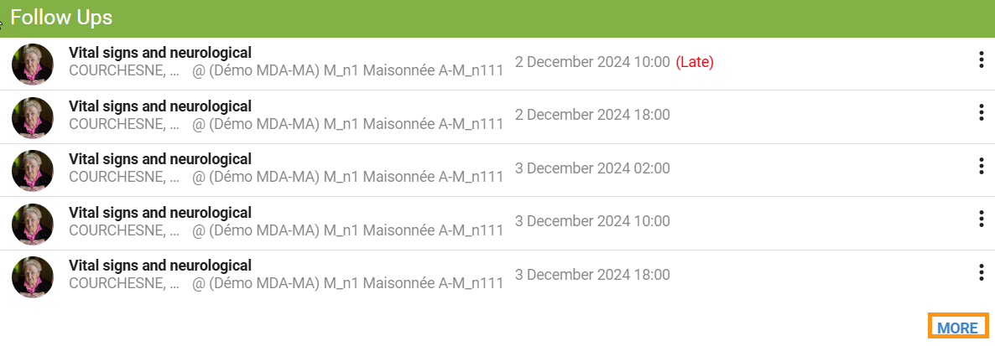
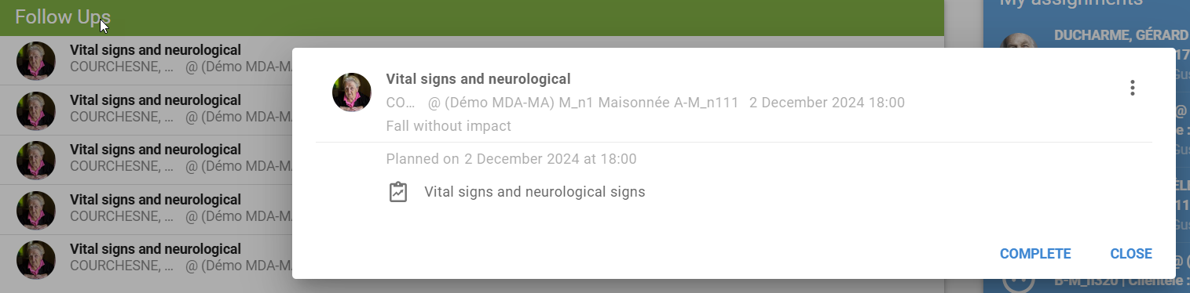
The "MORE" button provides a detailed view and allows filtering activities by those still pending or already handled.
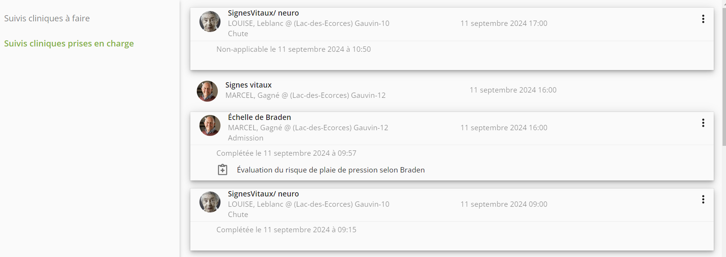

Complete a follow up
A completed activity will no longer appear in the list, and its completion details will be available under the "Handled Clinical Follow-Ups" filter.
- Select the activity and click "Complete".
- Enter the date and time.
- Click "Confirm".
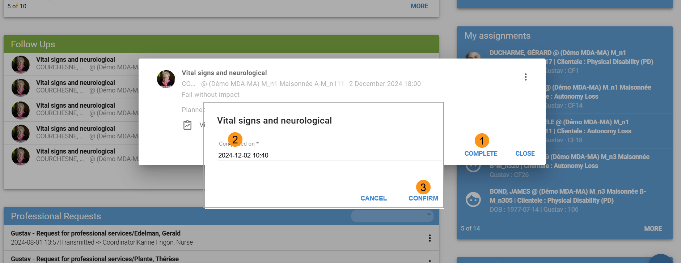

Report a folllow up
It is possible to report an overdue activity to a later time or the next shift. Justification is required for postponing to the next shift.
- Use the three-dot menu to select "Report".
- Select a time or the next shift (justification required).
- Click "Confirm".
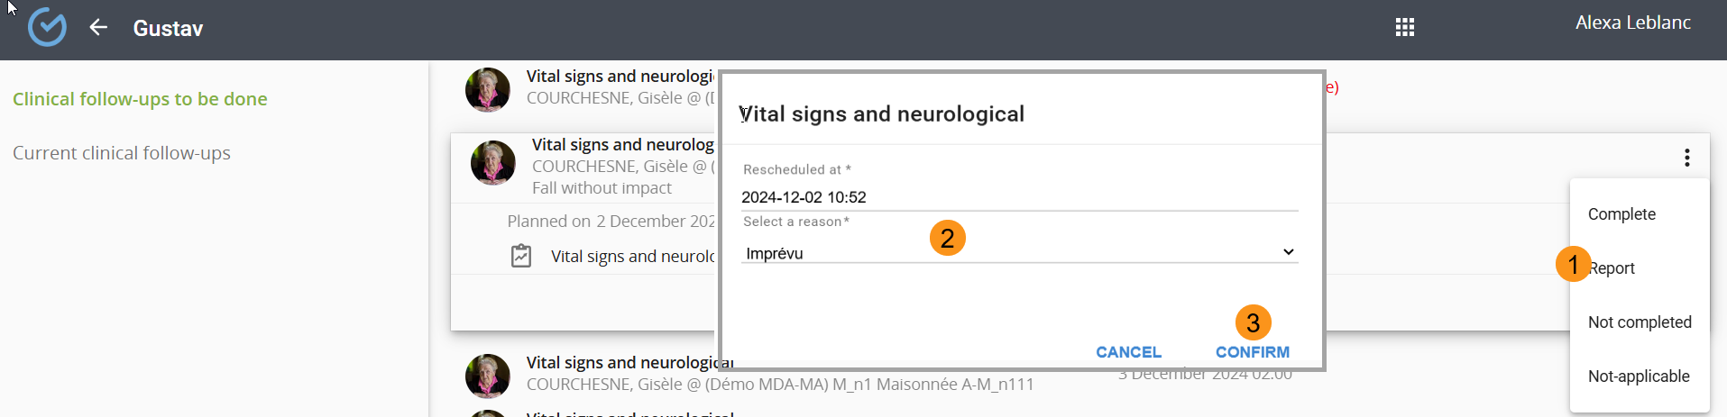

Not complete a follow up
An incomplete activity requires selecting a reason.
- Select "Not complete".
- Choose a reason.
- Click "Confirm".
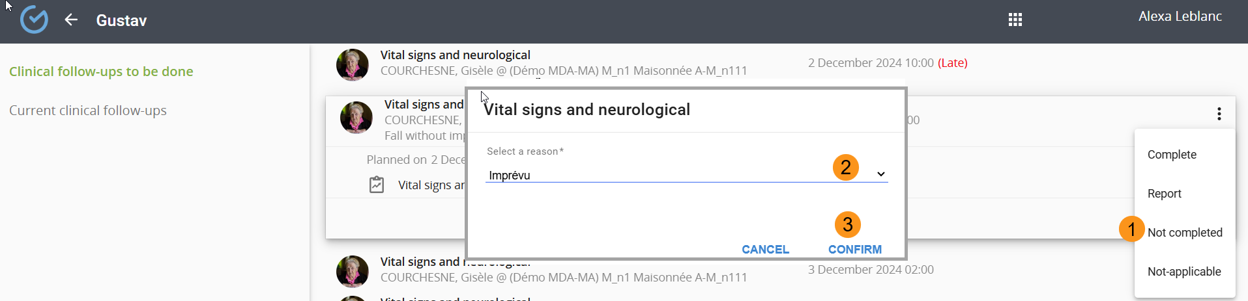

Not applicable follow up
An activity can be marked as "Not Applicable", and this information will be available in the "Handled Clinical Follow-Ups" filter.
- Use the three-dot menu to select "Mark as Not Applicable".
- Click "Confirm".
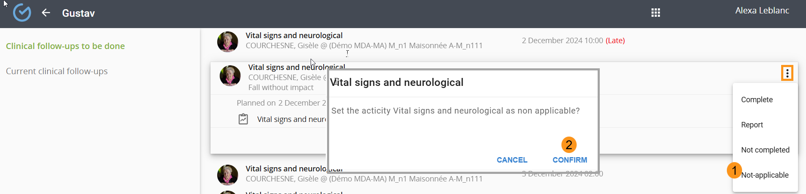

Reset a follow up
Depending on the user’s permissions, the activity can be reset via the "Curent Clinical Follow-Ups" filter.
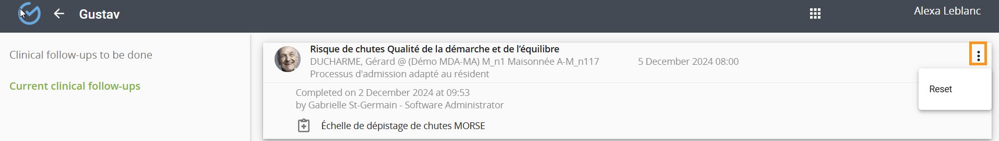

PROFESIONNAL REQUEST
To create a request, refer to the "PROFESSIONAL REQUESTS" refer to REQUÊTES PROFESSIONNELLES
Depending on the organization’s configuration, request processing may require steps performed by a coordinator.
The request list is displayed based on priority and the user’s profession. A request remains visible in the initiator’s tile until completion and can be accessed in read-only mode.
The coordinator’s tile shows requests awaiting approval and requests can also be accessed and acted upon via the user’s file.
Request details include:
- Request title.
- User’s name.
- Date and time of transmission.
- Name, surname, and profession of the requester.
- Status.
It is possible to purify the display using the site filter. The “MORE” button provides access to detailed view as well as filtering by location, status, domain and printing if necessary.
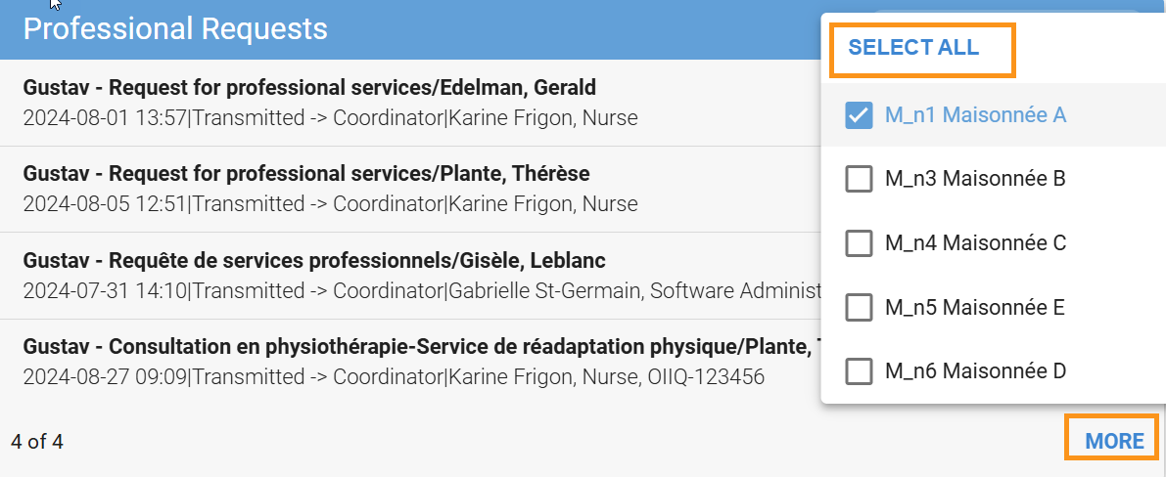
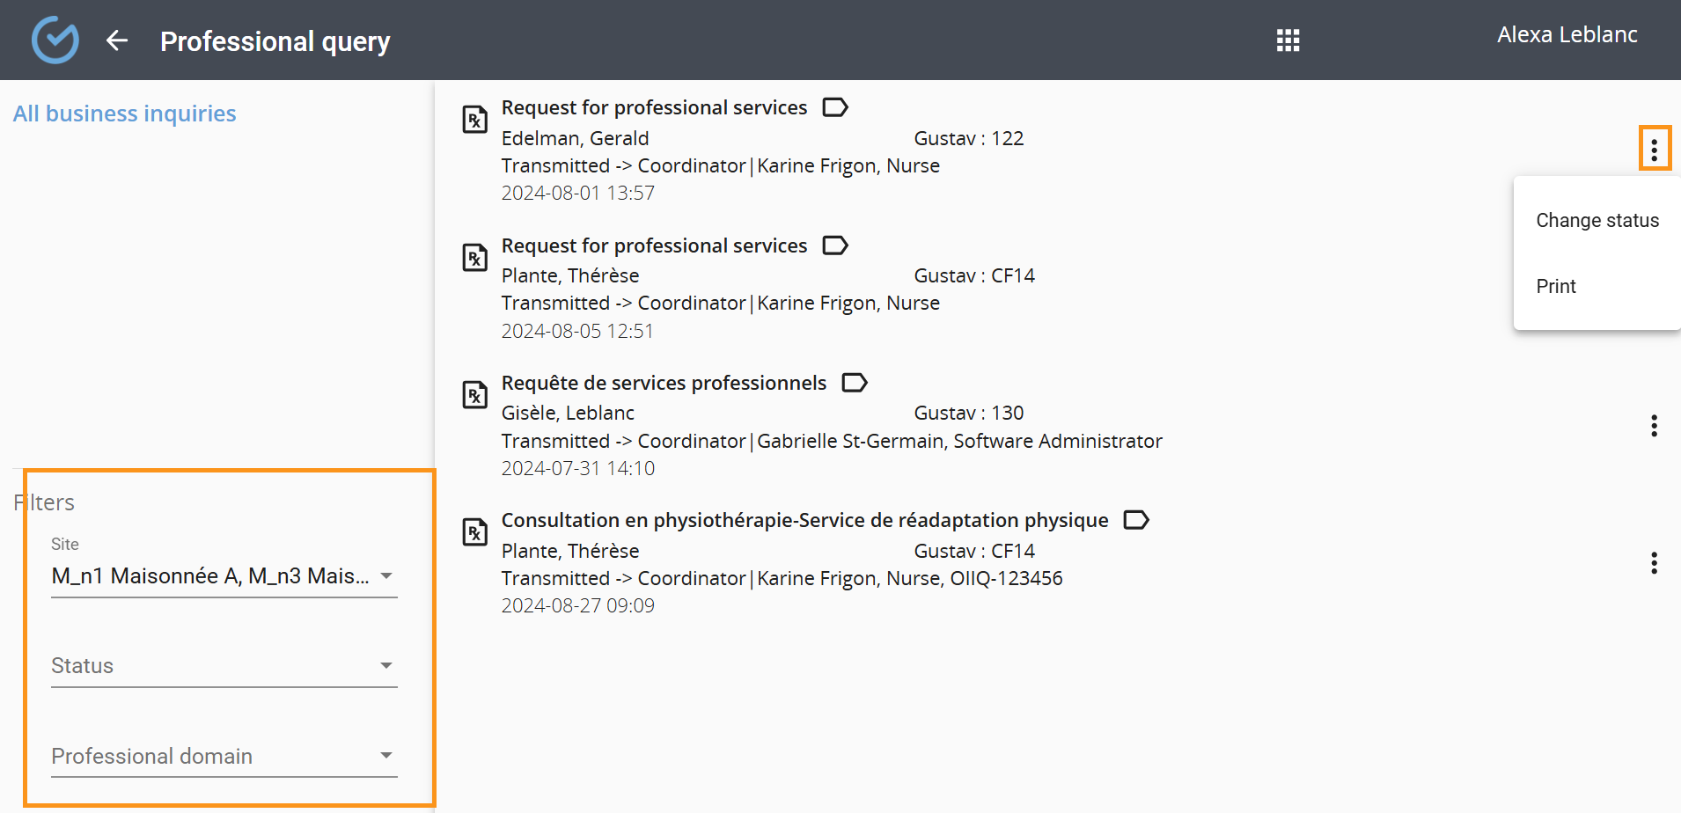

Change or remove status
To change the statuts
- From 3 dots, select «Change status»
- Edit status and enter a note (optionnal)
- Confirm
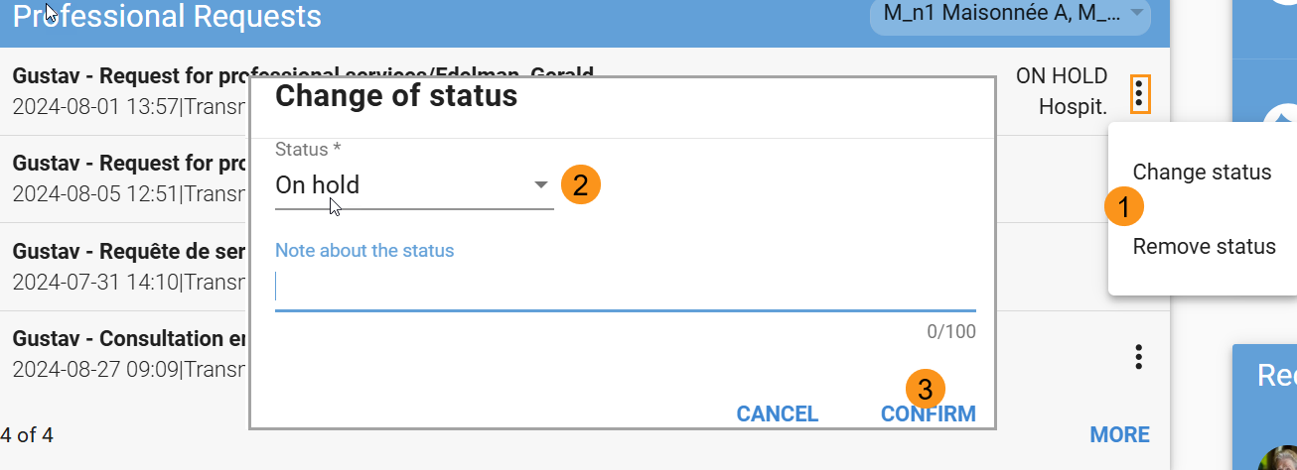

Approve a request
This feature is available based on the organization’s configuration and if the user has a coordinator role.
A request must be approved to be visible in the assigned profession’s tile. Once approved, the request will no longer appear in the coordinator’s workspace but will remain accessible in the file.
To approve a request, select the request and click "Approve".
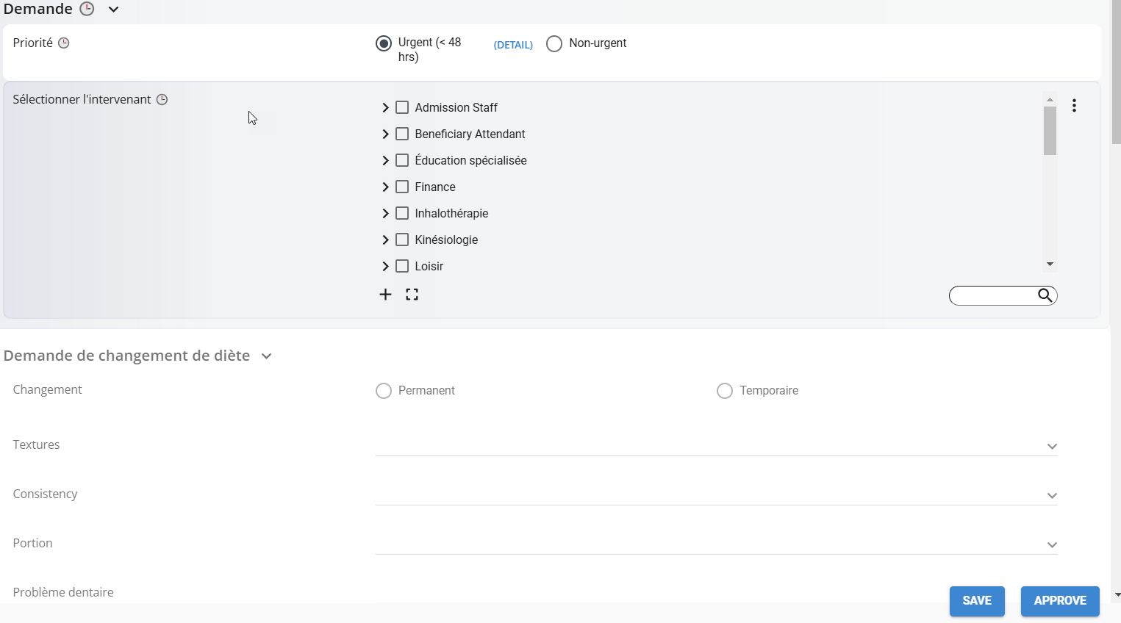

Reject a request
Before being handled, a request can be rejected, which ends the transmission process. The request status will be marked as "Rejected" in the file and justification is required.
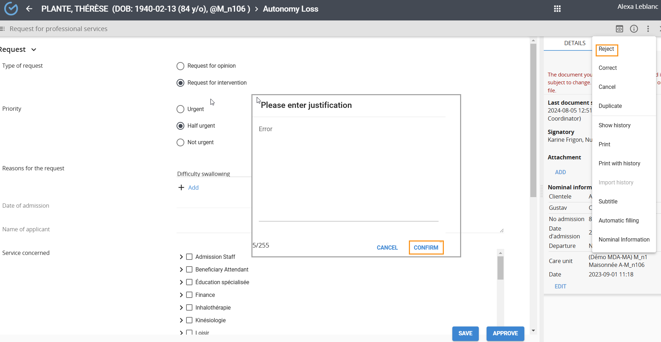
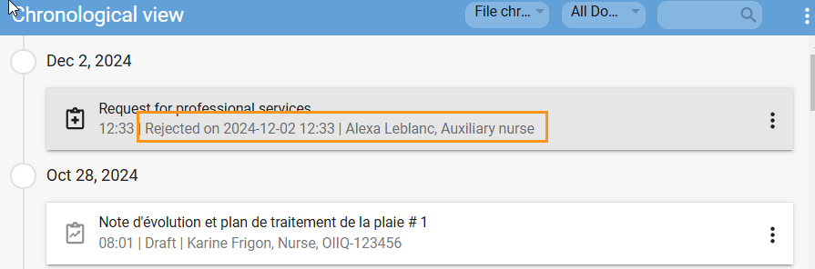

Take charge of a request
For organizations with a coordinator, the "Take Charge" button will only be available once the request has been approved.
Taking charge is only available to the domain/profession concerned by the request.
To take charge of a request:
- Select the request and click "Take Charge".
- Enter the required information.
- Click "Complete".
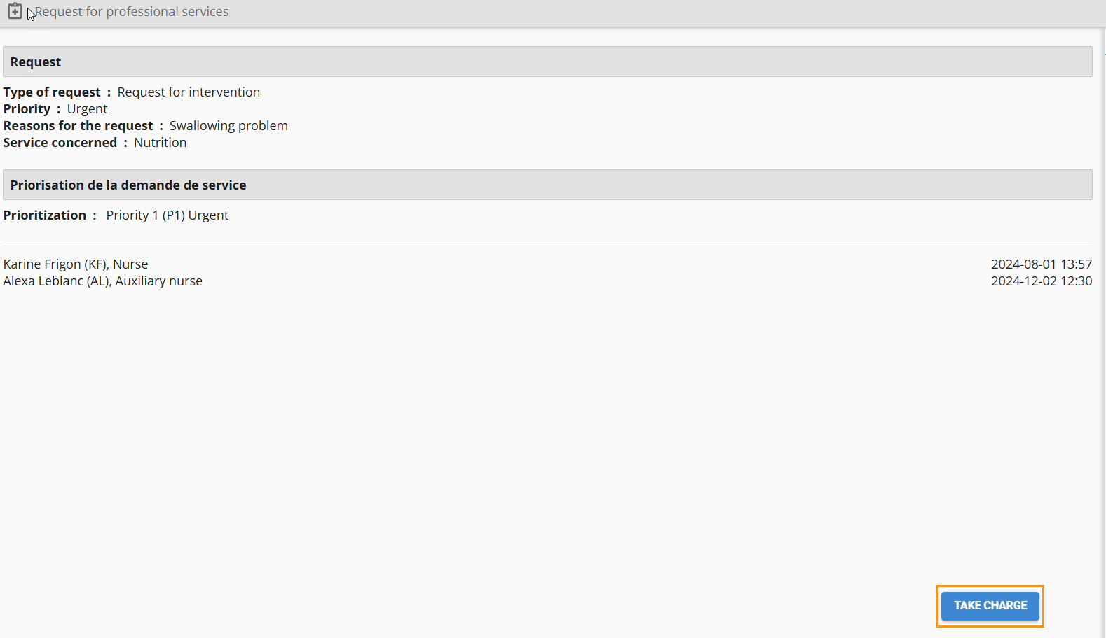
Completed requests will no longer appear in the tile but will remain accessible in the file.
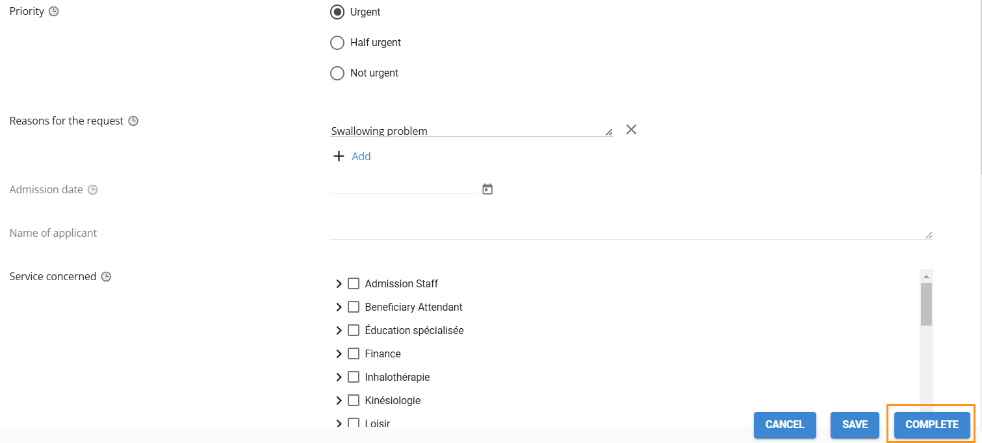

Transfer a request
A request sent to multiple professional domains can be transferred. After the transfer, only the receiving profession can take charge of the request.
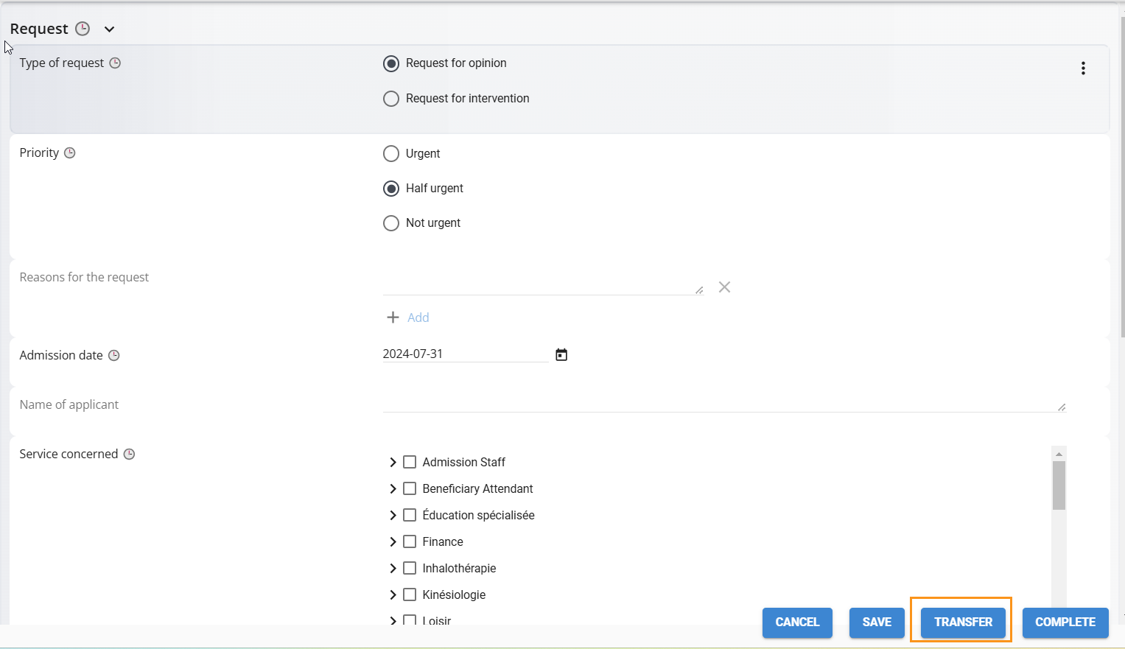

Correct a request
Correcting a request is possible based on the user’s permissions.
To correct a request:
- Use the three-dot menu to select "Correct".
- Make the correction and click "Correct".
- Enter a justification and click «Confirm".
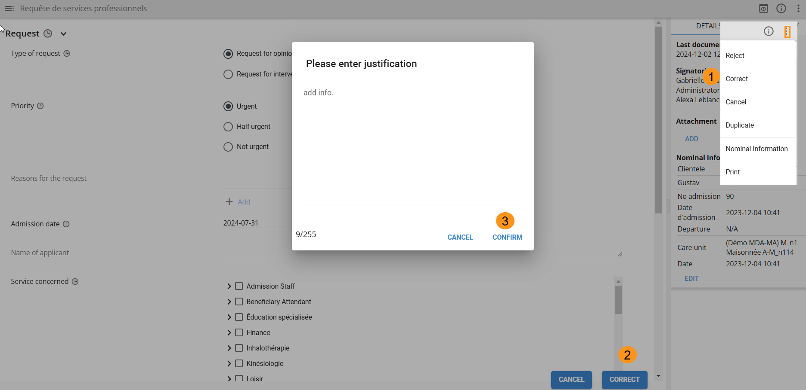

Cancel a request
Cancelling a request is possible based on user permissions. After cancellation, the request will appear under "View Cancelled" in the file.
To cancel a request:
- Use the three-dot menu to select "Cancel".
- Enter a justification and click "Confirm".
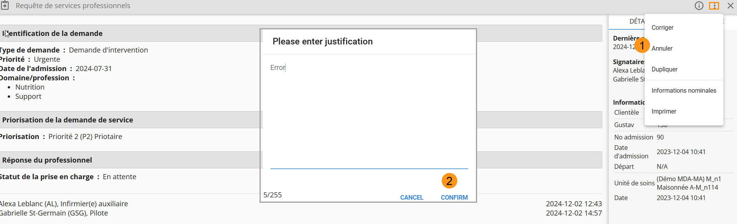

PRESCRIPTION
To create a new order, refer to the ORDONNANCE NON PHARMACOLOGIQUE section
The list of non-pharmacological orders is displayed in chronological order of transmission. Once transmitted, an order remains in read-only mode in the initiator’s tile until completed.
Actions such as Complete, Correct, and Cancel can be performed directly from the user’s file.
Displayed information includes:
- Order title.
- User information.
- Date and time of transmission.
- Name, surname, and profession of the initiator.
- Status.
Filters are available to sort by location. The " MORE" button provides a detailed view, additional filters, and print options.
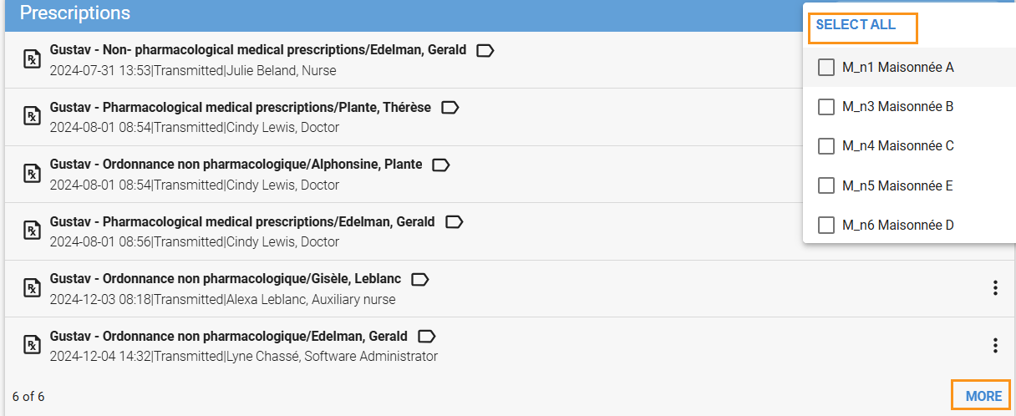
To change or remove a status, use the three-dot menu
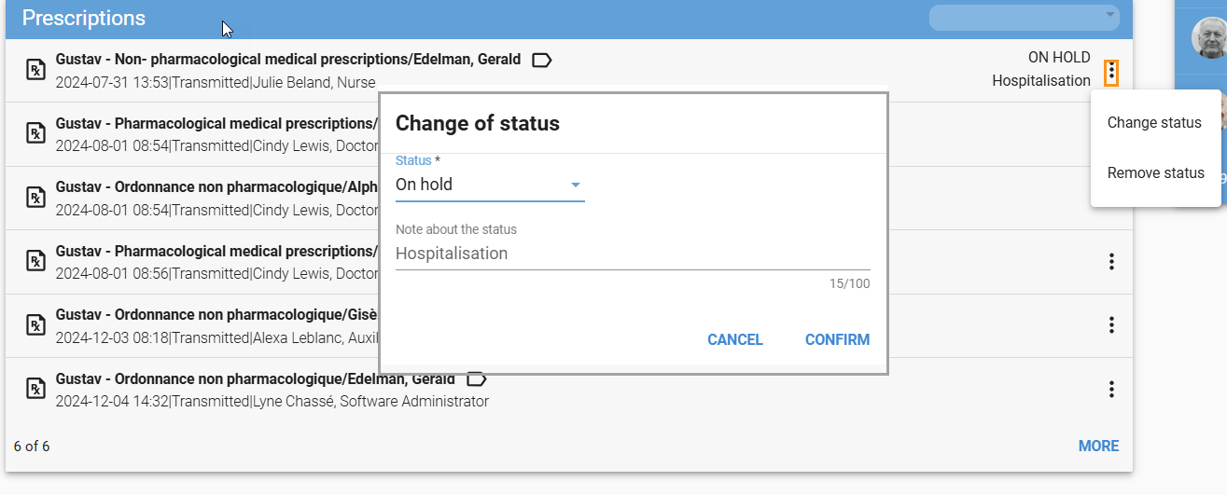

Complete a prescription
Completion is possible based on the user’s permissions. Once completed, the order will no longer appear in the tile but will remain accessible in the file with a "Completed" status.
To complete an order:
- Select the order.
- Click "Complete".
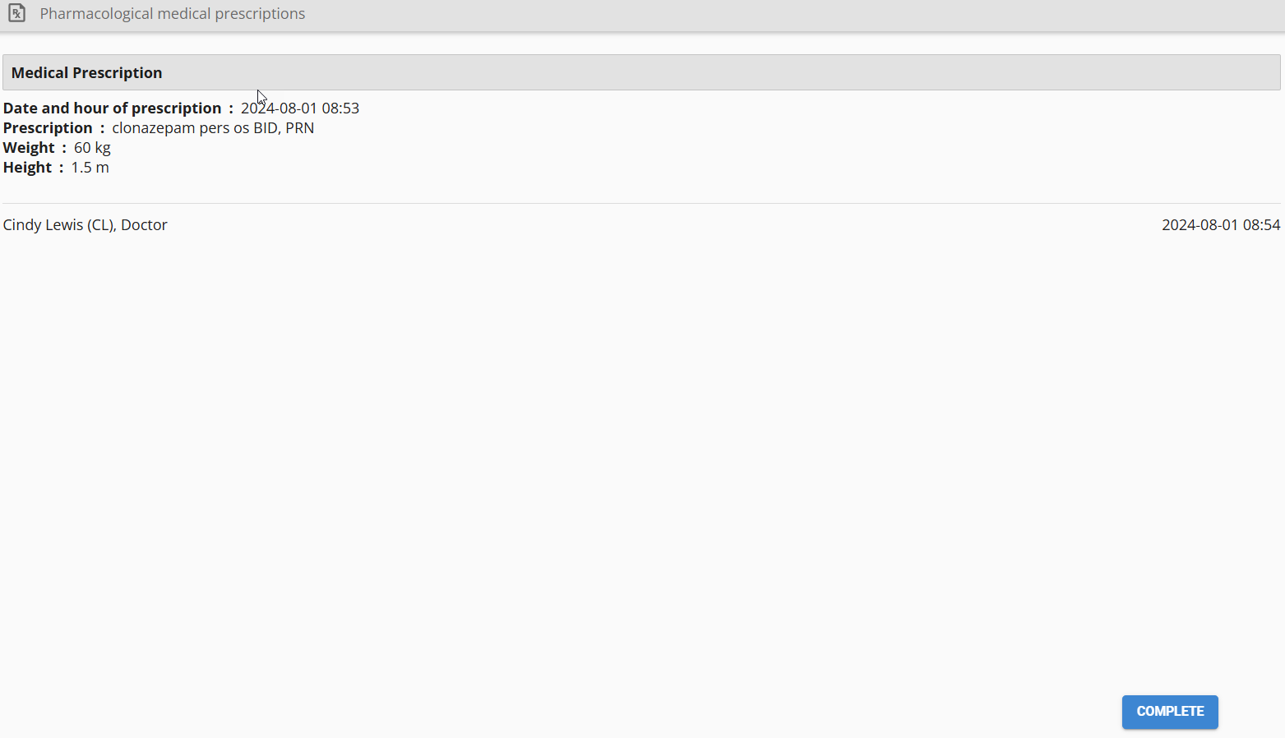

Correct a prescription
Correcting an order is possible based on the user’s permissions.
To correct an order:
- Use the three-dot menu to select "Correct".
- Make the correction and click. "Complet".
- Enter a justification and click "Confirm"
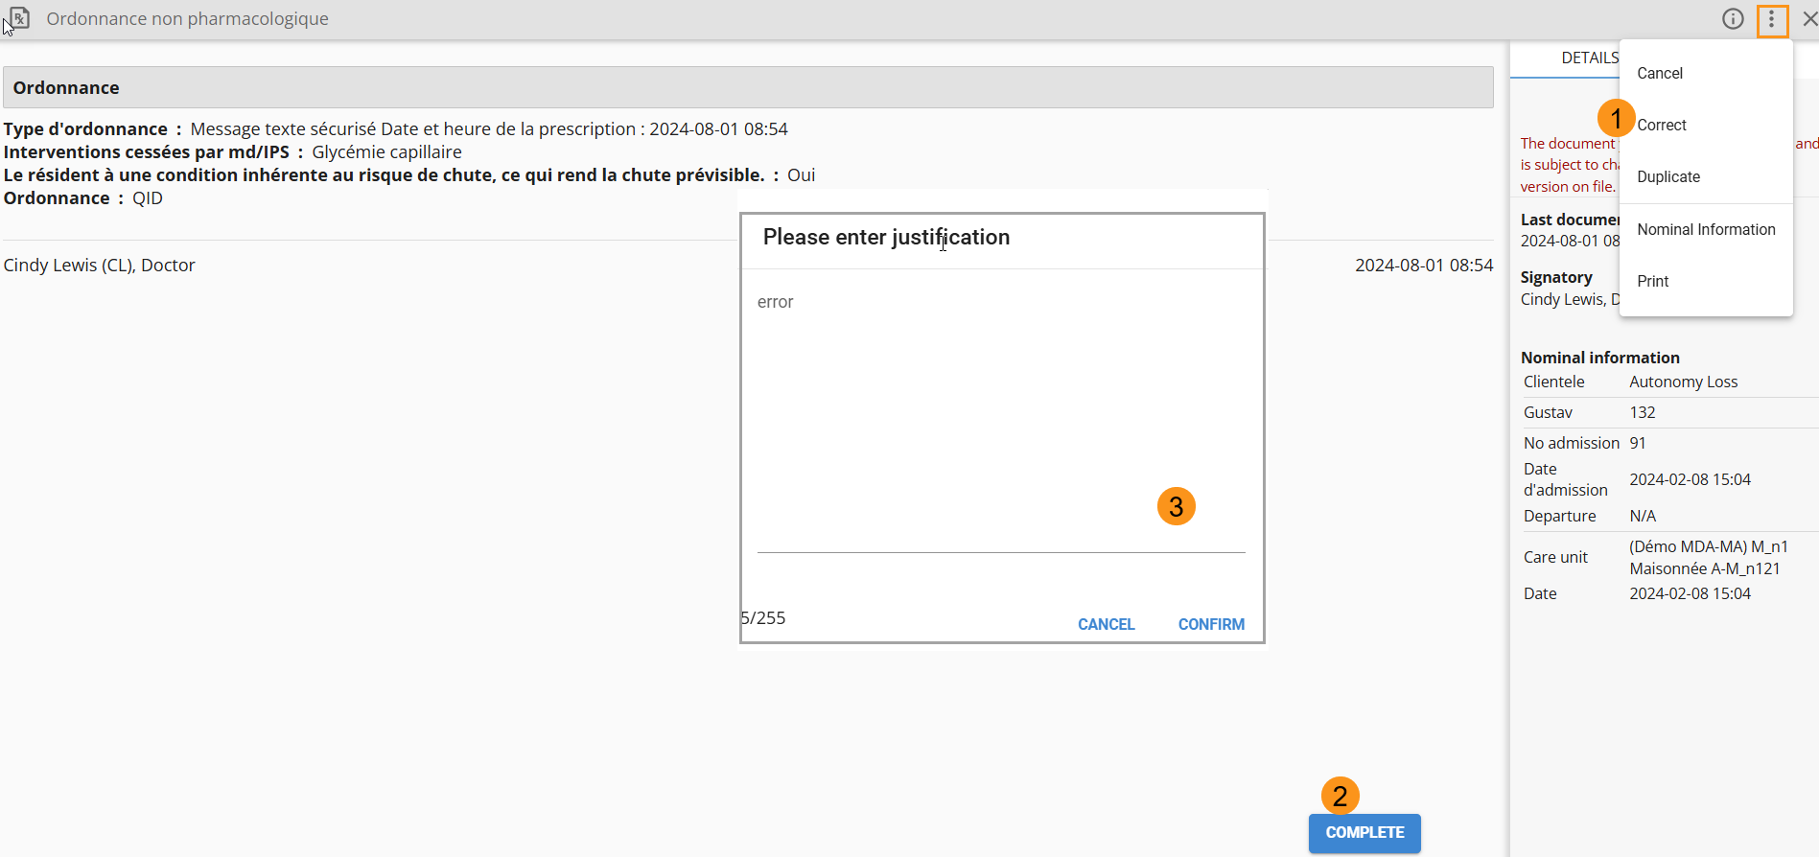

Cancel a prescription
Cancelling an order is possible based on user permissions. Once cancelled, the order will appear under the "View Cancelled" section in the file.
To cancel an order:
- Use the three-dot menu to select "Cancel".
- Enter a justification and click "Confirm".
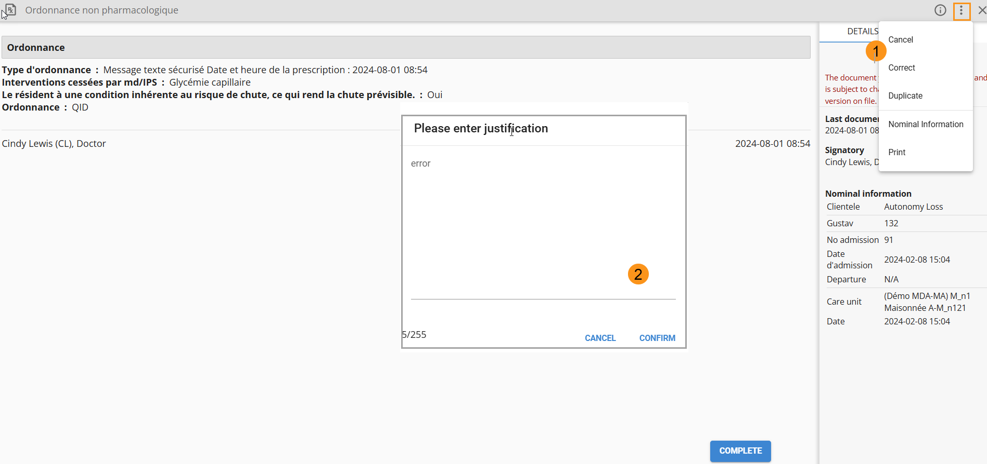

OPEN A FILE
For clients using an ADT system, refer to your organization’s IT support.
To open a file:
- Click the button in the bottom-right corner.
- Enter the file number, first name, last name, gender, and any additional information.
- Click "Create"
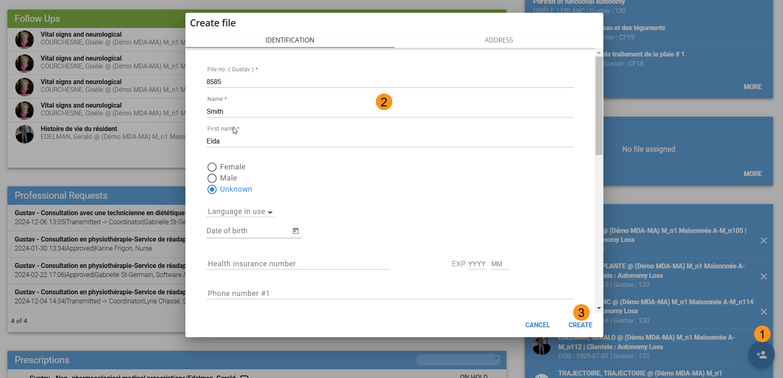

Add a picture
The user’s photo will appear on the identification tab of the file.
To add a picture:
- Use the scroll bar and click within the designated frame.
- Select the photo and click "Open".
- Click "Create".
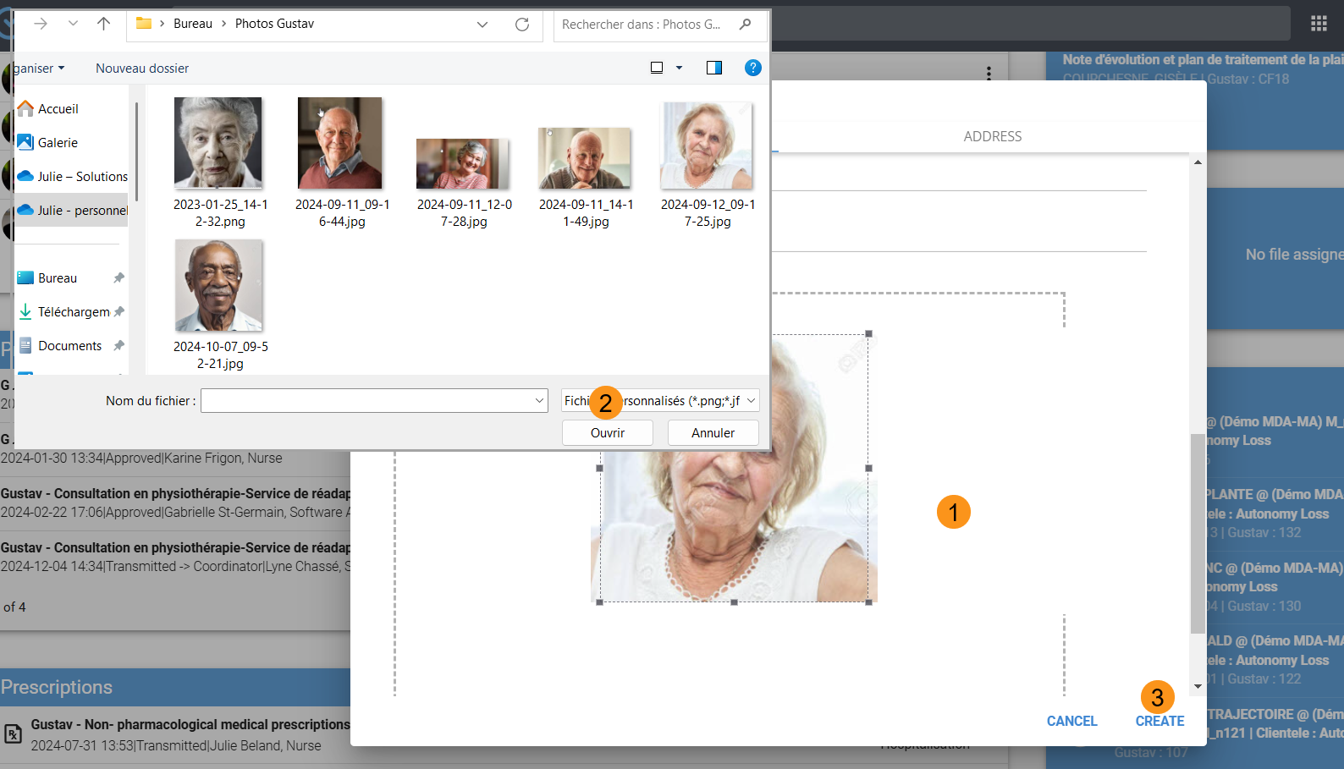
To remove the picture, click the (X) in the top-left corner of the frame.
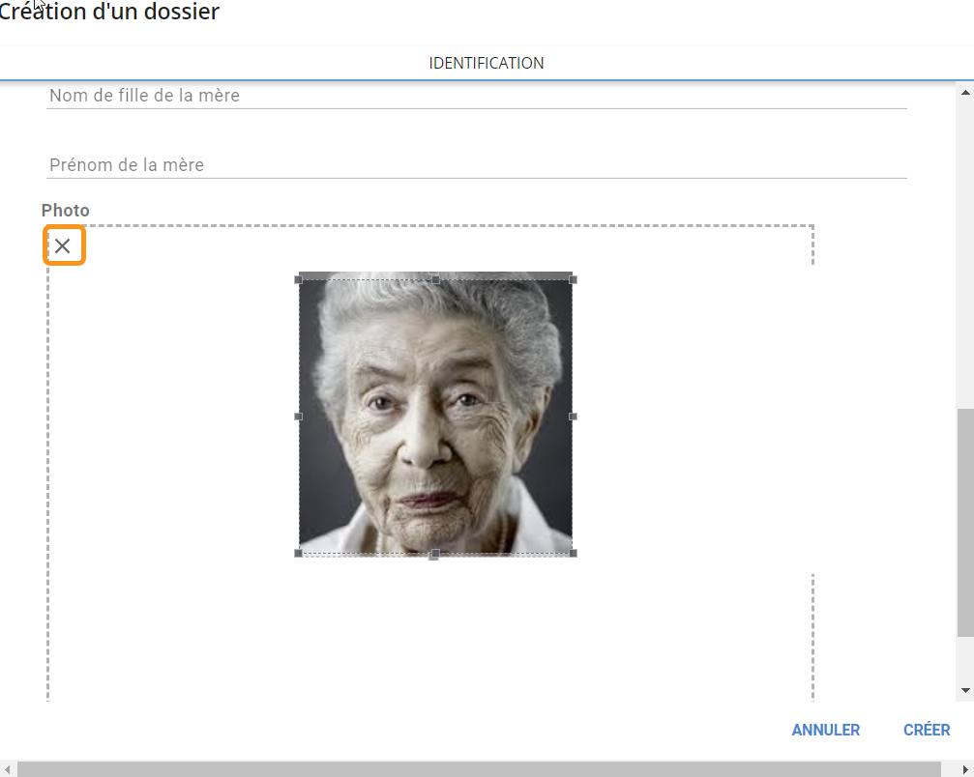

User identification section
This section displays the user’s identification, stay number, and file number. Additional information is available via the "More" button.
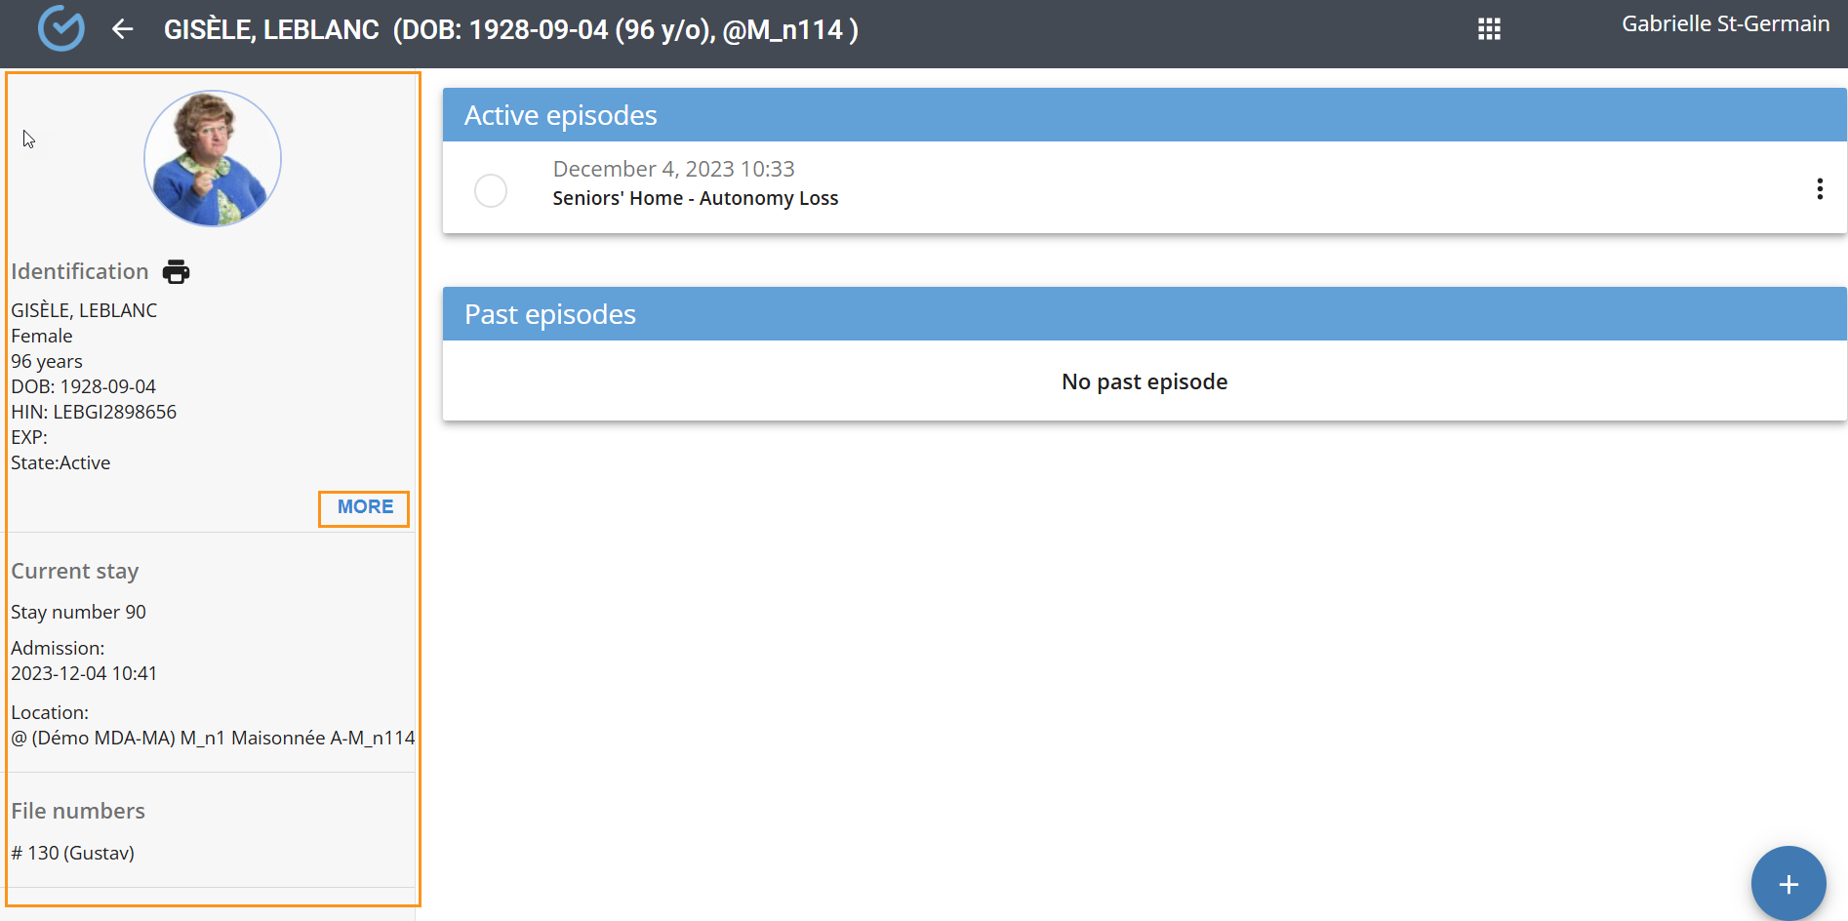

Modify user identification
For clients using an ADT system, do not manually enter data. Refer to your organization’s IT support.
To modify information, click the "More" button in the identification section.
- Select "Modify".
- Make the changes.
- Click "Modify".
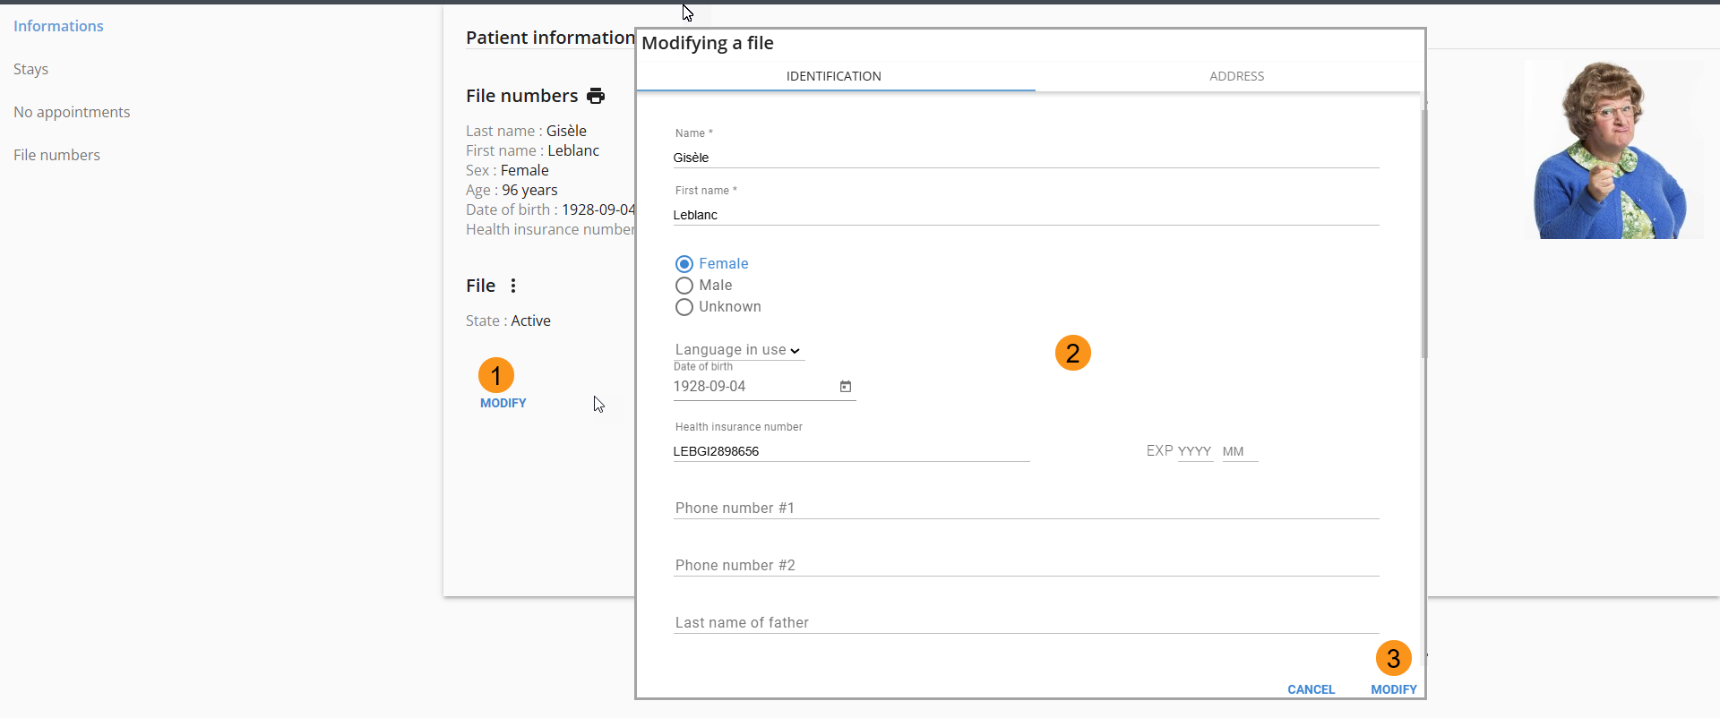

Print a legal
Depending on the organization’s configuration, it is possible to print a label with the user’s identification details.
To print a label:
- Click the icon beneath the user’s photo.
A PDF label will appear in a new window and can be printed.
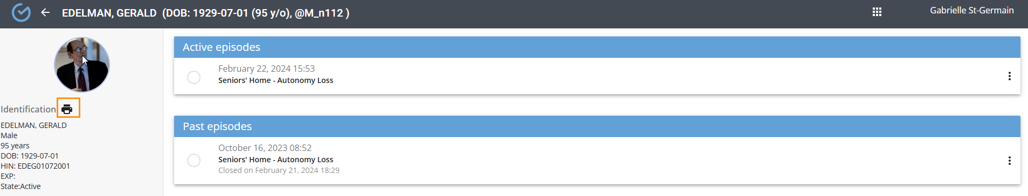
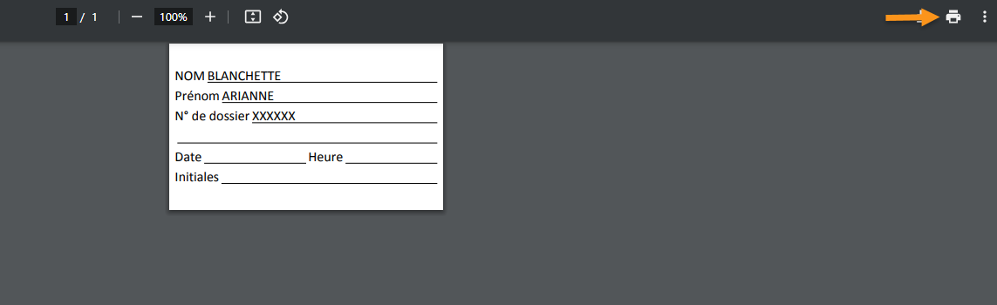

deactivate a file
Deactivating a file closes current episodes and removing the file from search results.
To deactivate a file, use the three-dot menu, select "Deactivate" and Click "Confirm".
For clients using an ADT system, do not manually enter data. Refer to your organization’s IT support.
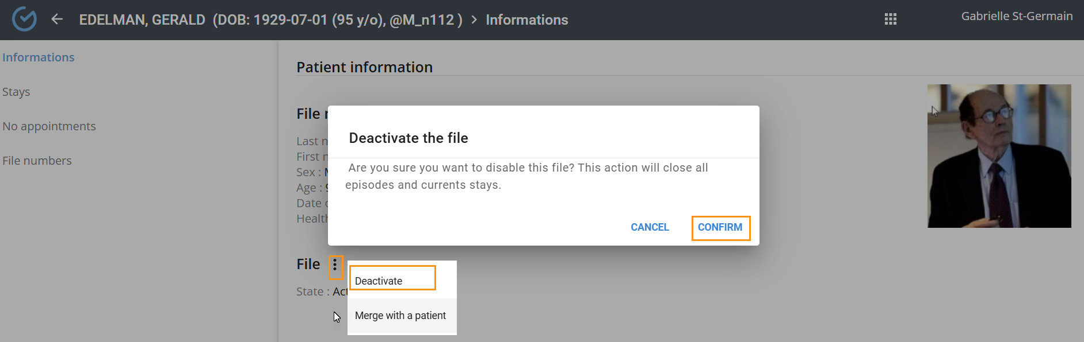

merge a fille
Merge is used in cases of duplicate files. The documentation of the selected file will be transferred, and the file will be deleted.
From the "MORE" button in the identification section:
- Click on the three dots to the right of the file.
- Select "Merge with a user «, Select the file to merge. and confirm
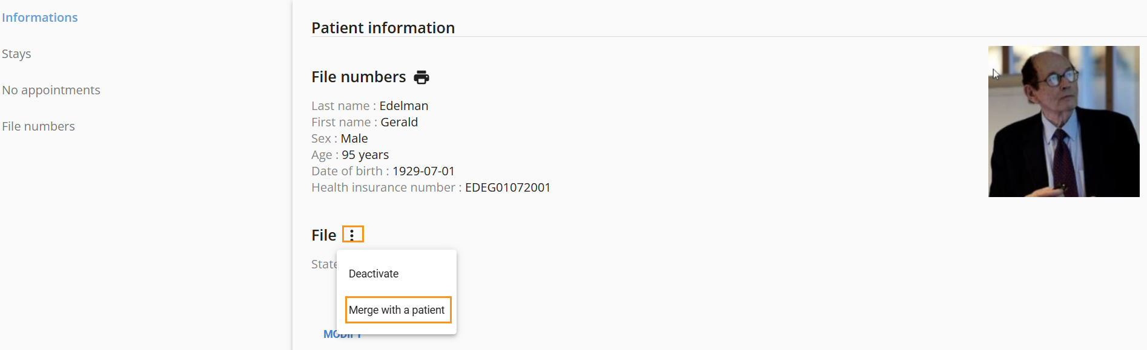

Stays section
For clients with an ADT system, do not enter anything manually; please refer to your institution's pilot.
This section manages admissions, discharges, and transfers and displays details of current and past stays as well as the history of temporary discharges. Actions performed in this section will be reflected in the movements section.
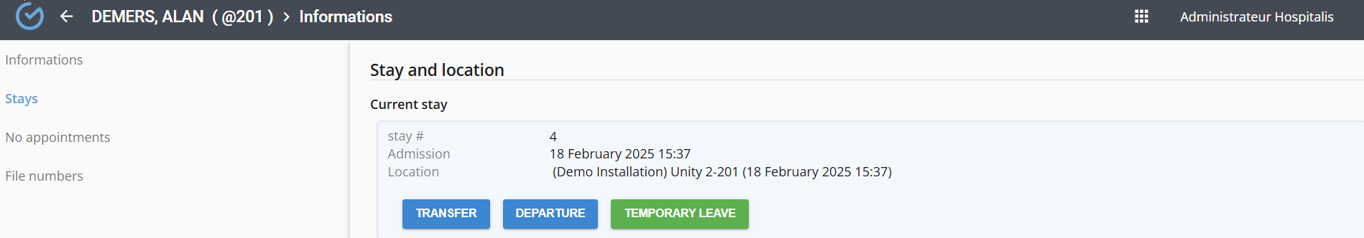

Modify a stay
For clients with an ADT system, do not enter anything manually; please refer to your institution's pilot.
Depending on the user’s permissions, it is possible to modify the date and time of a stay. This can be done using the pencil icon, activated by hovering the cursor.
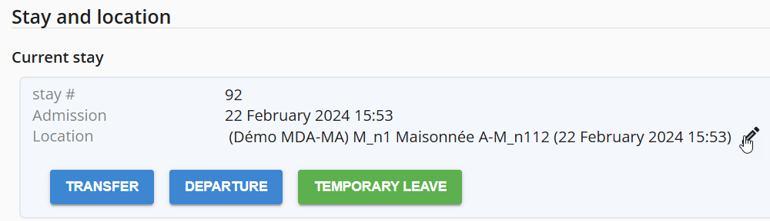

Transfer
For clients with an ADT system, do not enter anything manually; please refer to your institution's pilot.
The Transfer feature relocates the user’s file. If the file contains a care plan, this action reassigns planned activities to routines at the new location.
To transfer a file:
- Click the "Transfer" button.
- Select the date and time.
- Choose and confirm the new location.
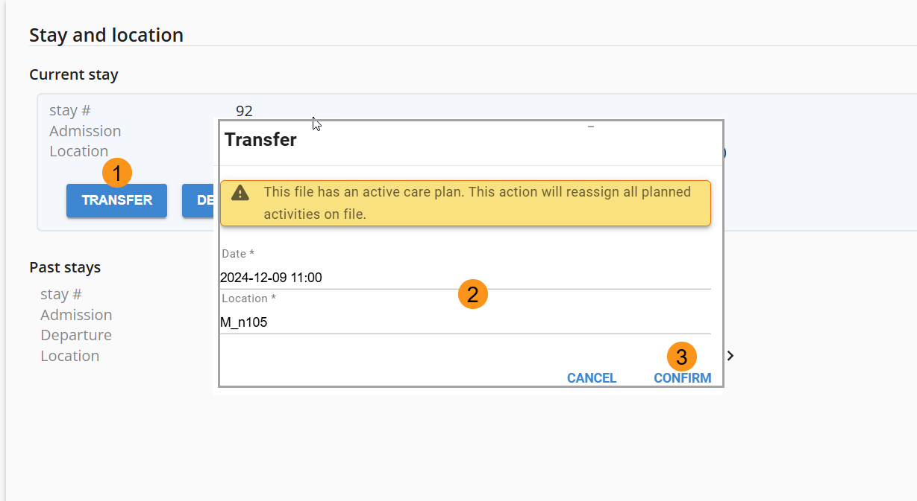

Departure
For clients with an ADT system, do not enter anything manually; please refer to your institution's pilot.
A departure automatically closes open episodes and activities linked to the care plan.
To discharge a user:
- Use the "Departure" button.
- Select the date and choose a discharge reason (optional)
- Click "Confirm".
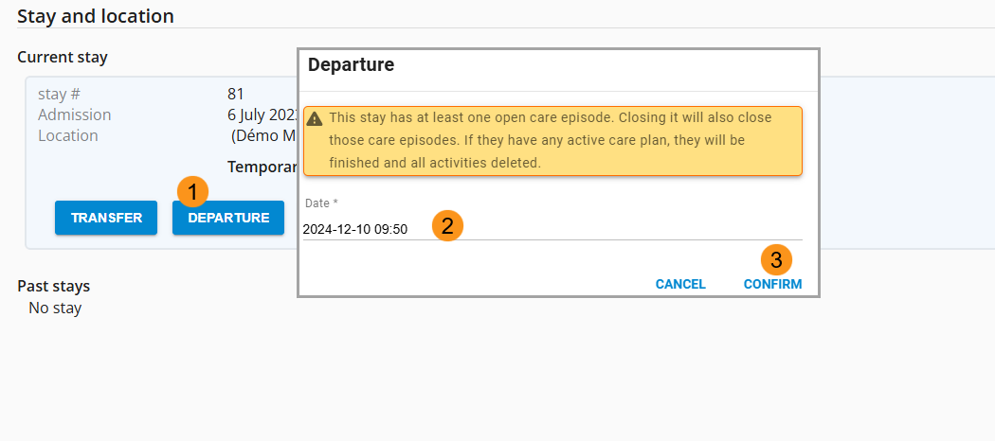

temporary leave
For clients with an ADT system, do not enter anything manually; please refer to your institution's pilot.
Temporary leave notifies the absence of a user and suspends planned care/services in routines. These will automatically reactivate upon confirmation of return.
To process a temporary leave:
- Use the "Temporary Leave" button.
- Select the reason for leave, expected return date and time,
- Activate service suspension and "Confirm".
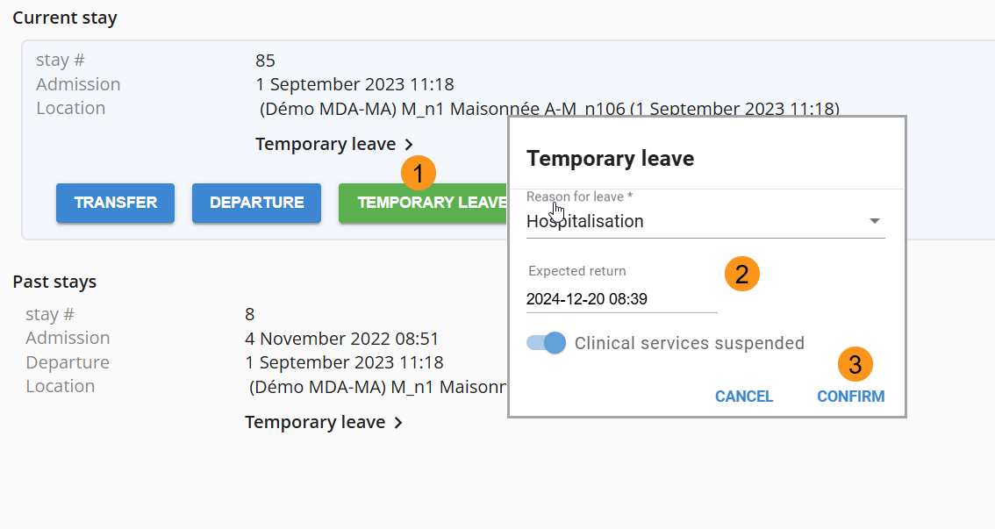
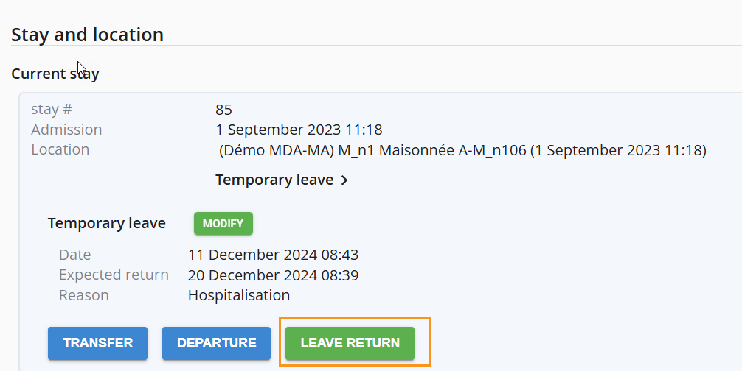

appointments
This section displays appointments for organizations using an ADT system appointments

file number
For clients with an ADT system, do not enter anything manually and refer to your institution's pilot.
To modify a file number:
- In the "File Numbers" section, click the "Modify" button.
- Update the detail and confirm.
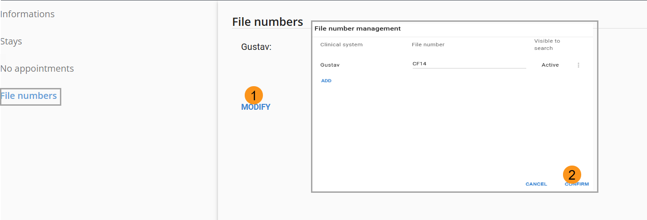

Episode of care
For clients using an ADT system, do not manually enter data. Refer to your organization’s pilot. Episodes are created automatically based on the episode category information associated with the program and the client index.

Open an episode of care
This step is mandatory to allow documentation entry into the file.
To open an episode:
- Click the "+" button.
- Select the Category (mandatory), client Type (mandatory), Trajectory (optional) and admission date
- Click "Create"
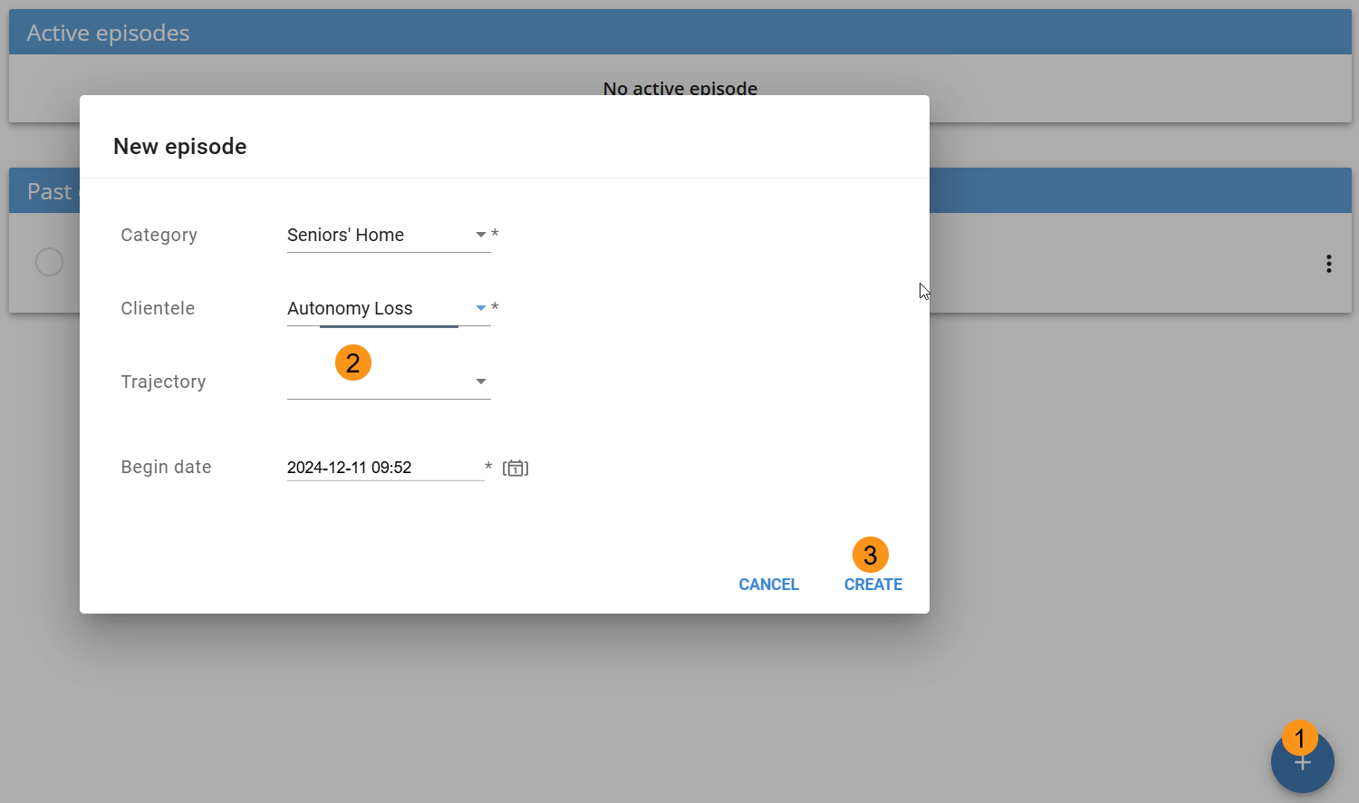
To access the user’s file, click the active episode
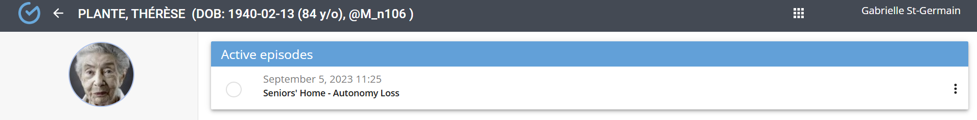

Change clientele type
To modify:
- Use the three-dot menu and select Change Clientele".
- Make the modification. and click "Confirm".
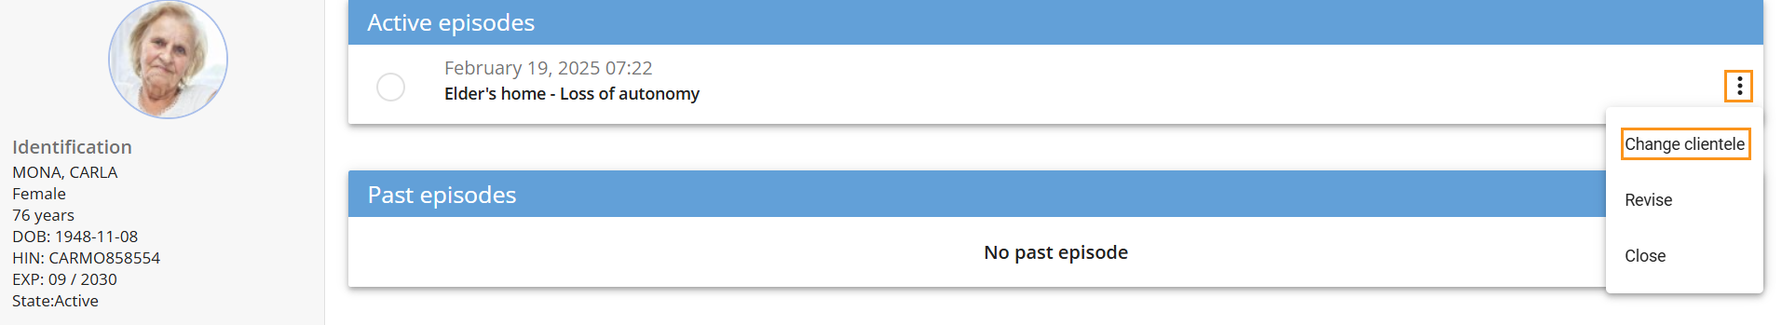
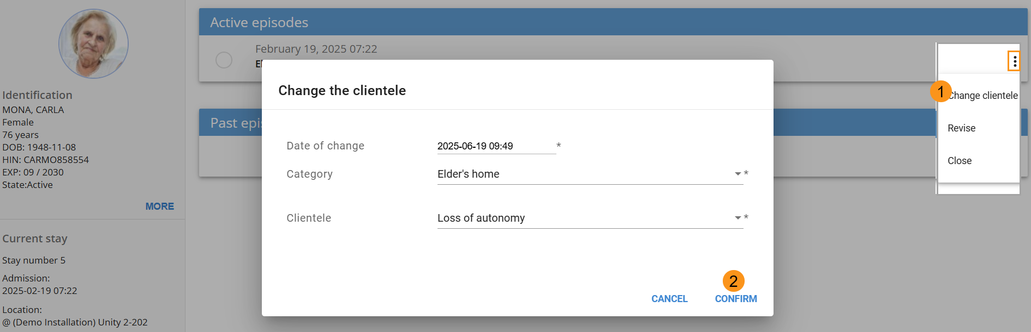

revise an episode
For clients using an ADT system, do not manually enter data and refer to your organization’s pilot support.
To revise an episode:
- Use the three-dot menu and select "Revise".
- . Make the modification. and click "Confirm"
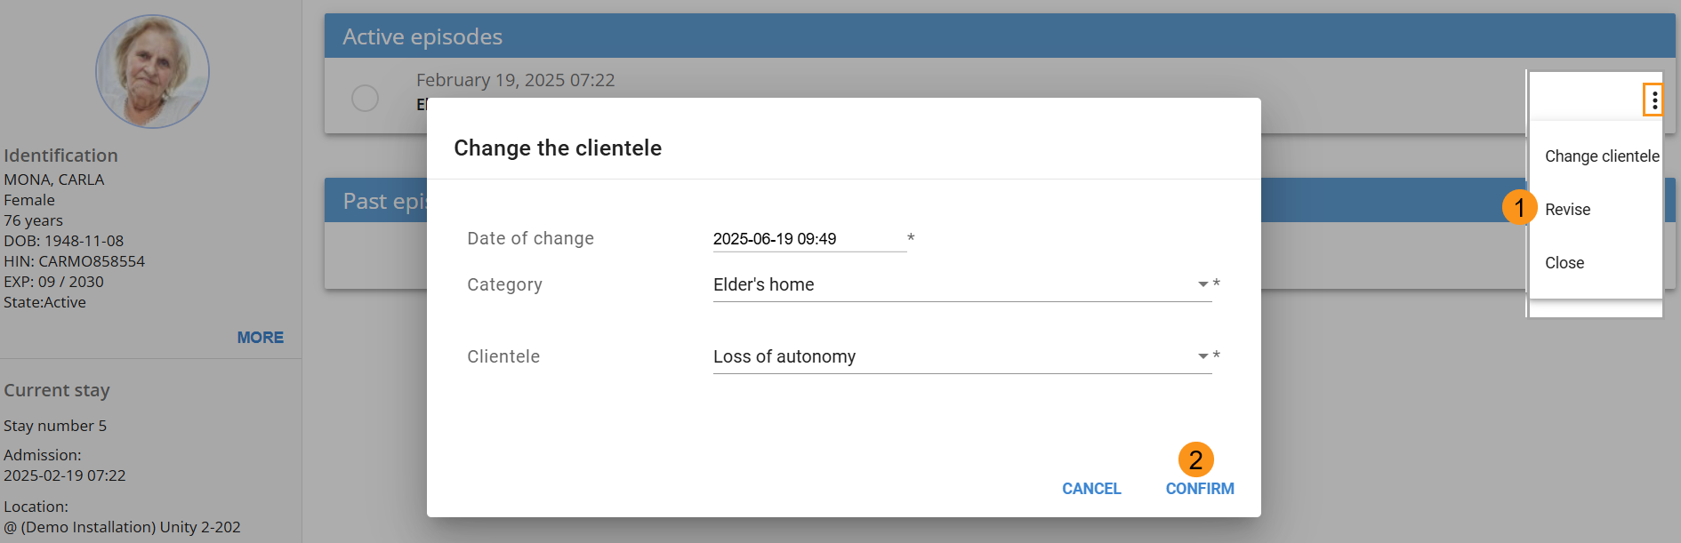

close an episode
For clients using an ADT system, do not manually enter data. and refer to your organization’s pilot support
Closing an episode automatically suspends activities linked to the care plan and trajectories. The episode can still be accessed for consultation and further documentation, except for the care plan.
To close an episode:
- Use the three-dot menu and select "Close".
- Enter the date and time and select "Confirm"
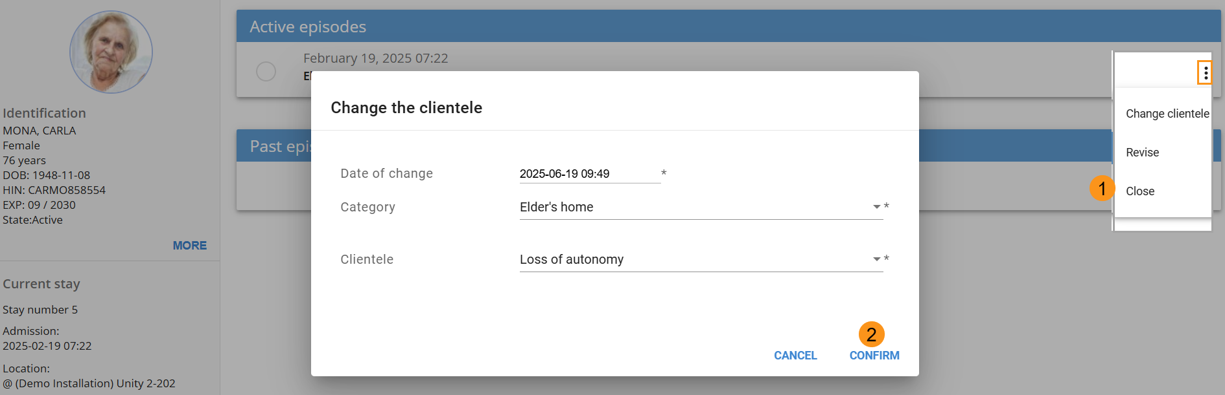

Reopen a closed episode
For clients using an ADT system, do not manually enter data and refer to your organization’s pilot support.
Except for the care plan and TNP, documentation can be continued after reopening the episode. A confirmation message will appear upon reopening.
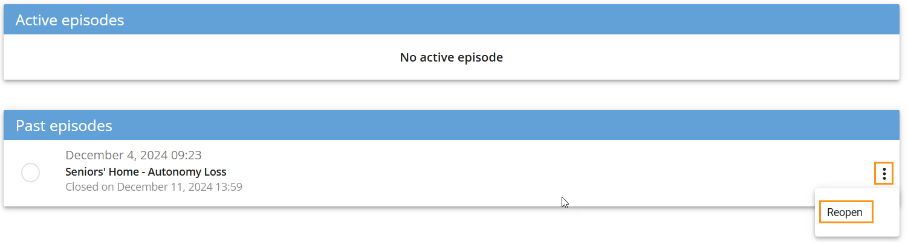

RISK MANAGEMENT
This console provides a global view of users under surveillance due to risk indicators.
- Indicators display the number of ongoing surveillances, along with cards containing user details and a summary of observations.
- Cards are activated by mandatory entries of triggering observations and are deactivated when termination observations are finalized in a form.
- Filters by time range and location are available to adjust the display.
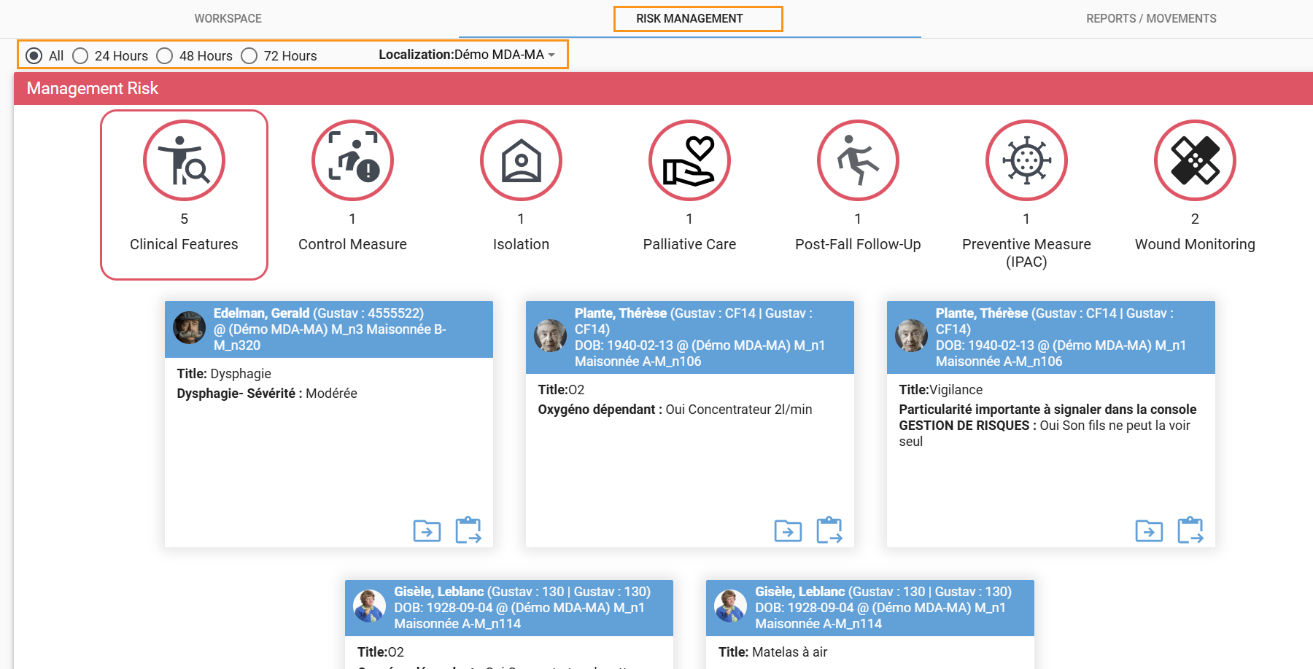
The icon on the left provides access to the chronological view of the file and the one on the right provides access to the form.
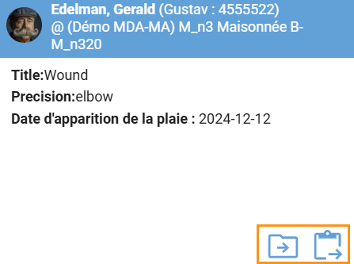

REPORTS/MOVEMENTS
This tab provides access to inter-shift report and user movements over the last 24 hours.

Inter-shift report
Inter-shirt displays a chronological view of recent report related to user assignments. The selection of a report displays the following information.
- Title
- User’s name, surname, and location.
- Details (optional)
- Date of creation and user information.
- Status
A detailed view is available via the " MORE" button.
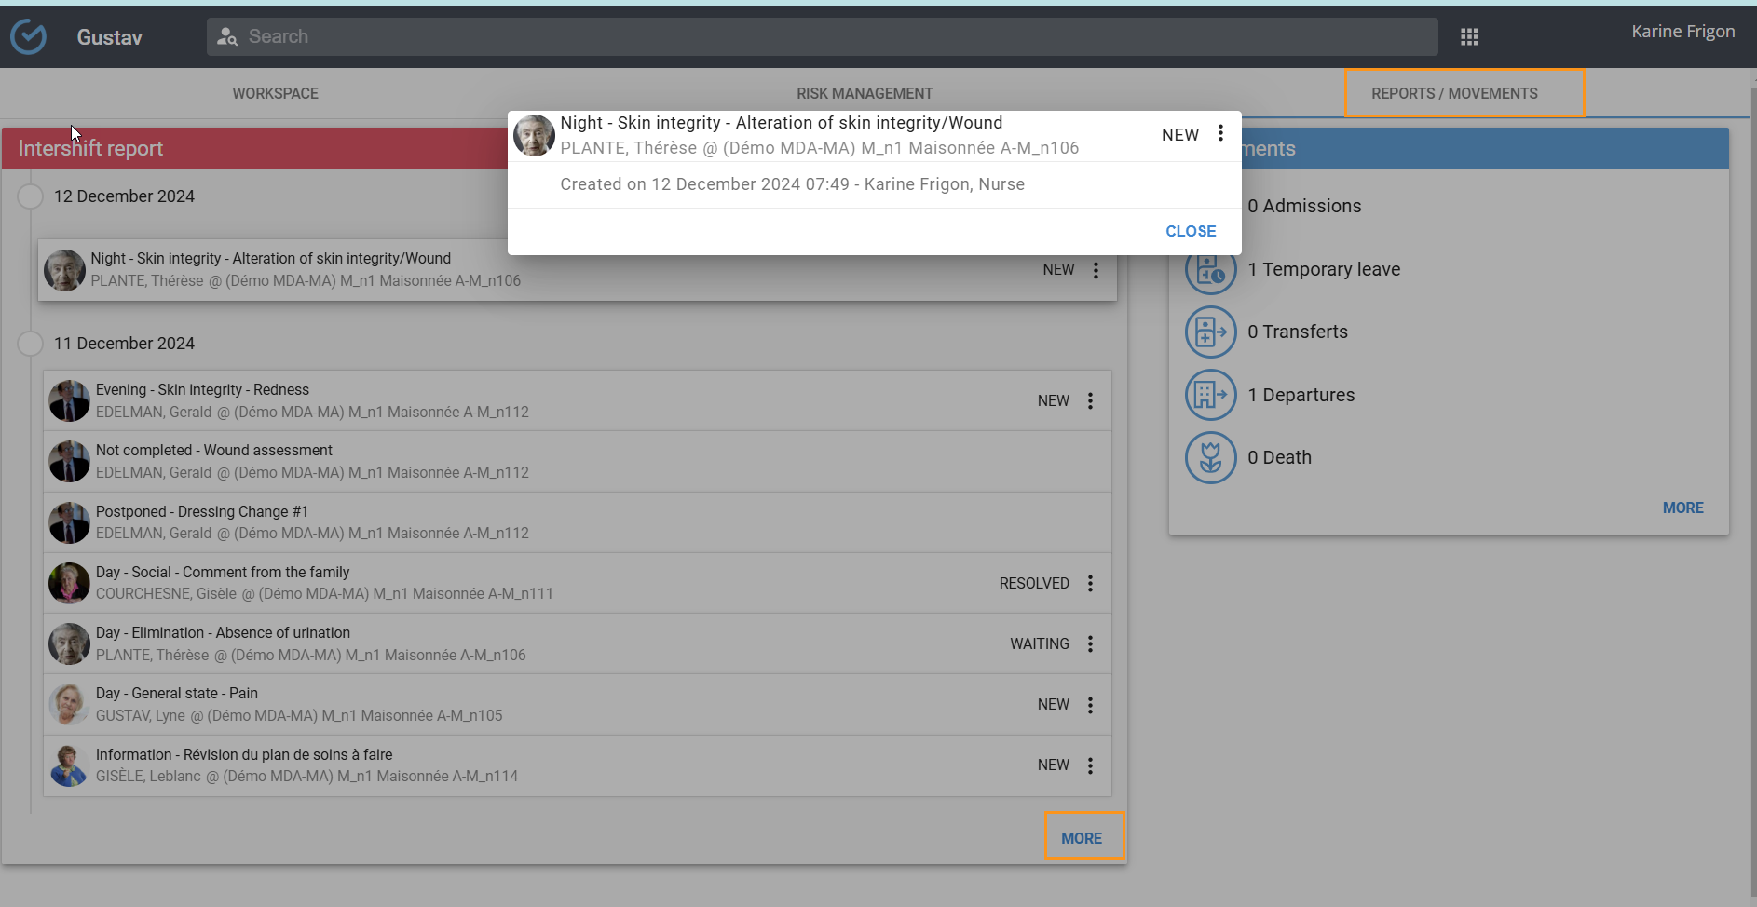
The report displays the timeline of the last 72 hours, and the "SHOW MORE" button allows access to the report beyond 72 hours. The arrows located to the left of the date allow the reports to be opened when they are not grouped by file.
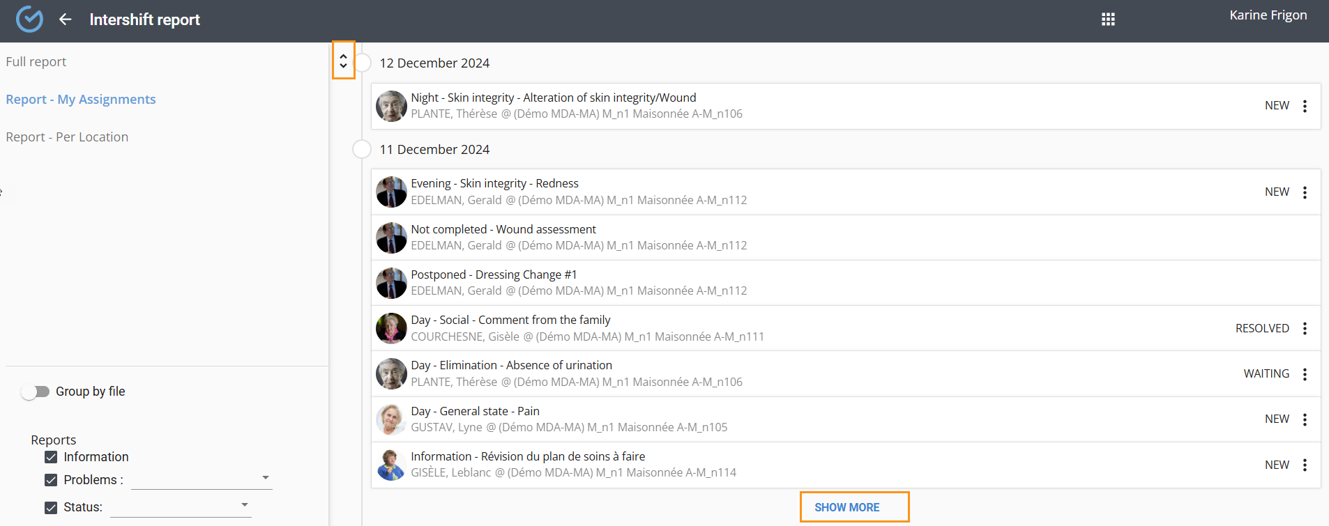
The left section allows filtering of the report display:
- The "Full report" groups all the users of the establishment
- The "My Assignments" report consolidates information on the users assigned to the user.
- The "Per location" report allows filtering by floors, wings…
- Group by file enables the report to be displayed by user.
- Filters based on the type and status of reports
- Filter for the status of activities.
- Filter by work shift
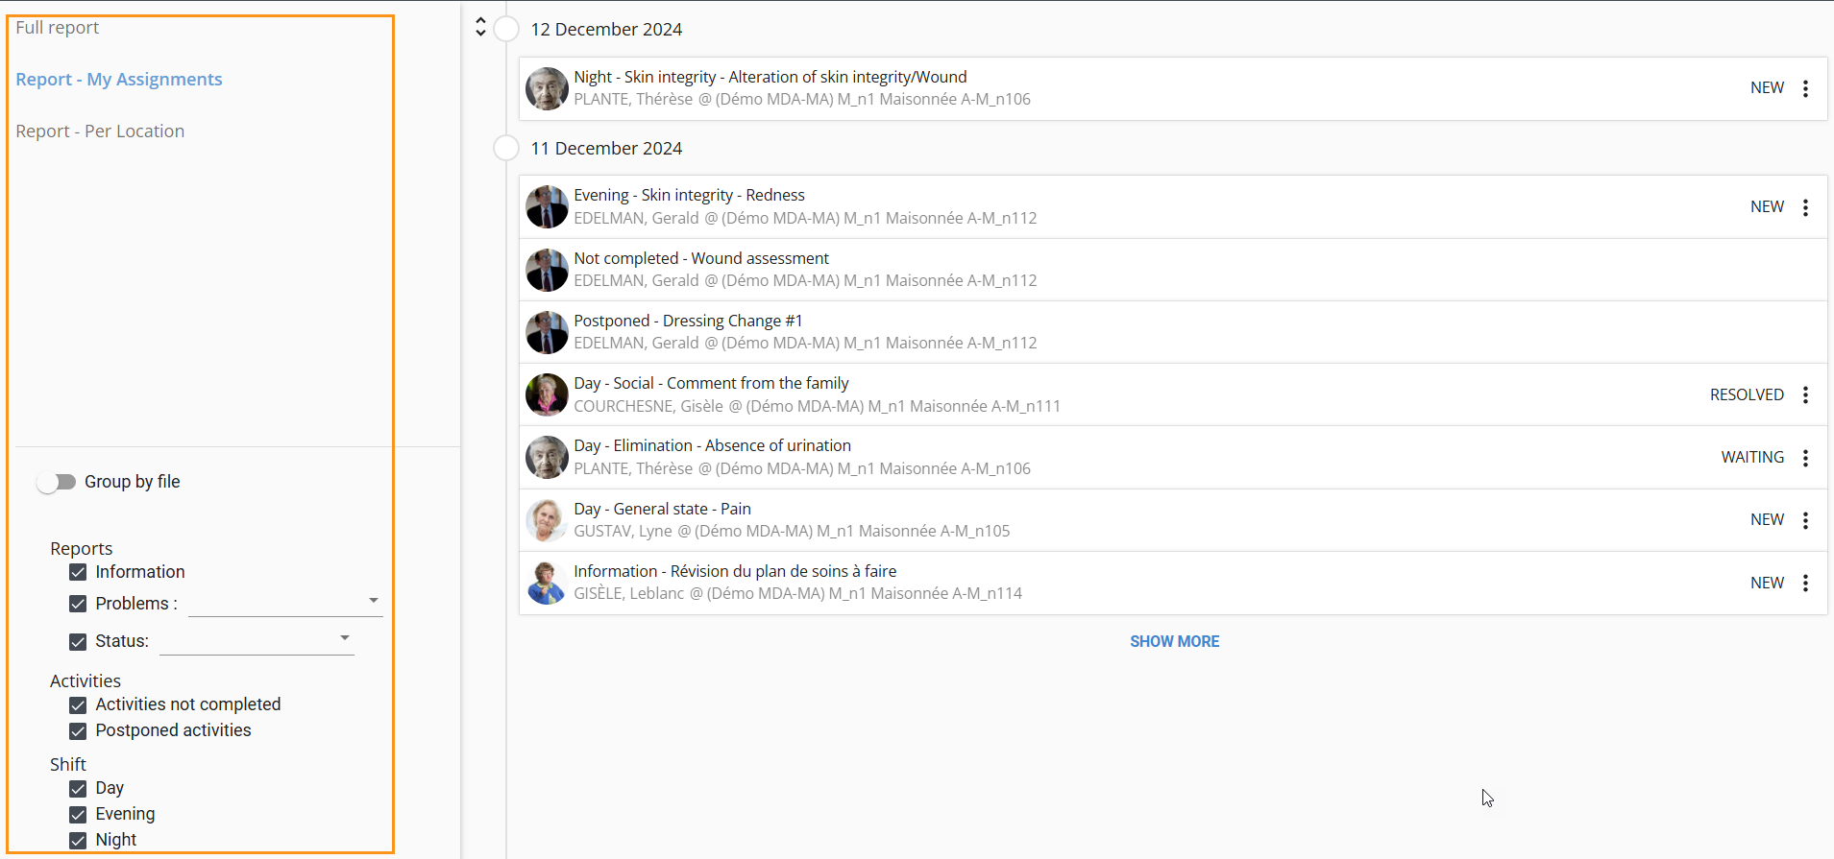

status update
A new report in the system will automatically display a status of "New and the update will be recorded and detailed in the file documentation.
To update the status:
- From the three-dot menu, click on Update Status.
- Select the status. And enter a note (optional)
- Confirm.
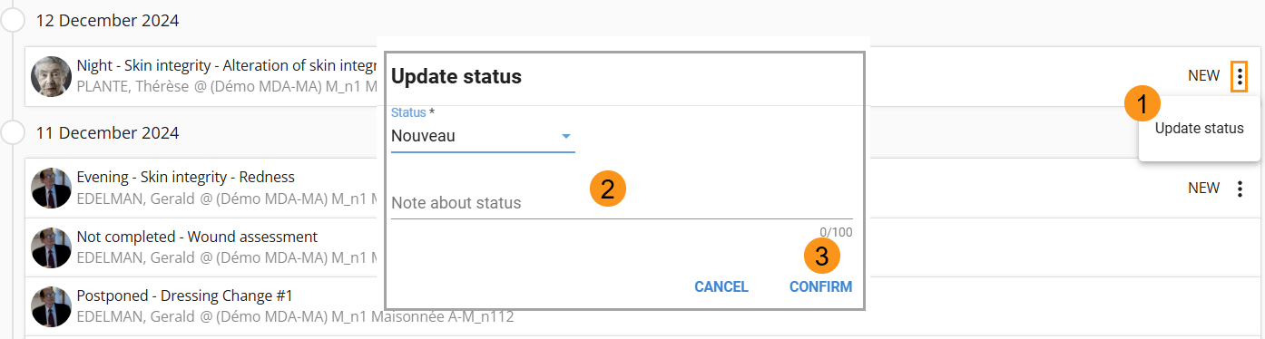
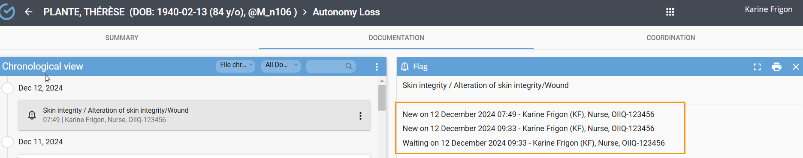

Reschedule an activity
Based on user permissions, incomplete activities can be rescheduled or postponed.
To reschedule:
- Click "Reschedule".
- Select a date and time and assign the task
- Confirm
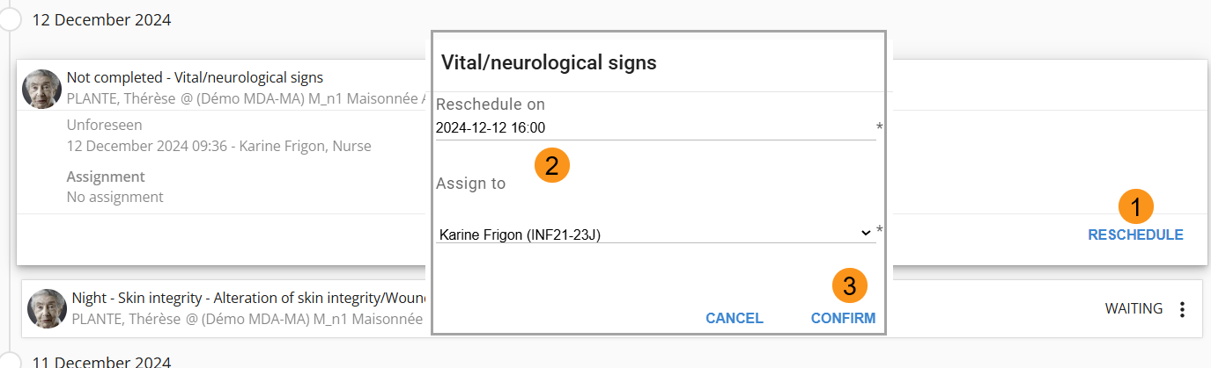

Movements
This tile displays user movements over the past 24 hours for the entire establishment:
- Admission
- Temporary leave
- Transfer
- Departure
- Death
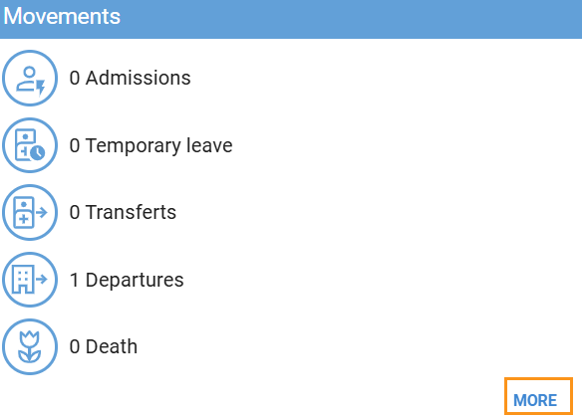
By selecting " More," it is possible to filter by time range, location, and category
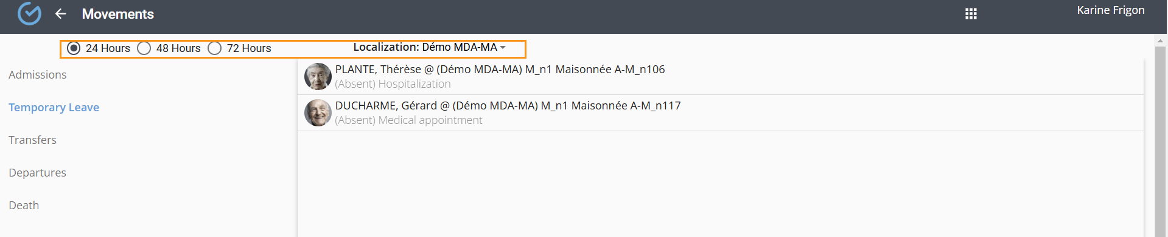

SUMMARY
The summary provides an overview of the user’s important information without needing to consult the full record. It is configurable by client type and profession and is populated with finalized data from the record’s documentation.
From the three dots, it is possible to display the sources of the data. The source shows the following information:
- Name of the form where the data was entered
- A hyperlink directing to the finalized version of the document
- First and last name of the person who entered the data
- Date and time of finalization
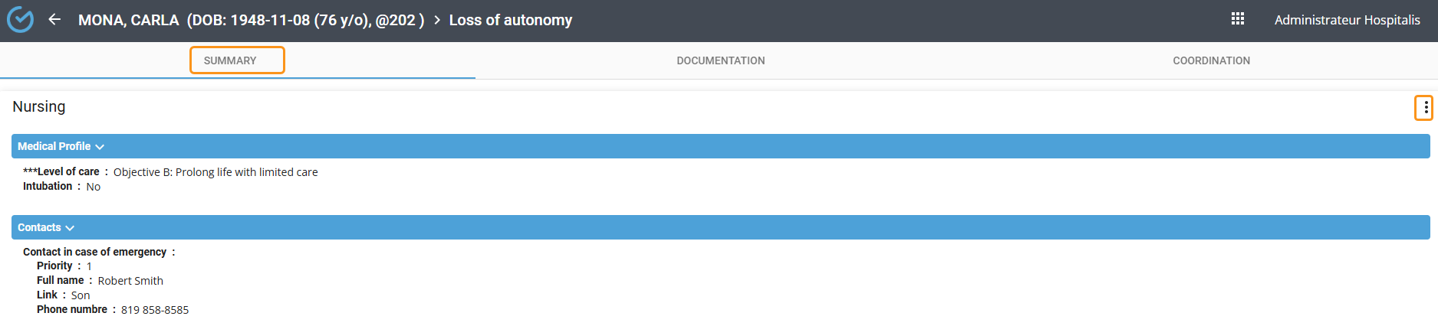

DOCUMENTATION
This tab provides chronological access to the user’s file documentation. Displayed information includes:
- Form title
- Date and time of the last action on the document.
- Signature, profession, and license number (optional)
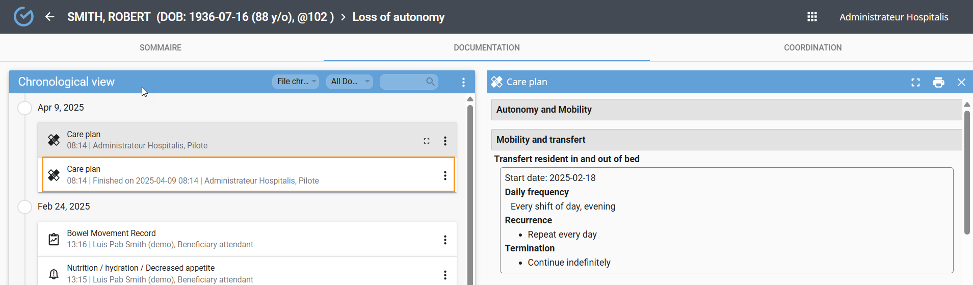

Search a document
When selected, the filters in the timeline view allow for refining the document search.
• The engine allows searching by document type.
• The domain allows sorting by profession.
• The file timeline allows sorting by document type.
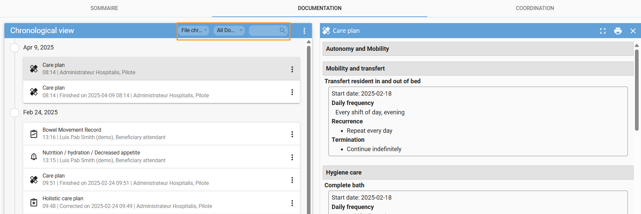

Search cancel document
You can display the list of documents that have been canceled in the file. From the three-dot menu, select "Show Canceled."
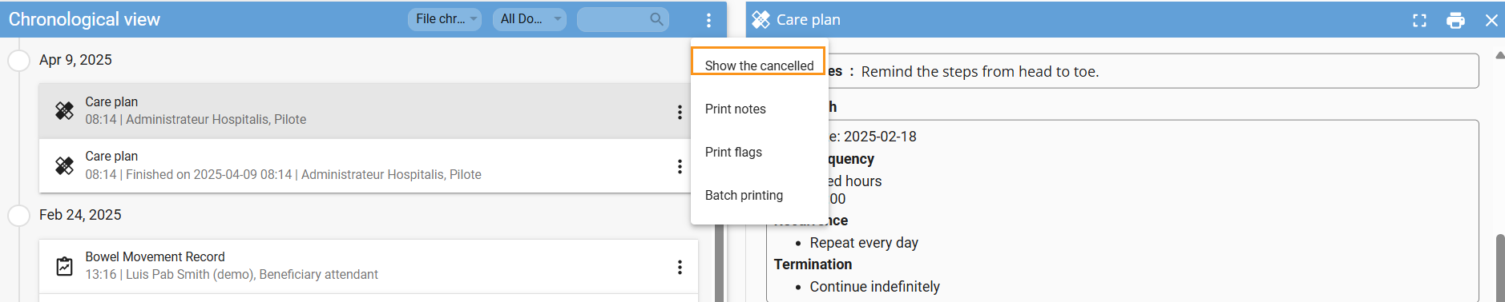
They are displayed according to the cancellation date, identified by a red icon and the document title is crossed out. The mention "Canceled" will appear on the print document. To return to the usual timeline view, select "Hide the canceled."
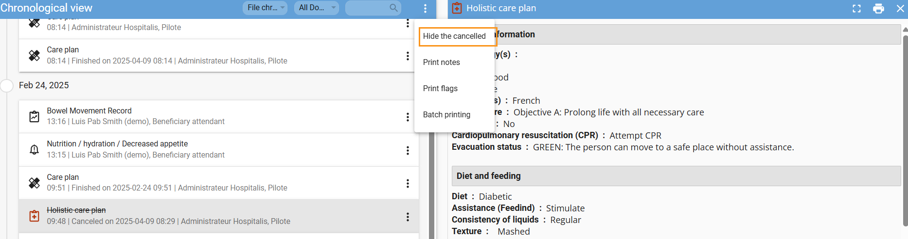

View a document

From the Chronological view, it is possible to review a document that has been submitted to the case file.
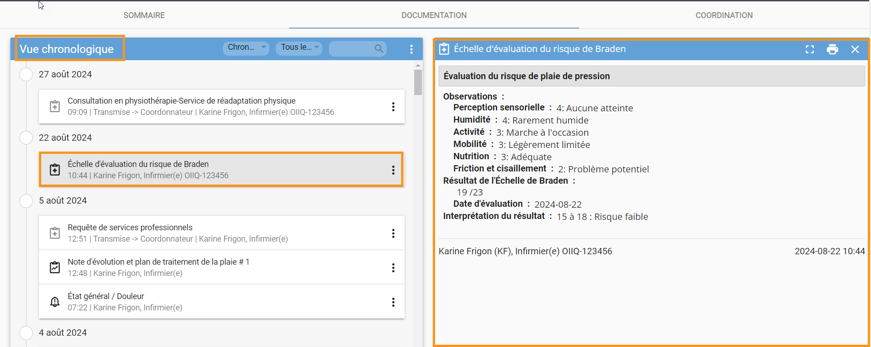
The document in full-screen format is available from the following icon.
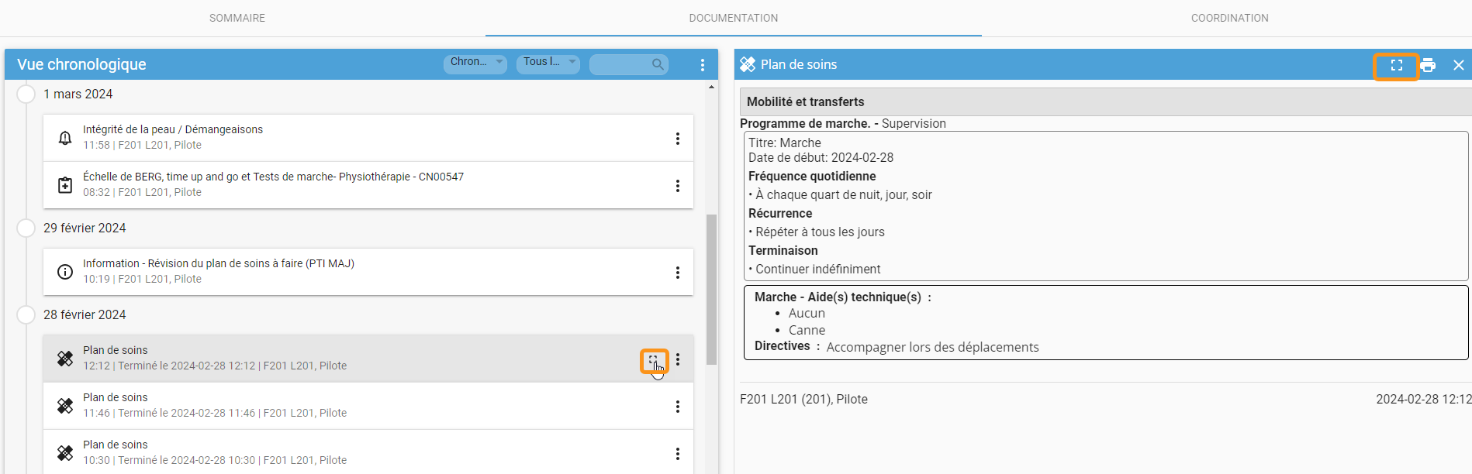

Print a document

The PDF print of a document is available from the icon or by selecting the three-dot menu.

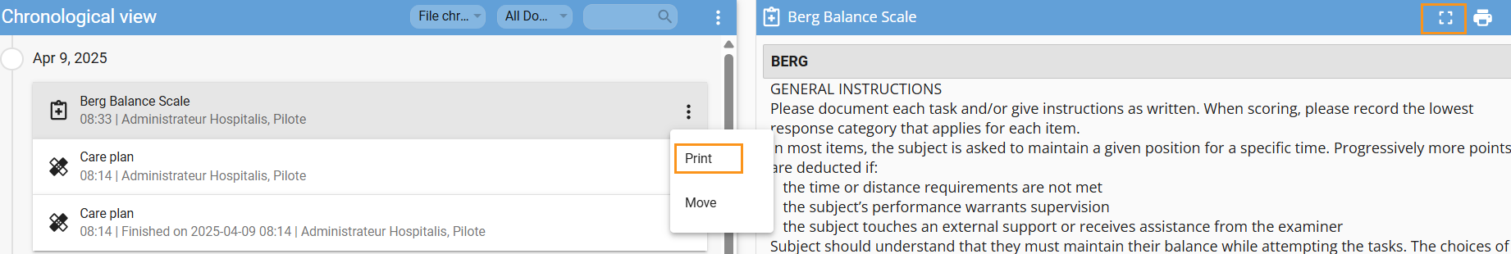

Batch printing
Batch printing allows you to print a summary of multiple finalized documents. The filters allow you to select the profession, document types, and the format to print.
- Click on the three dots and select "Batch Printing."
- Define the extraction range.
- Select the documents.
- Define the format.
- Click on "Launch the report»

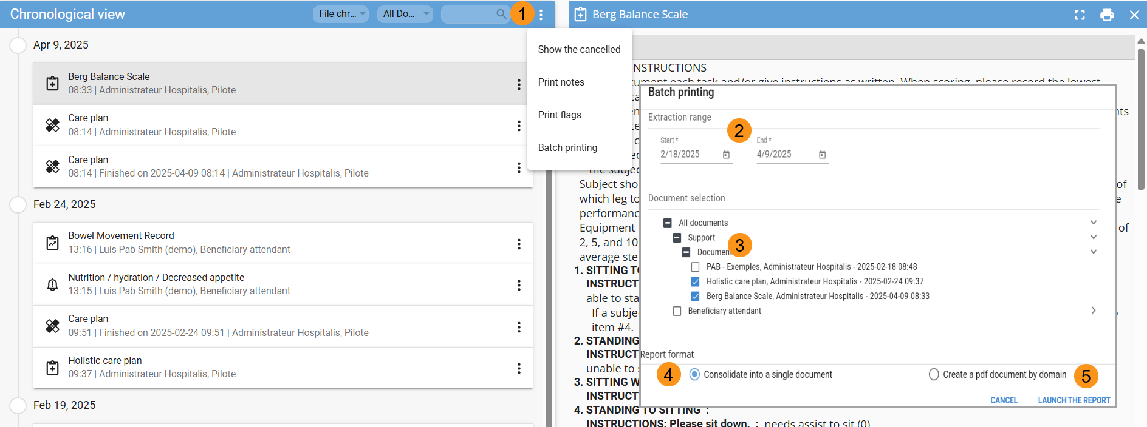
When the report is available, a red icon will appear on the grid. The PDF format opens in a new browser window, and the report can be printed from the printer icon.
- Click on the grid.
- Select the "Deferred Report" tab.
- Select the loading icon.
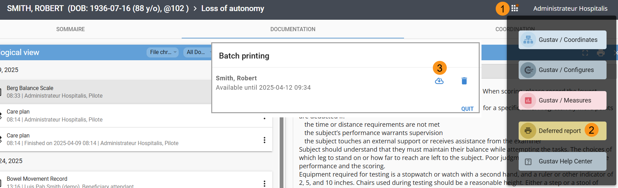

Fax a document
Faxing is available based on the organization’s configuration. This feature allows sending documents to a list of pre-configured recipients.
To fax a document:
- Use the three-dot menu and select "Fax".
- Enter a subject (optional).
- Enter a note (optional).
- Click "Set" to add the recipient.
- Select the recipient.
- Click "Add".
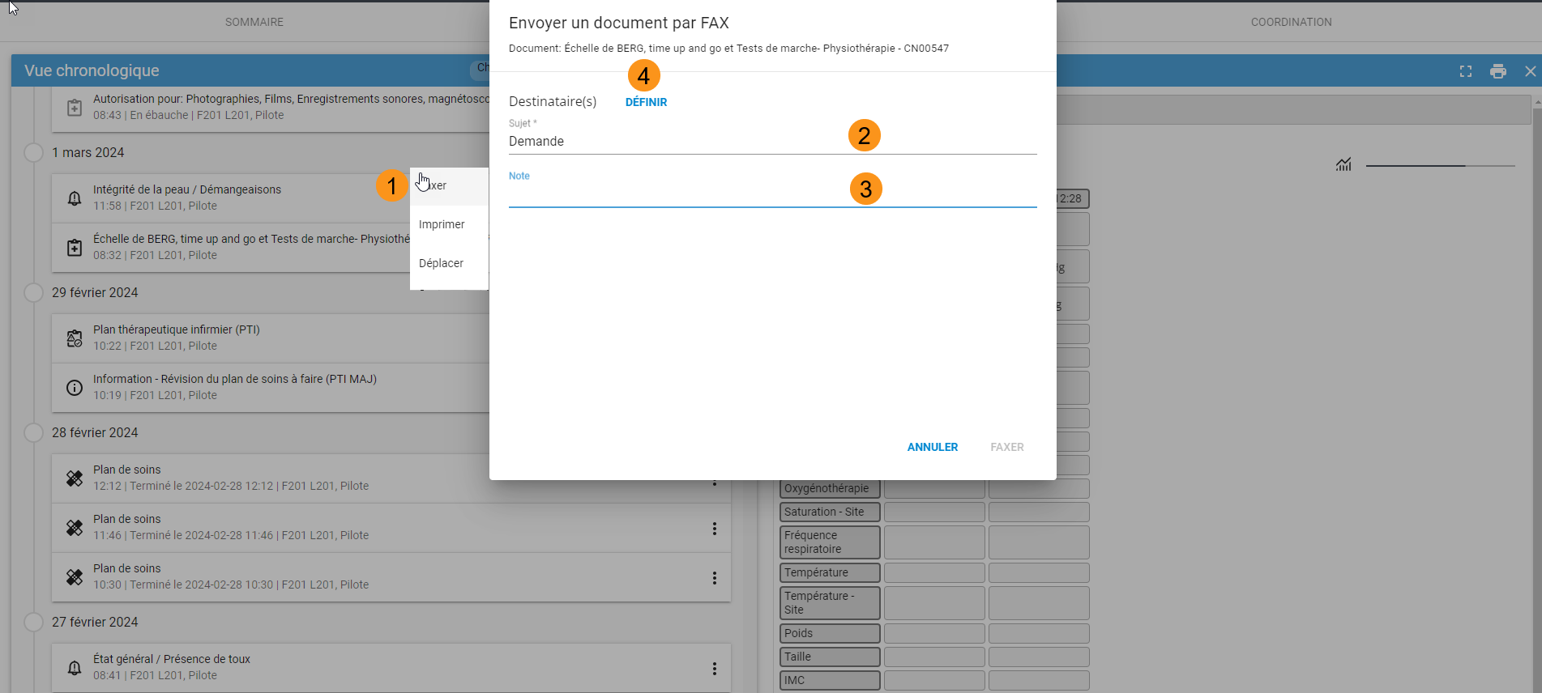
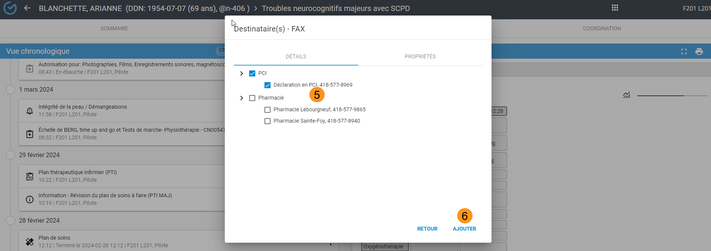
If the fax server configuration allows, you can add a recipient who is not on the list.
To add a recipient manually:
- Use the three-dot menu and select "Fax".
- Click "Set".
- Select "Properties".
- Enter the fax number, recipient’s name, and organization (optional).
- Click "Add".
- Enter a subject and note (optional).
- Click "Fax".
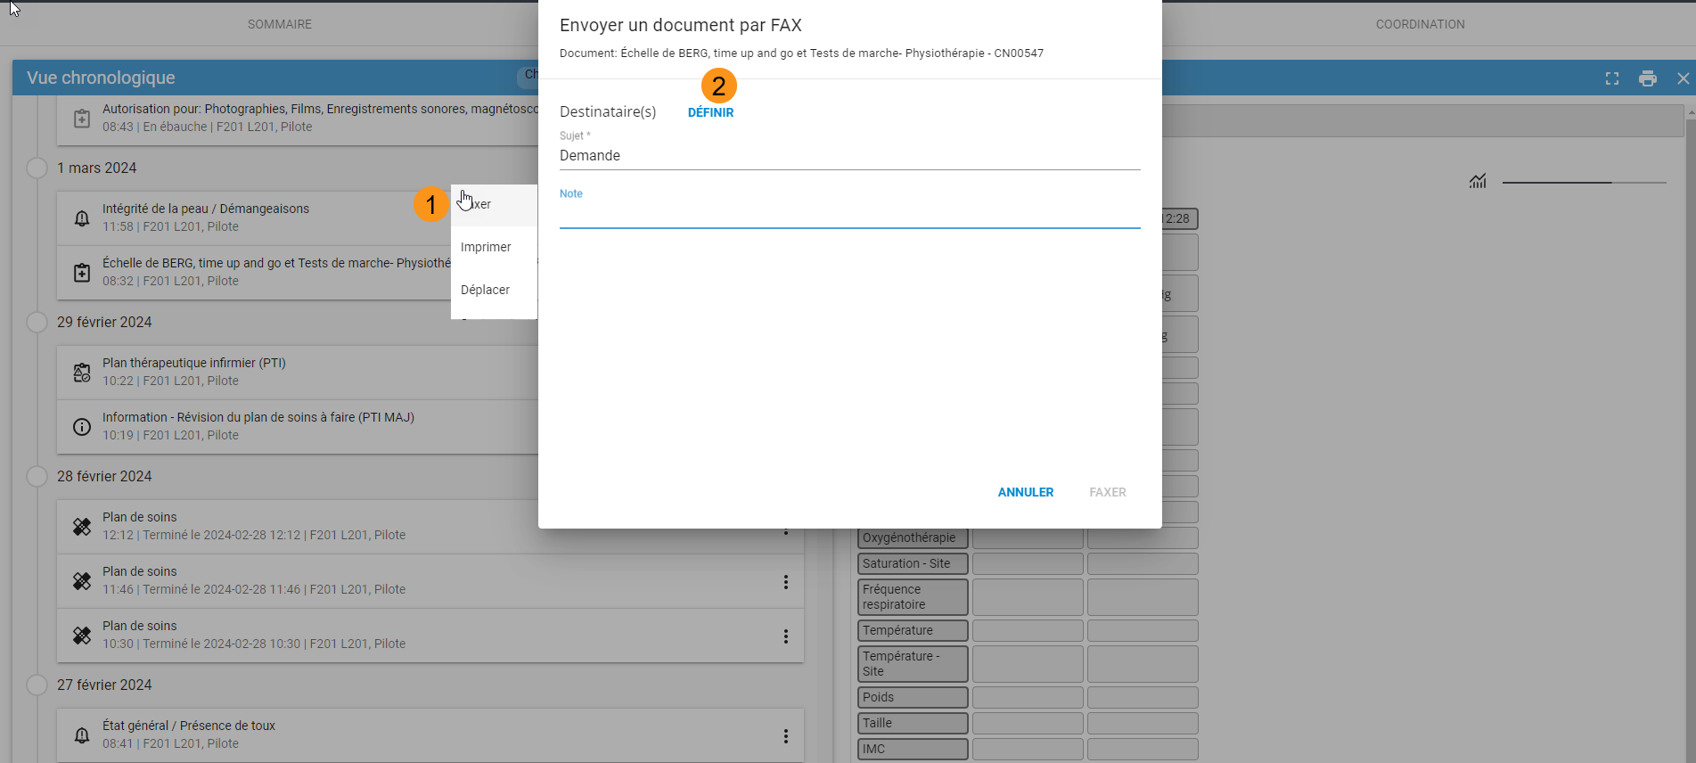
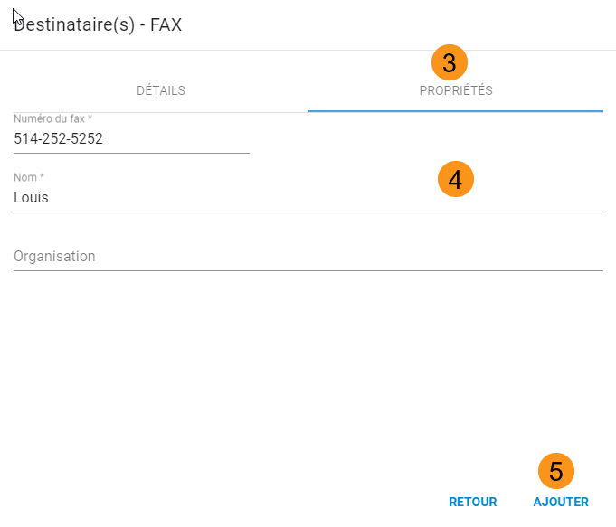
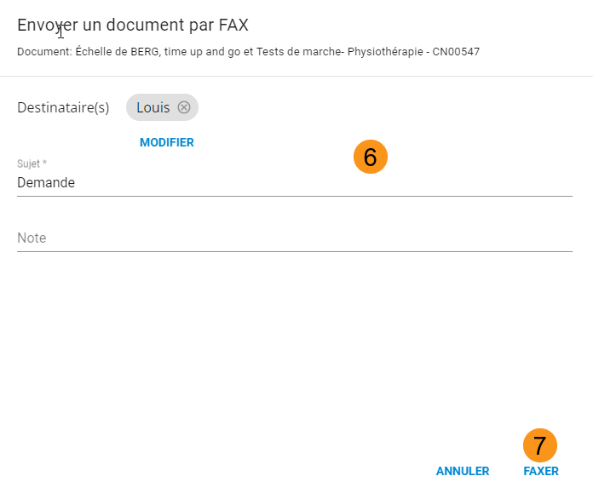

Moving a document to another file or episode
For facilities using an ADT (Admission, Discharge, Transfer) system, do not enter information manually. Please consult your facility’s designated pilot user for guidance.
Depending on the permissions granted to your user profile, you may have the ability to transfer a document to another patient file or care episode. To do so, follow the steps below:
- Click on the three-dot menu associated with the document and select "Move", then search for and select the destination file.
- Select "Move", then search for and select the destination file
- Ensure the Facility and File information is correct
- Choose the corresponding Stay from the list
- Click "Confirm" to complete the operation
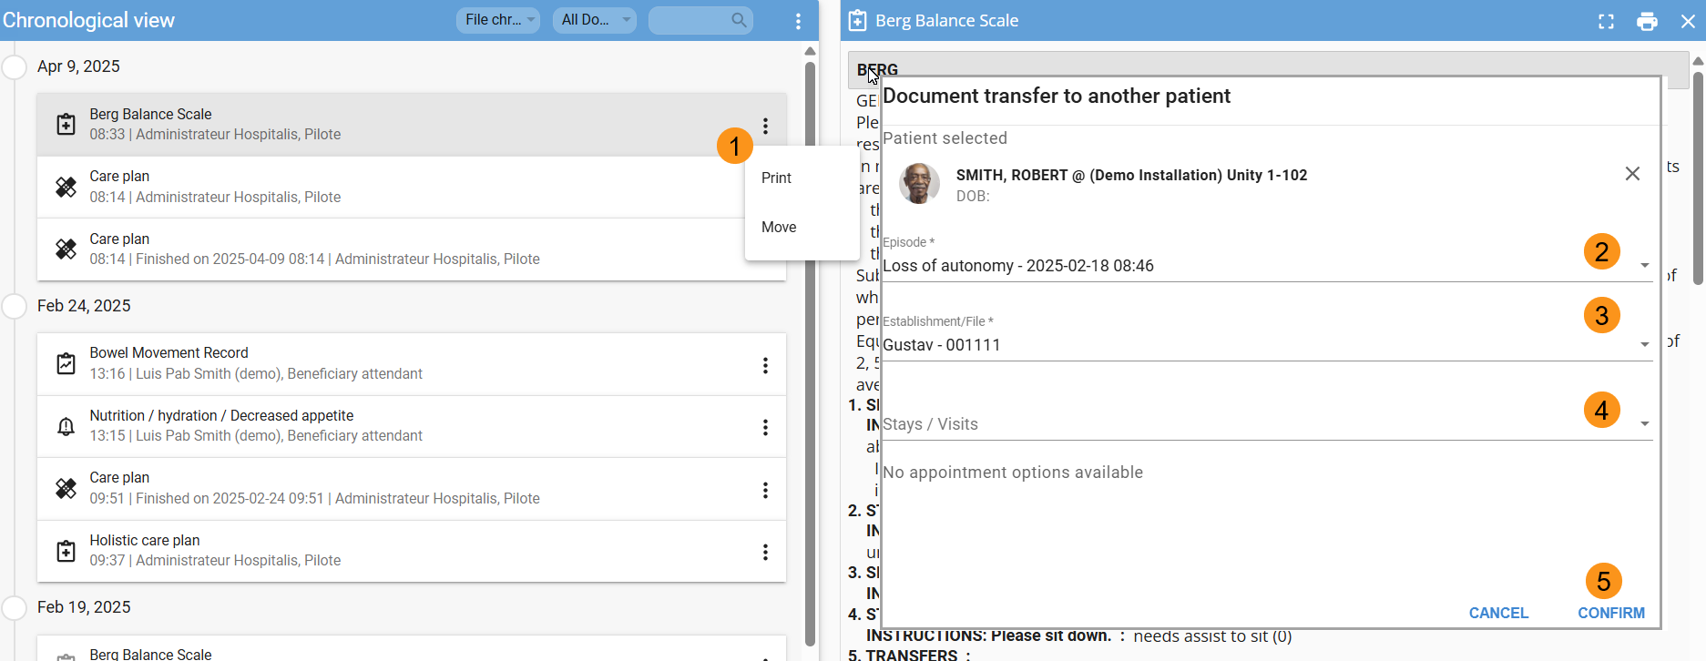

FLAG (Creating a report)

A report is information related to a patient that must be communicated and addressed by the care team. Once created, the report is automatically added to the Inter-shift Report and the file
How to create a report from de + button:
- Click on the Report icon in the Clinical Library and select the type of report and choose between a Problem or Information.
- Select the problem type or define the subject if it's an informational note.
- Select the specific problem from the list.
- Optionally, enter additional details
- Click "Save" to finalize the report.
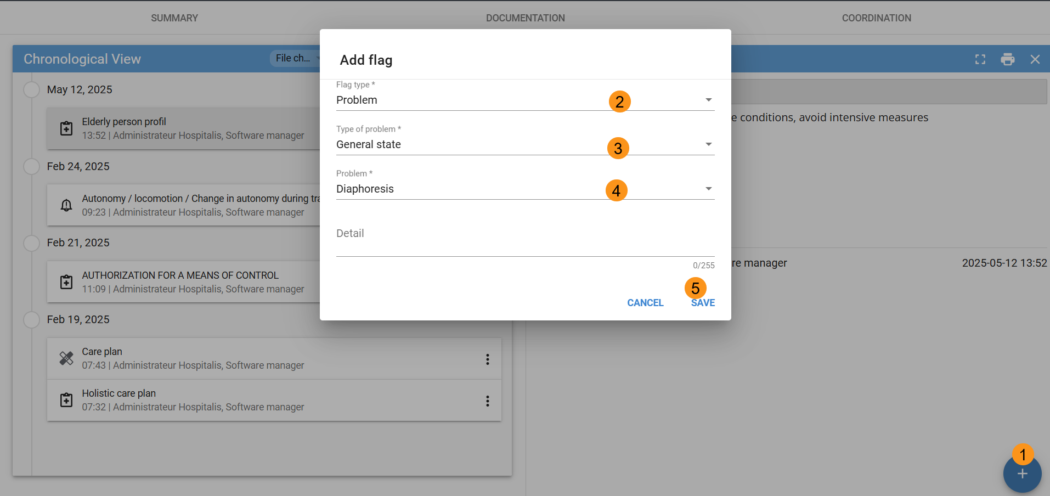

ÉVALUATIONS
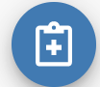
An evaluation is a structured form based on best practices and the record-keeping rules of your profession.

Create an Evaluation
From the Documentation tab:
- Click on the “+” and select the “Evaluation” icon
- Search for the document title
- Select the document
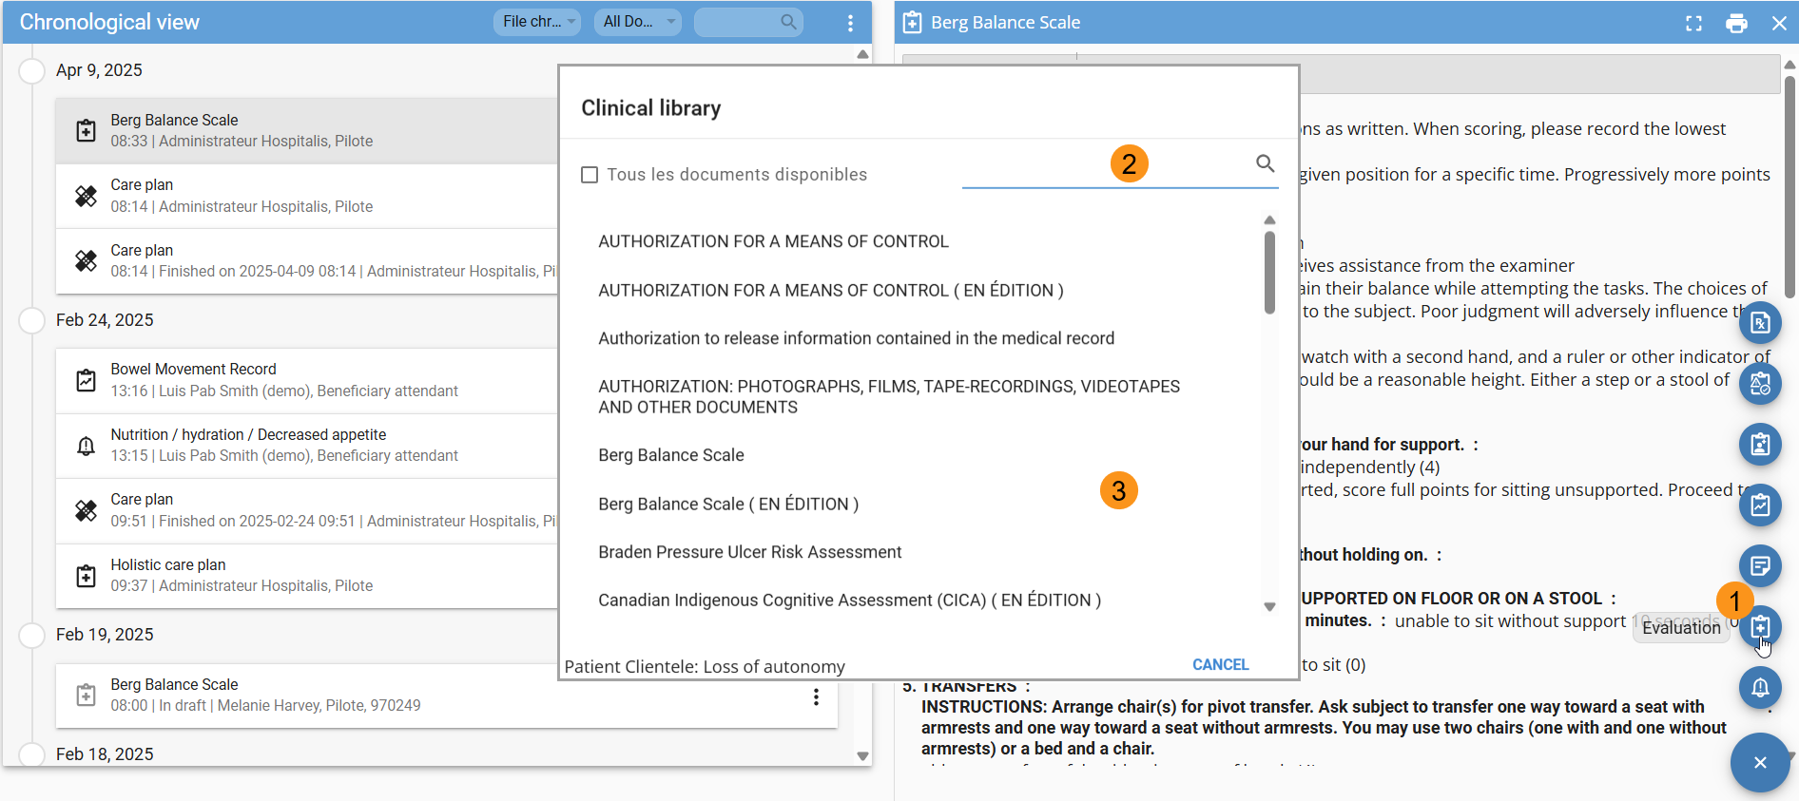

Navigate through the table of contents
The table of contents is available by selecting the icon located to the left of the document title. It displays the different sections of the document and makes navigation easier.
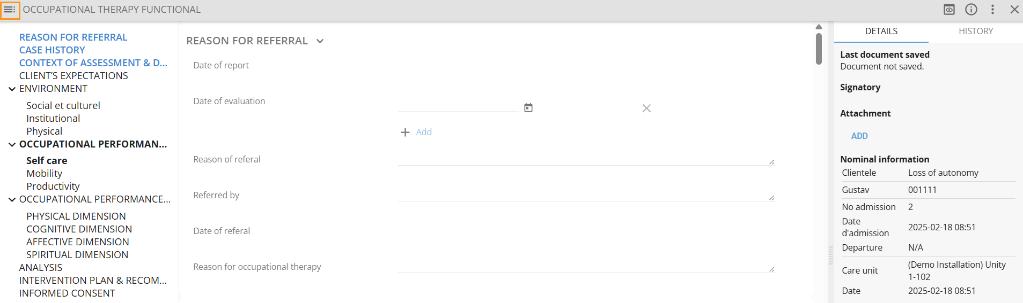

Details and history
The “Details” tab displays the date/time of the last save, the document status, its signatories, attachments, and the nominal information. When a document is in draft status, a warning message is displayed.

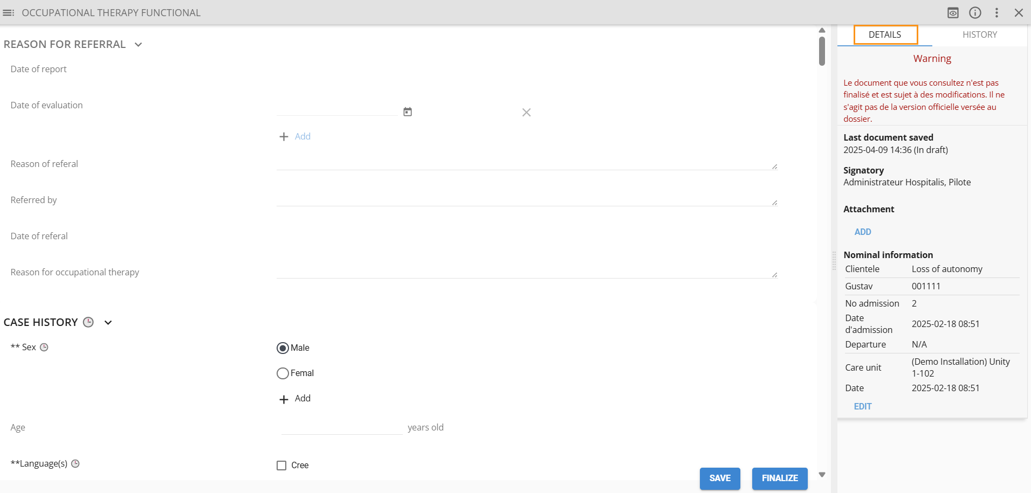
From the "History" tab, you can view the different versions of the document (creation, finalization, correction, or cancellation) And the (i) allows you to close both tabs.
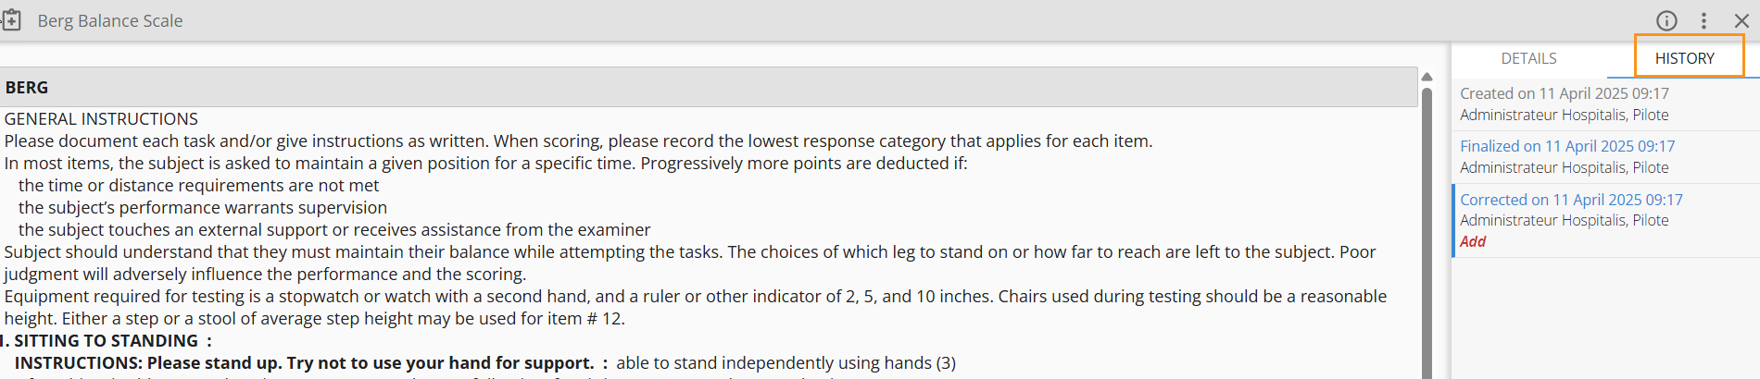

Previewing a document in draft mode
The preview provides an overview of the information while drafting the document. The data is displayed and updated after saving.
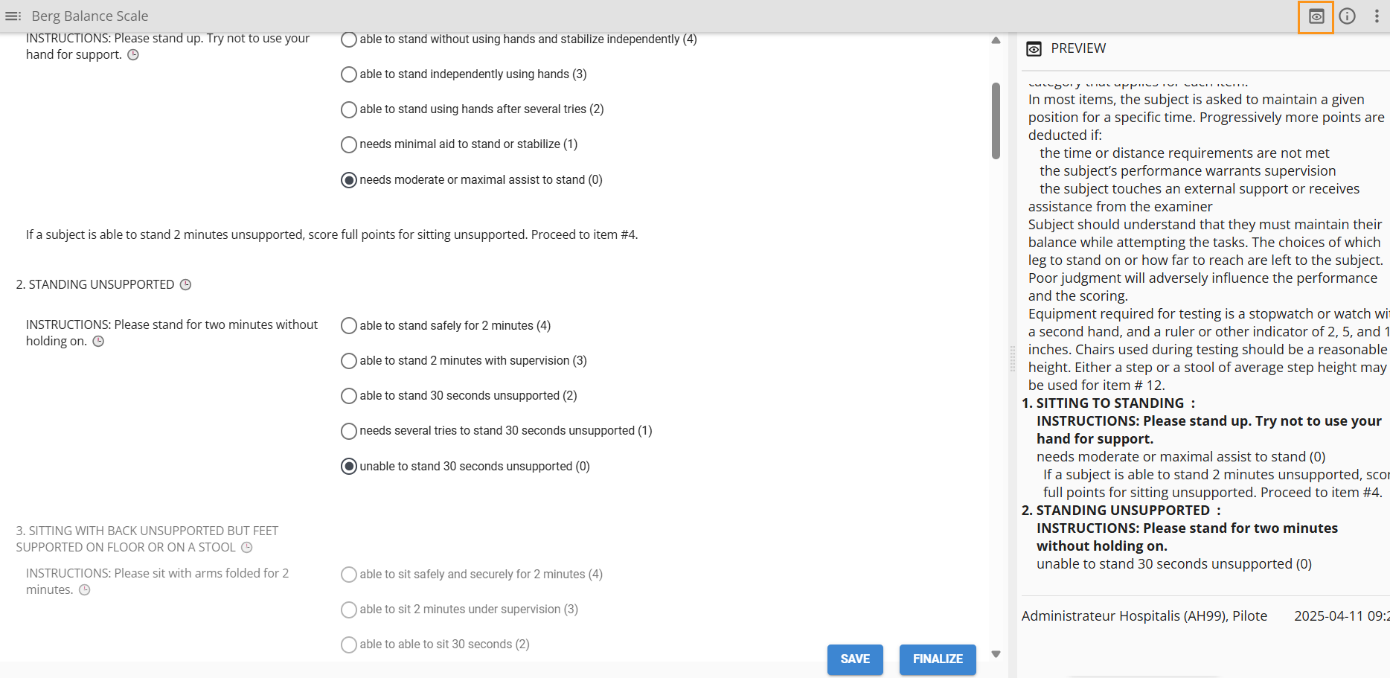

Importing a history
Importing allows you to use finalized observations from another document, whether created by you or another professional. A message appears when opening the document, and clock icons indicate which data can be imported. For optimal use, it is strongly recommended to import the history as soon as the document is opened. After the import, the source name, date, and time of the data will be displayed. Depending on the context of the assessment, the information can be enhanced or deleted

To import:
- From the three-dot menu, select "Import History"
- Choose the source and the time
- Click Import
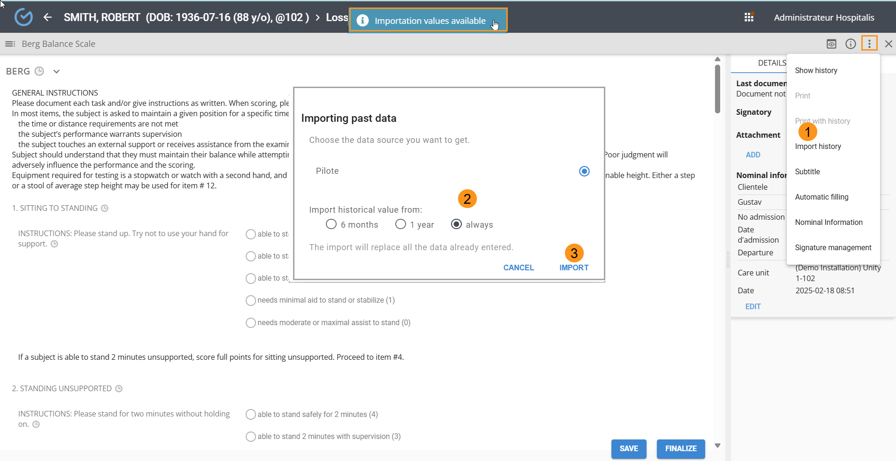

Import a section or an observation
From the three dots located to the right of a section or observation name, it is possible to import only a specific section or data point from the assessment.
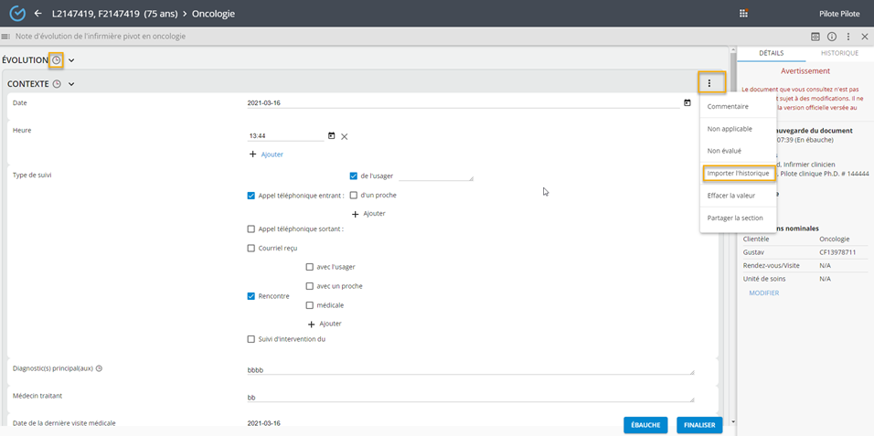

Share a section
By clicking the three dots, it is possible to share a section of an unfinished document and make it available for data importation.
Once shared, an icon will appear to the right of the section title.
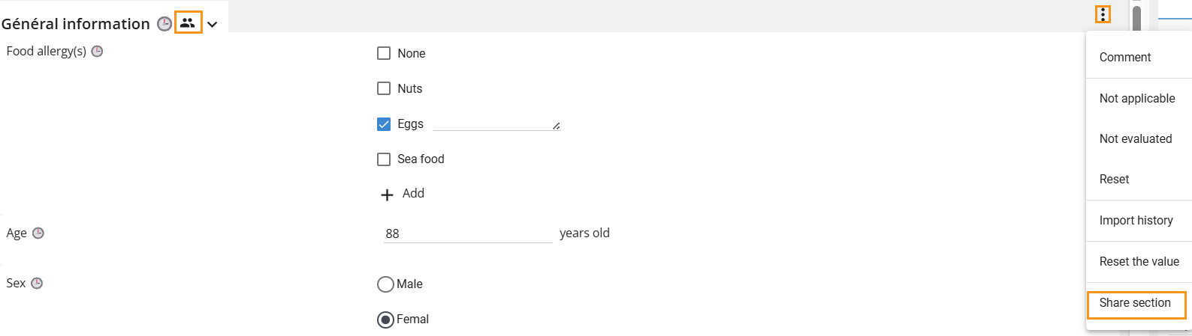

add a comment
You can add additional details to a section or observation using the "Comment" feature.
- Click on "Comments" from the three-dot menu
- Enter the information
- Confirm
The comment will appear below the section name and above the observation name.

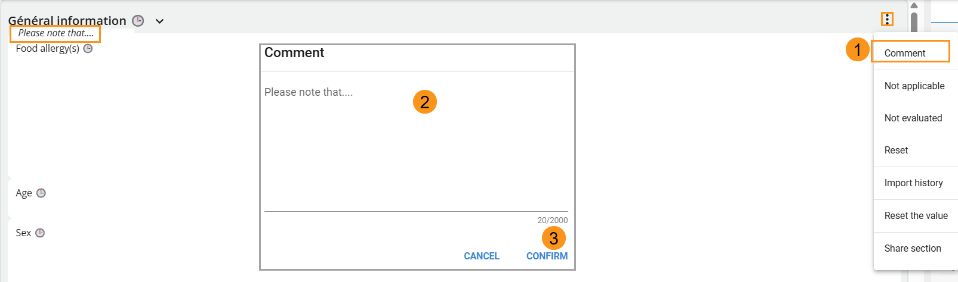

Non applicable/Non evaluated
From the three-dot menu, you can assign a "Not Applicable" or "Not Evaluated" status to a section or an observation. Once confirmed, it will no longer be possible to enter information.
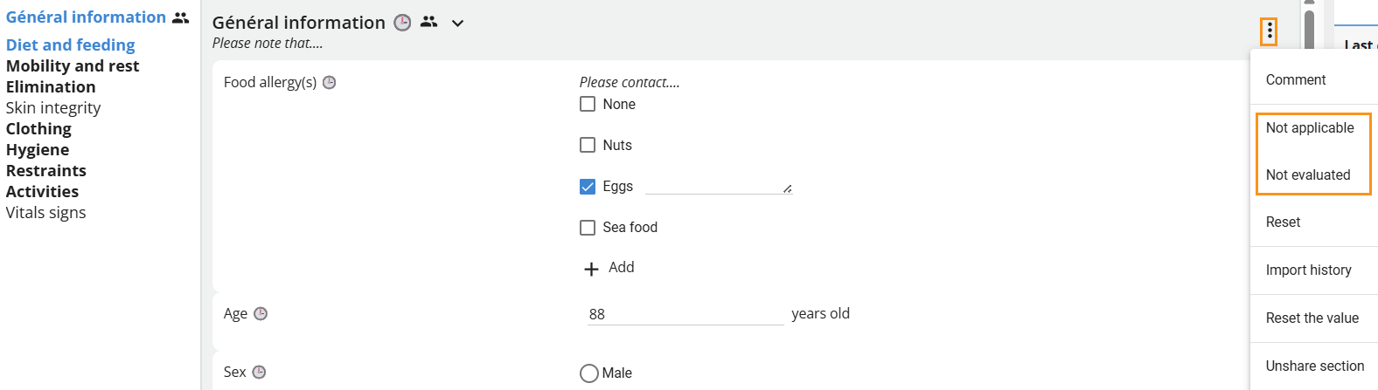
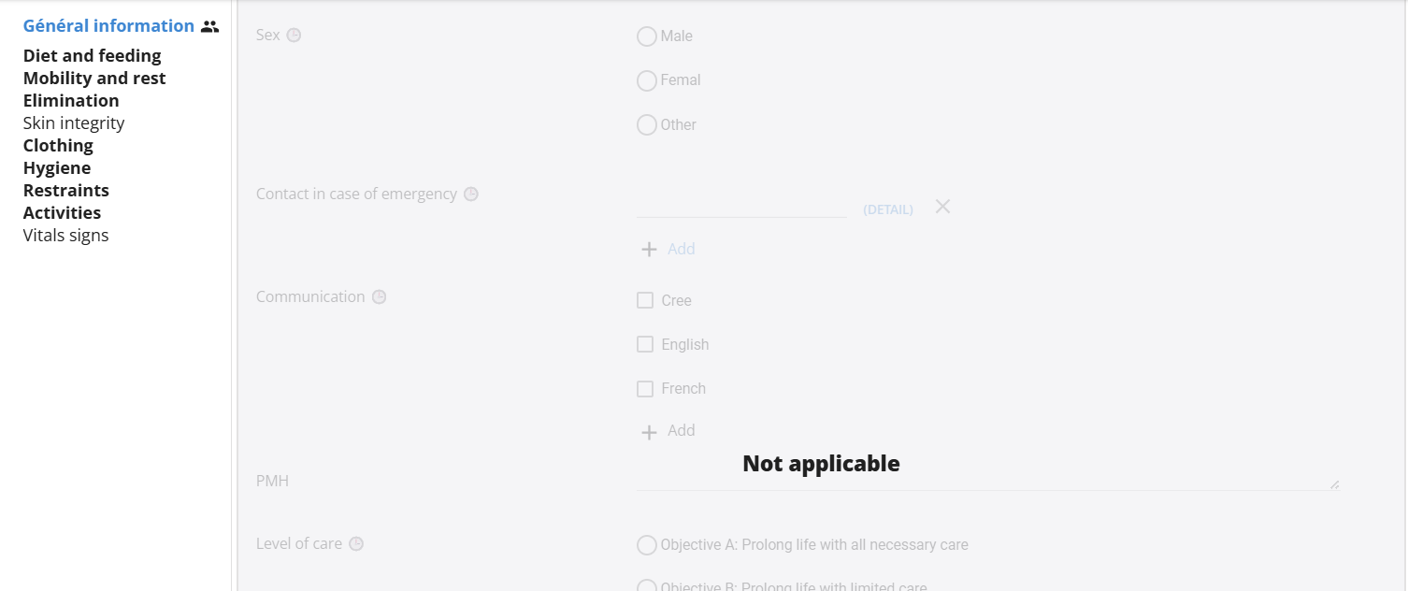

Reset
This option allows you to remove the display of old values from summary views as well as from future imports.
After resetting, the observation will no longer appear in the summary view or be available for import.
Example: The Transfer Autonomy Level is removed from a form but still appears in the summary view.
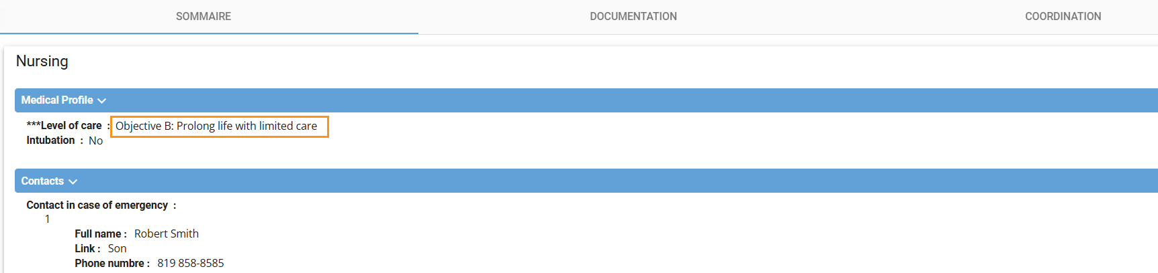
Select the three dots, click "Reset", then finalize the document. The initial data entry from the list will be removed from the form, and the summary will be automatically updated.
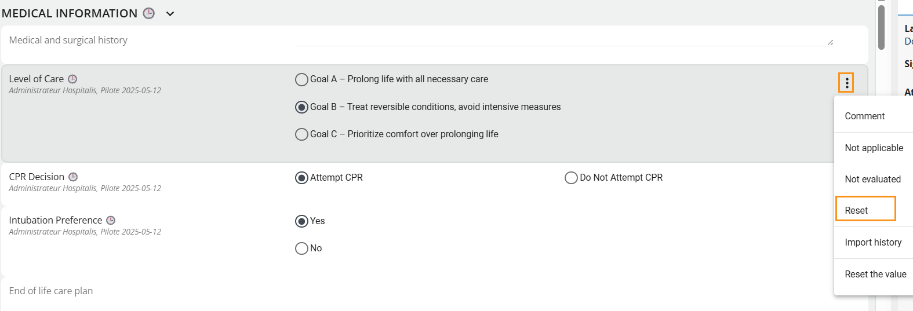

reset de value
From the three dots, it is possible to delete the values entered either by observation or by section.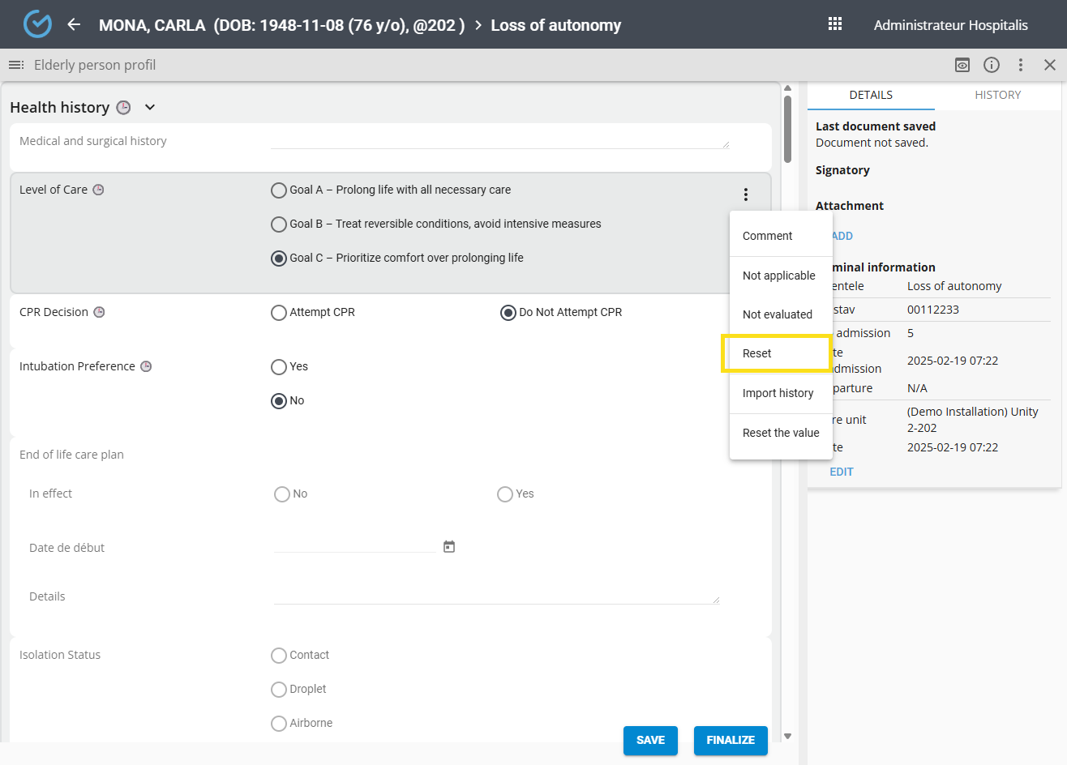

save and Finalize
Saving allows the current draft of the document to be saved and made available for consultation (as a draft). When viewed, a message indicates that the document is not finalized.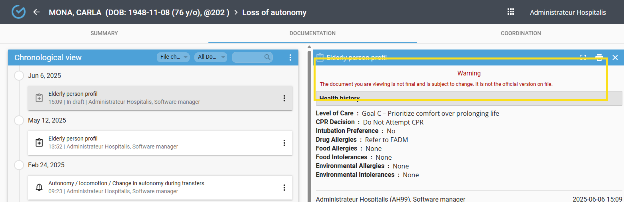
A finalized document becomes read-only, and the user can no longer make changes unless a correction is made with justification.
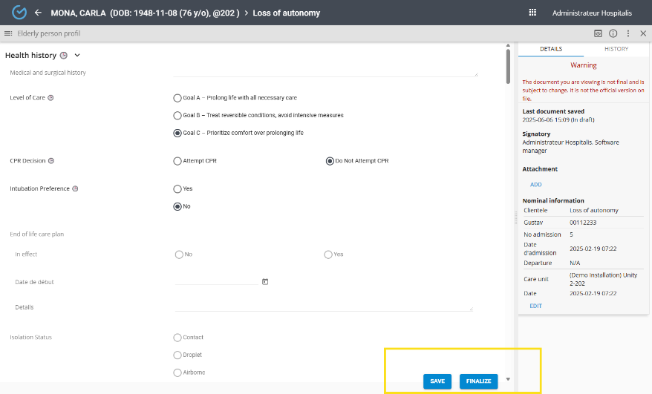
Depending on the configuration, additional authentication with a password may be required when finalizing the document.

NOTES

The note allows users to enter information in a text field and highlight content using bold, italic, and underline formatting.
From the icon available under the "+" in the documentation panel:

- Write the note
- Click "Save/Finalize
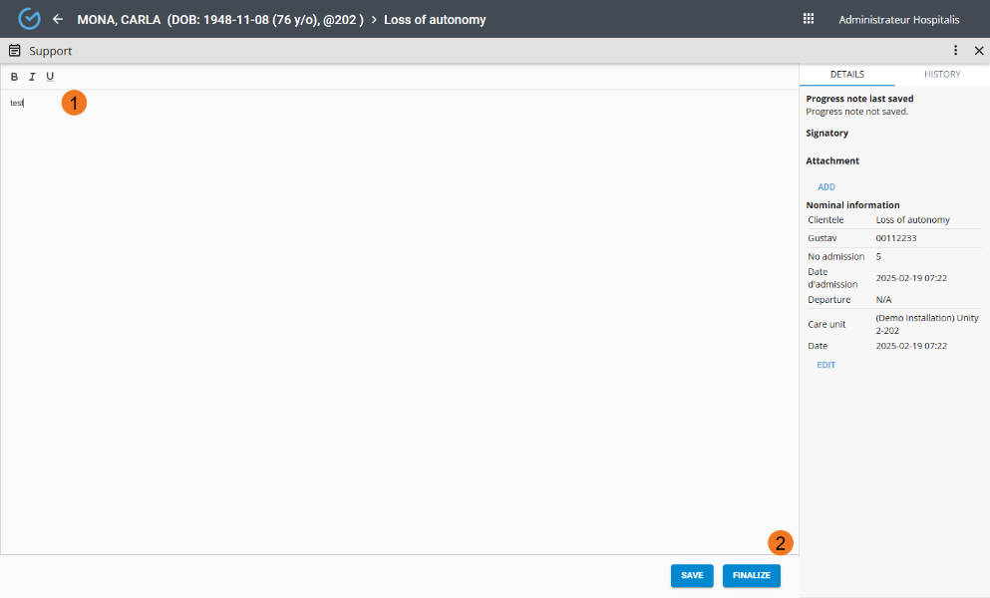
The date, time, signer, and nominal information are available in the "Details" section of the note.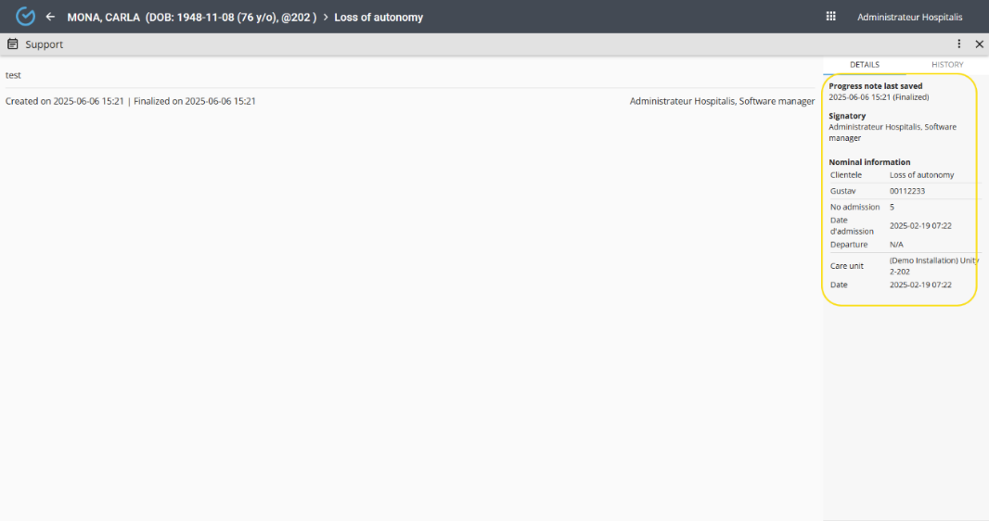

Attach a document
It is possible to attach documents from the record to a note. These will be available as hyperlinks and can be viewed from the chronological view.
To attach a document:
- From the three dots menu, click the "Attach Documents" button
- Select the documents and confirm
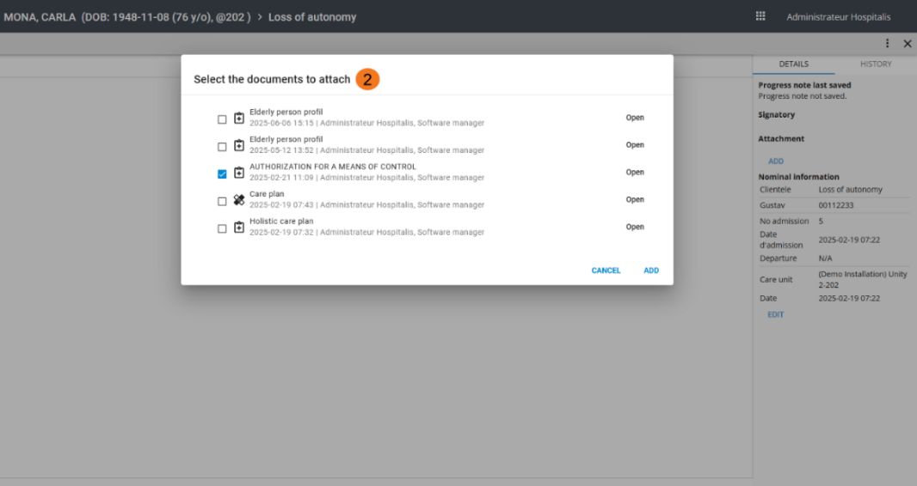
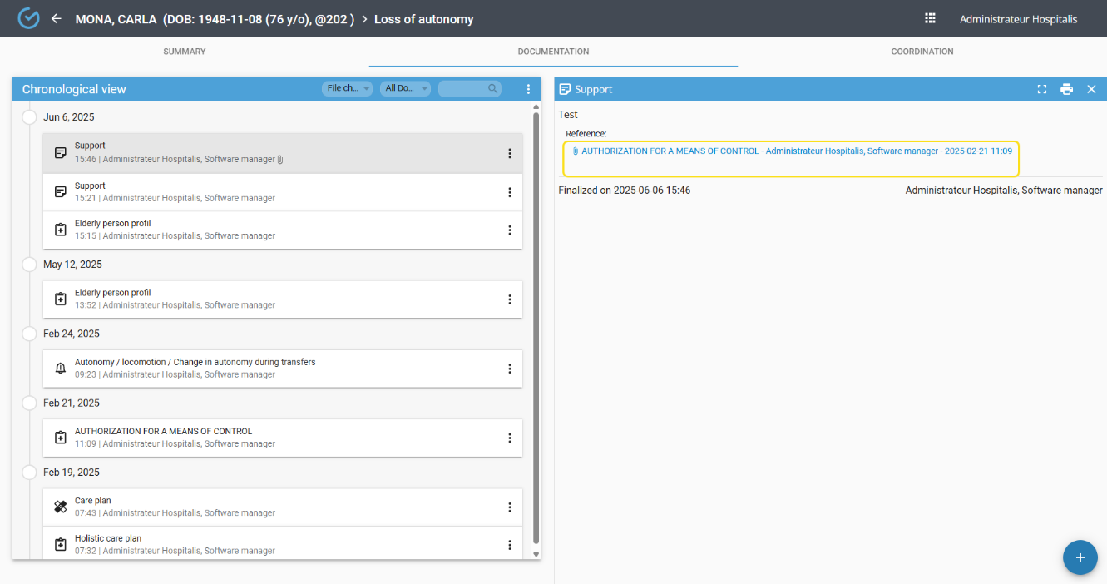

FOLLOW-UPS

For clients with devices connected to Gustav, vital signs and blood glucose data will automatically be recorded in the user's follow-up record. This information can also be entered manually if needed.
The follow-up allows data entry according to a time interval. Observation items are displayed in the header, and the initials of users who contributed to the data entry are shown in the "Initials" column.
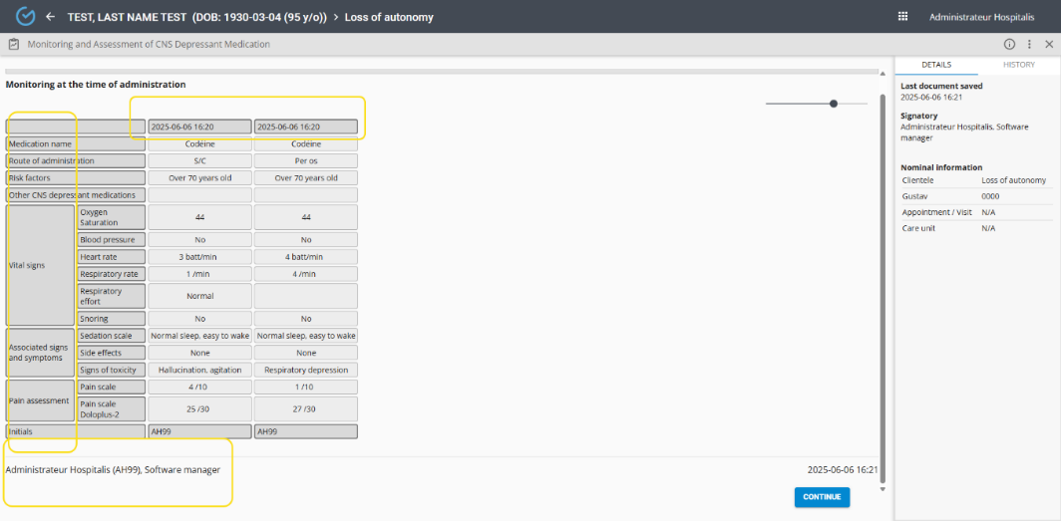
When viewing in the chronological view, the display can be enlarged or reduced.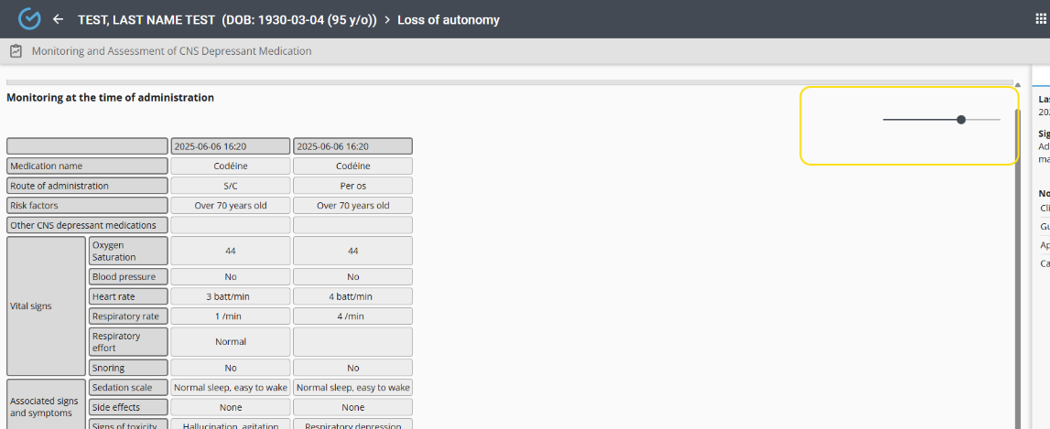
À "From the following icon, it is possible to display the follow-up data in a graph (depending on the configuration).

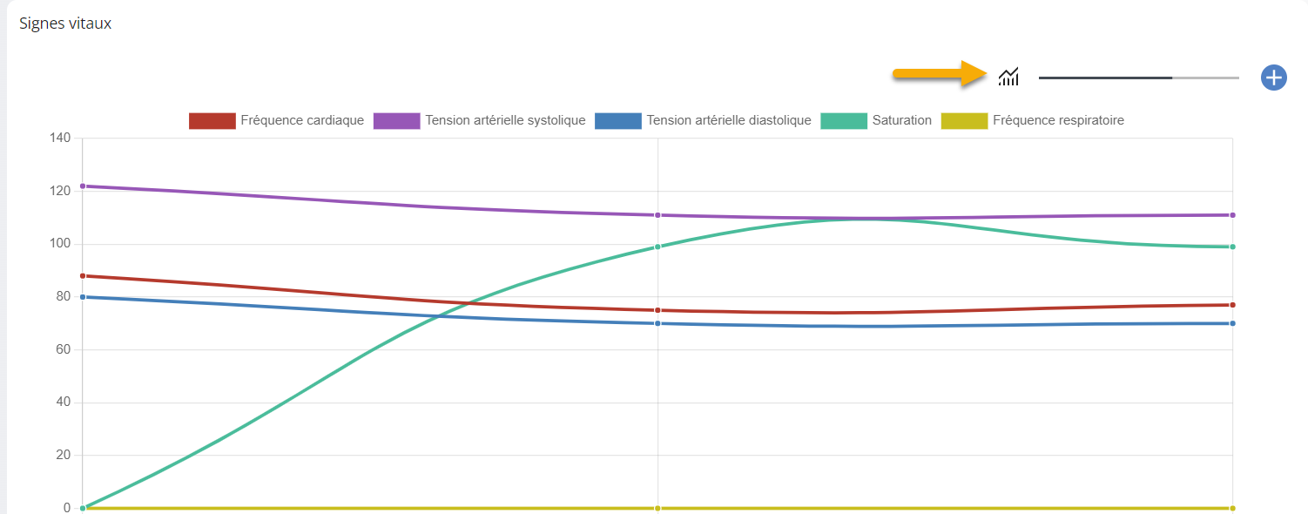

Create a follow-up
From the Documentation tab:
- Select the Follow-up icon
- Search for and select the desired follow-up
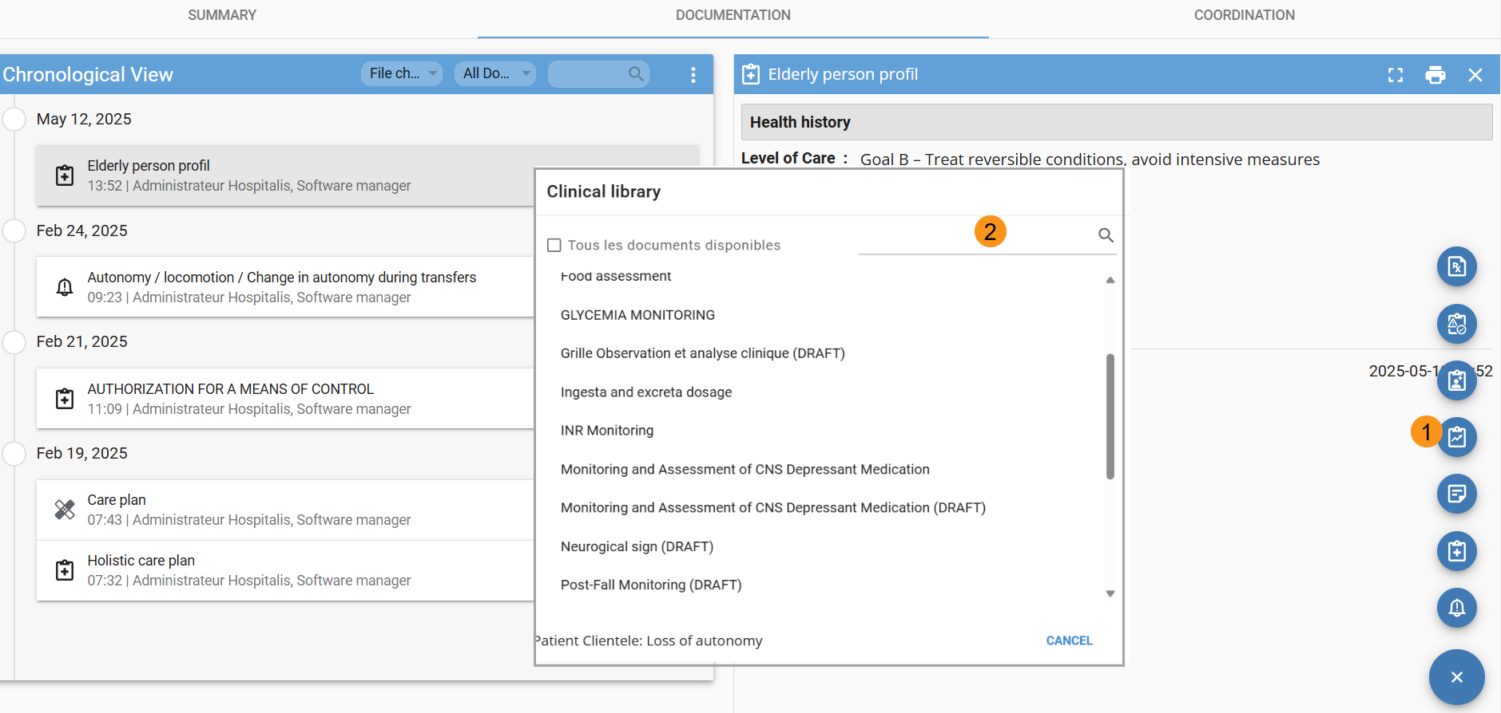
- Select the “+” icon located on the right side of the screen
- Enter the information (the "Entered" field is mandatory) and Click “Confirm”
- Click “Finalize”
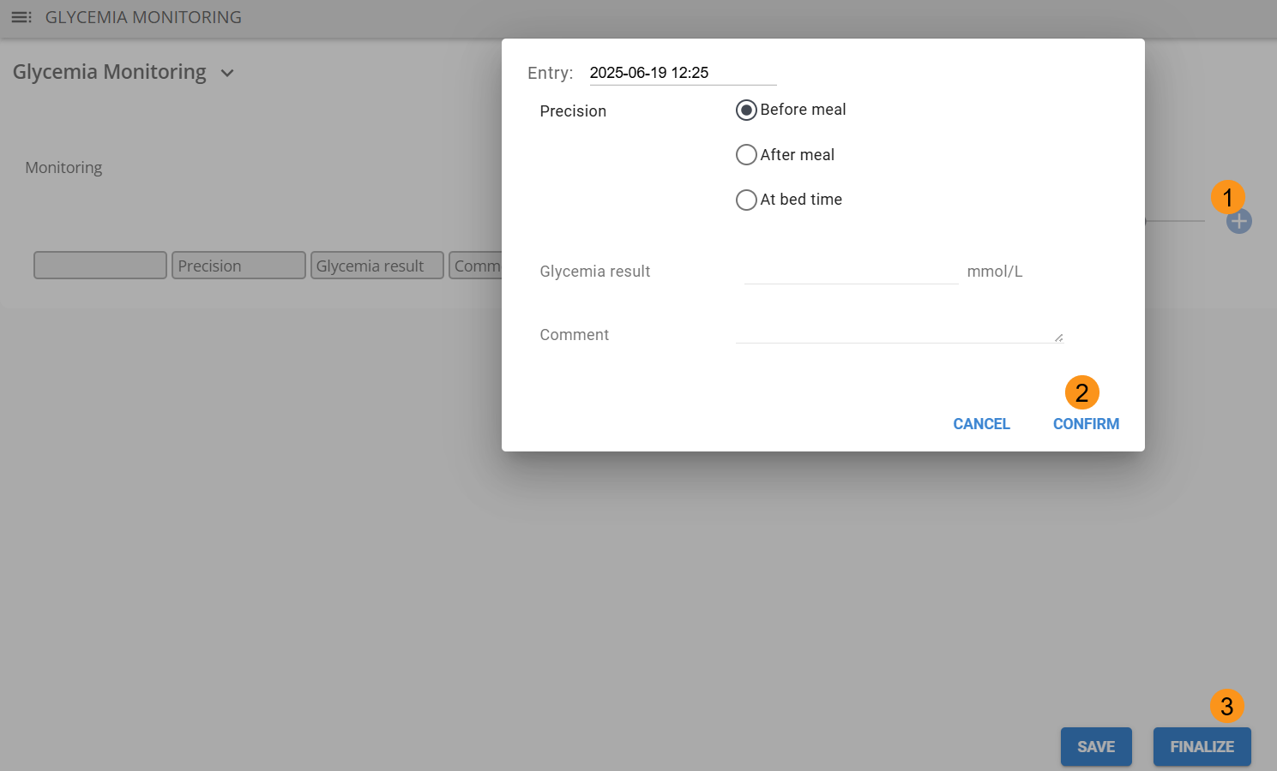
Multiple Instances of a Follow-Up
Depending on its configuration, a follow-up may allow multiple instances — for example, to create several wound follow-ups. When creating a new instance, entering a subtitle is mandatory to help distinguish it during record consultation and in the library.

Steps: Enter the subtitle and confirm
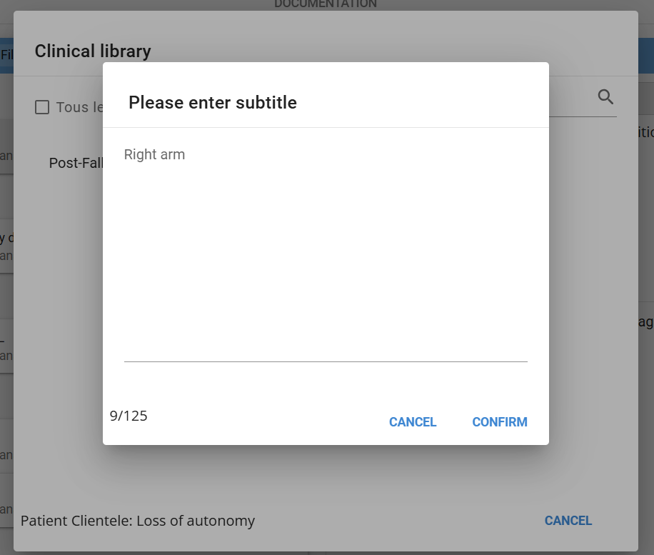
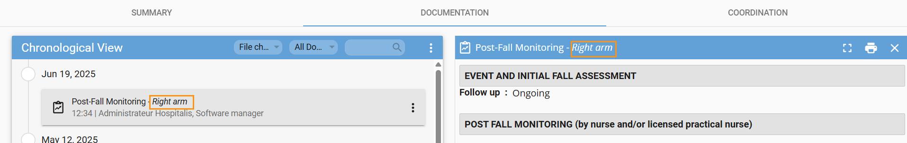
If more than one follow-up is in progress. Select the form in progress or new form
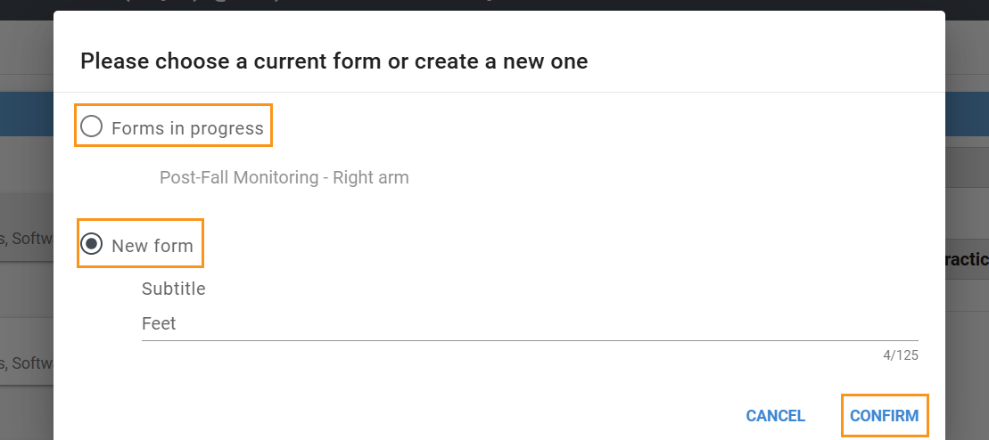

Continue a follow-up
A visual indicator in the library shows that a follow-up has been started. Select the “Continue” button available when opening the document.
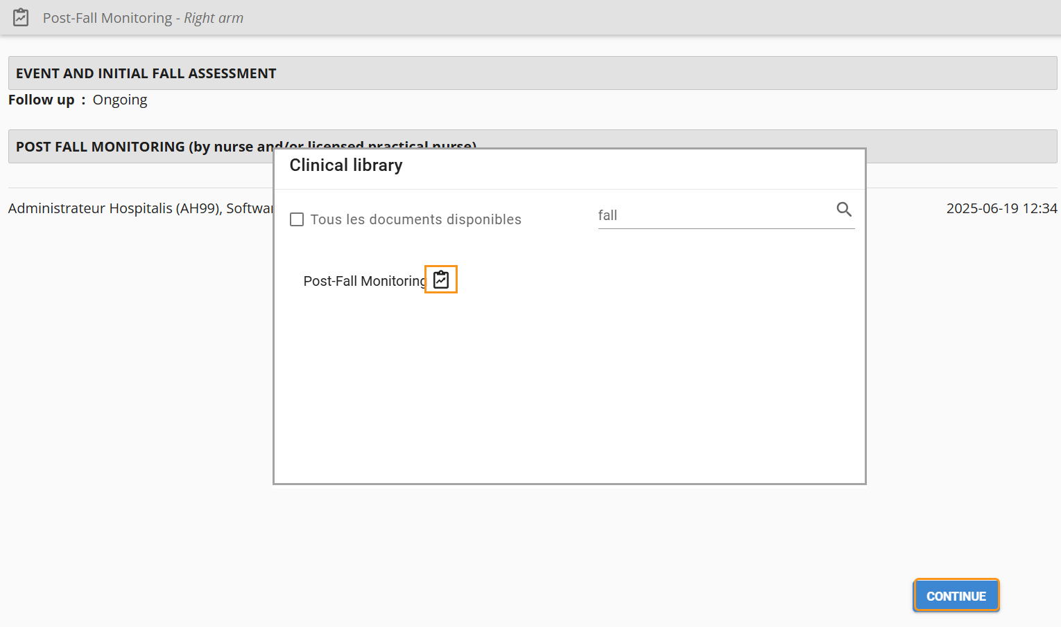

Add an observation
Depending on the configuration you can add an observation to allow the entry of new text data. The observation will appear in both the header and the data entry window.
- From the three dots on the grid, click the “Add Observation” button
- Click the “New Observation” header
- Enter a name and click OK

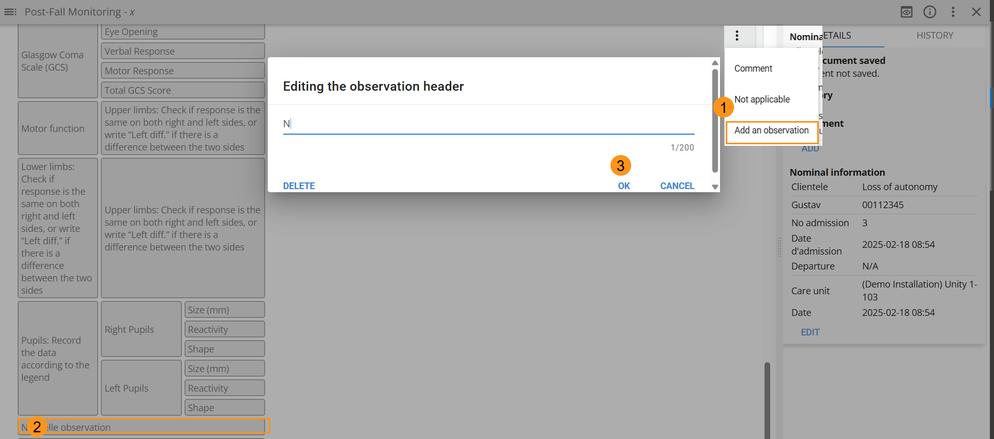
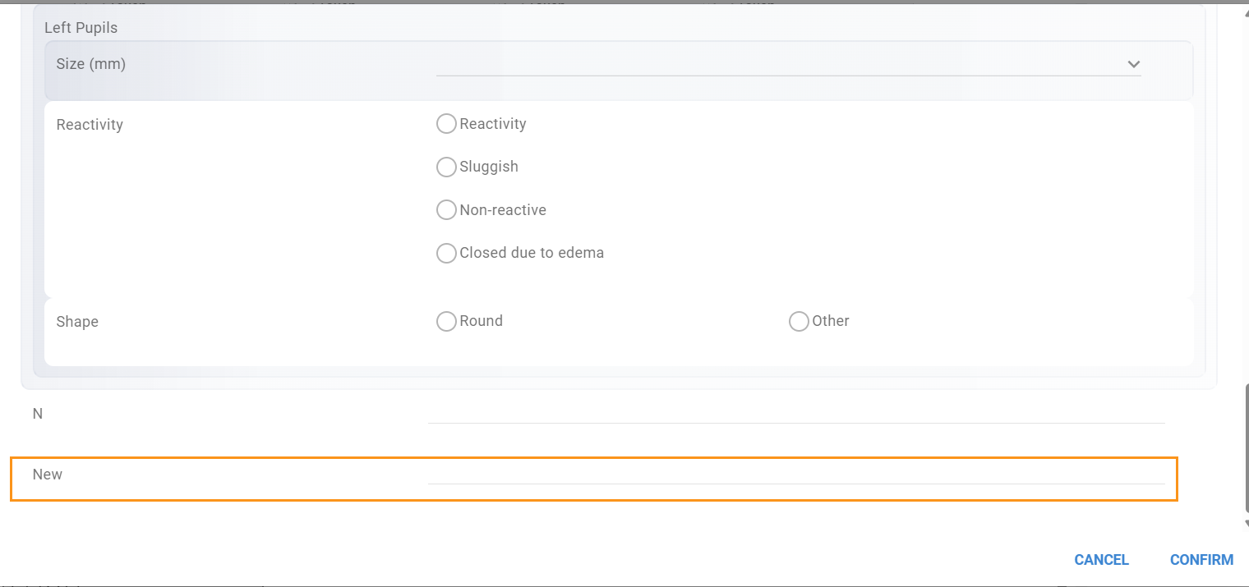

Add a comment
A comment will be displayed below the follow-up grid.
To add, edit, or remove a comment from a follow-up column

- From the three dots, select “Comments”
- Enter the comment and Click “Confirm”
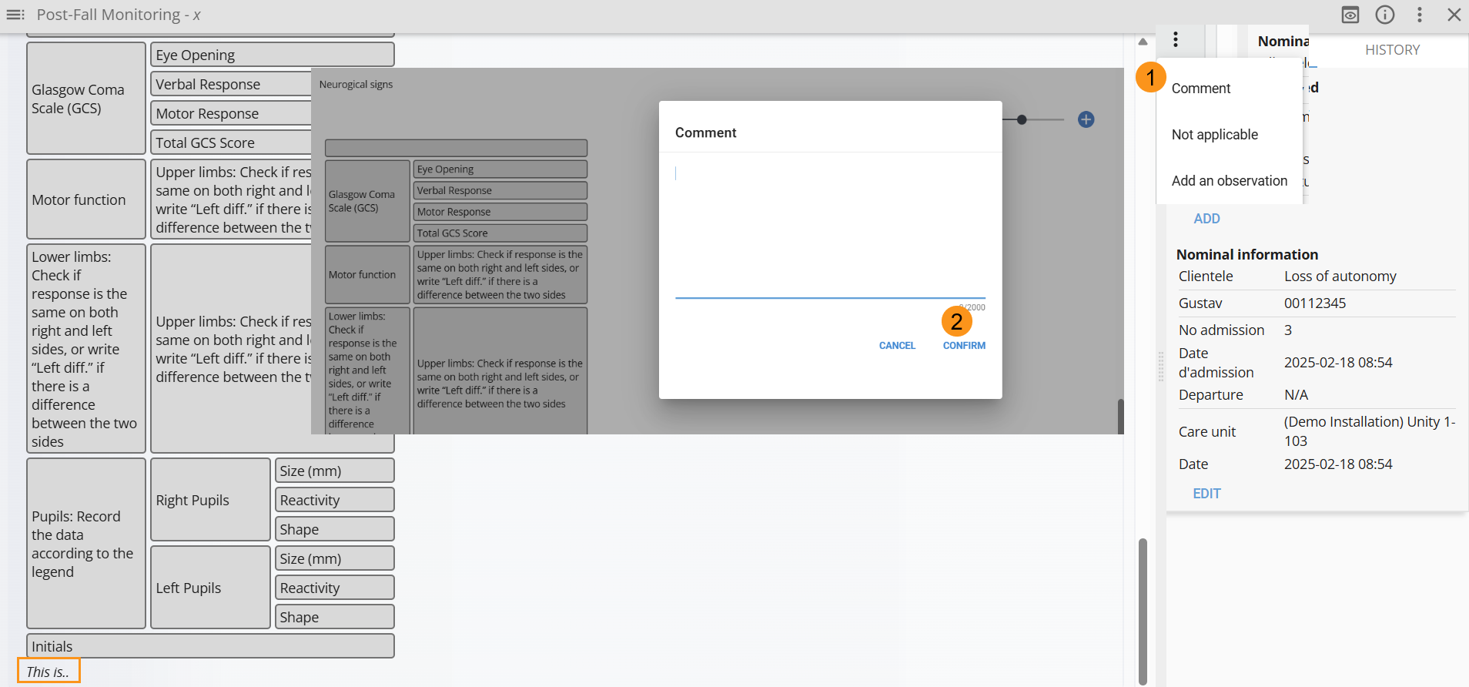

Duplicate a column
From the three dots, it is possible to duplicate a column to reuse the entered data.
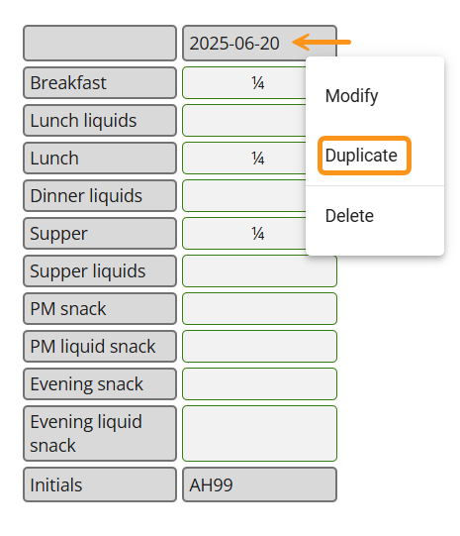

Correct a data entry
From the three dots, it is possible to correct and entry. The correction history is available by selecting “Show History” from the three-dot menu.

To correct data entered in a follow-up:
- From the three dots, click “Correct”
- Enter a justification and confirm
- Make the correction and confirm
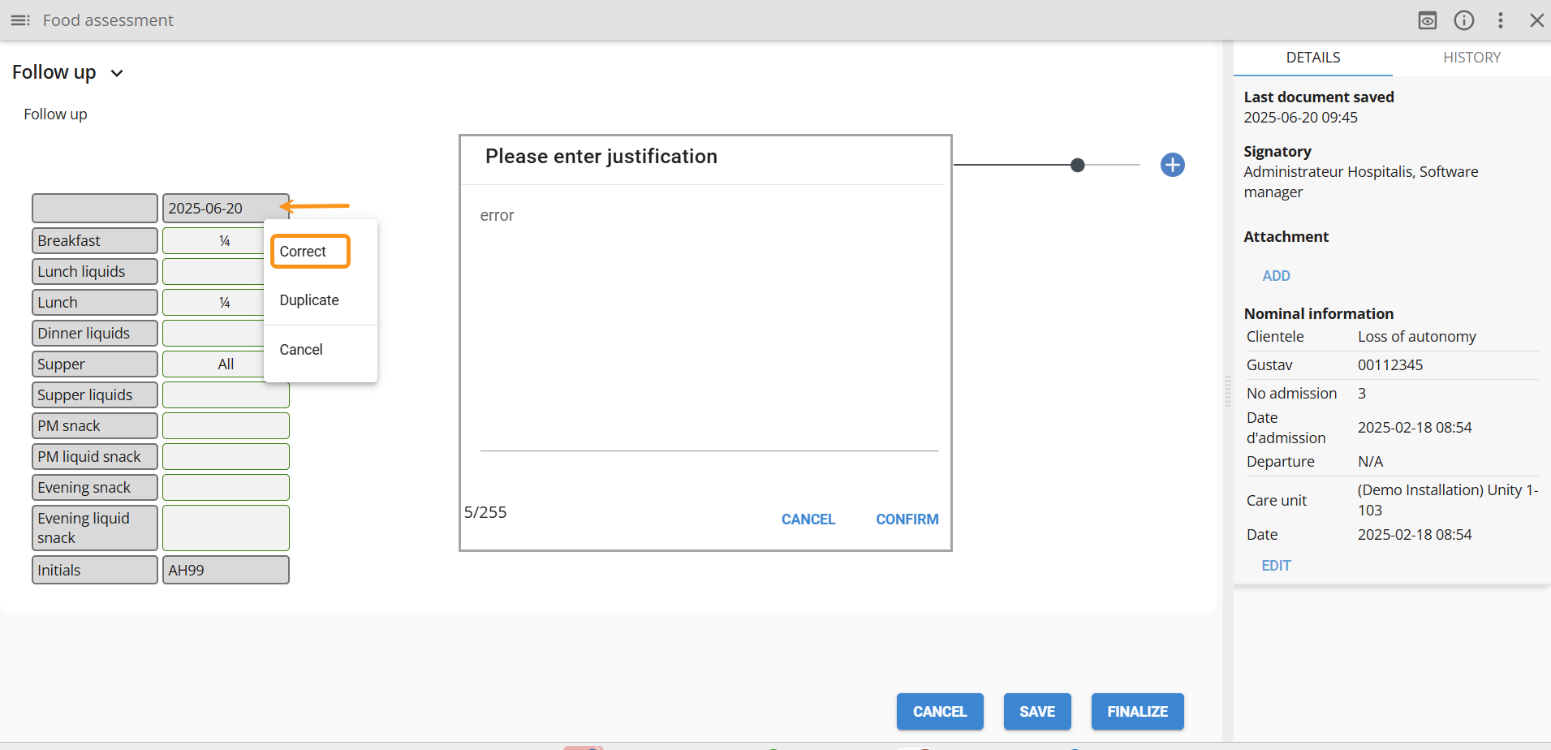
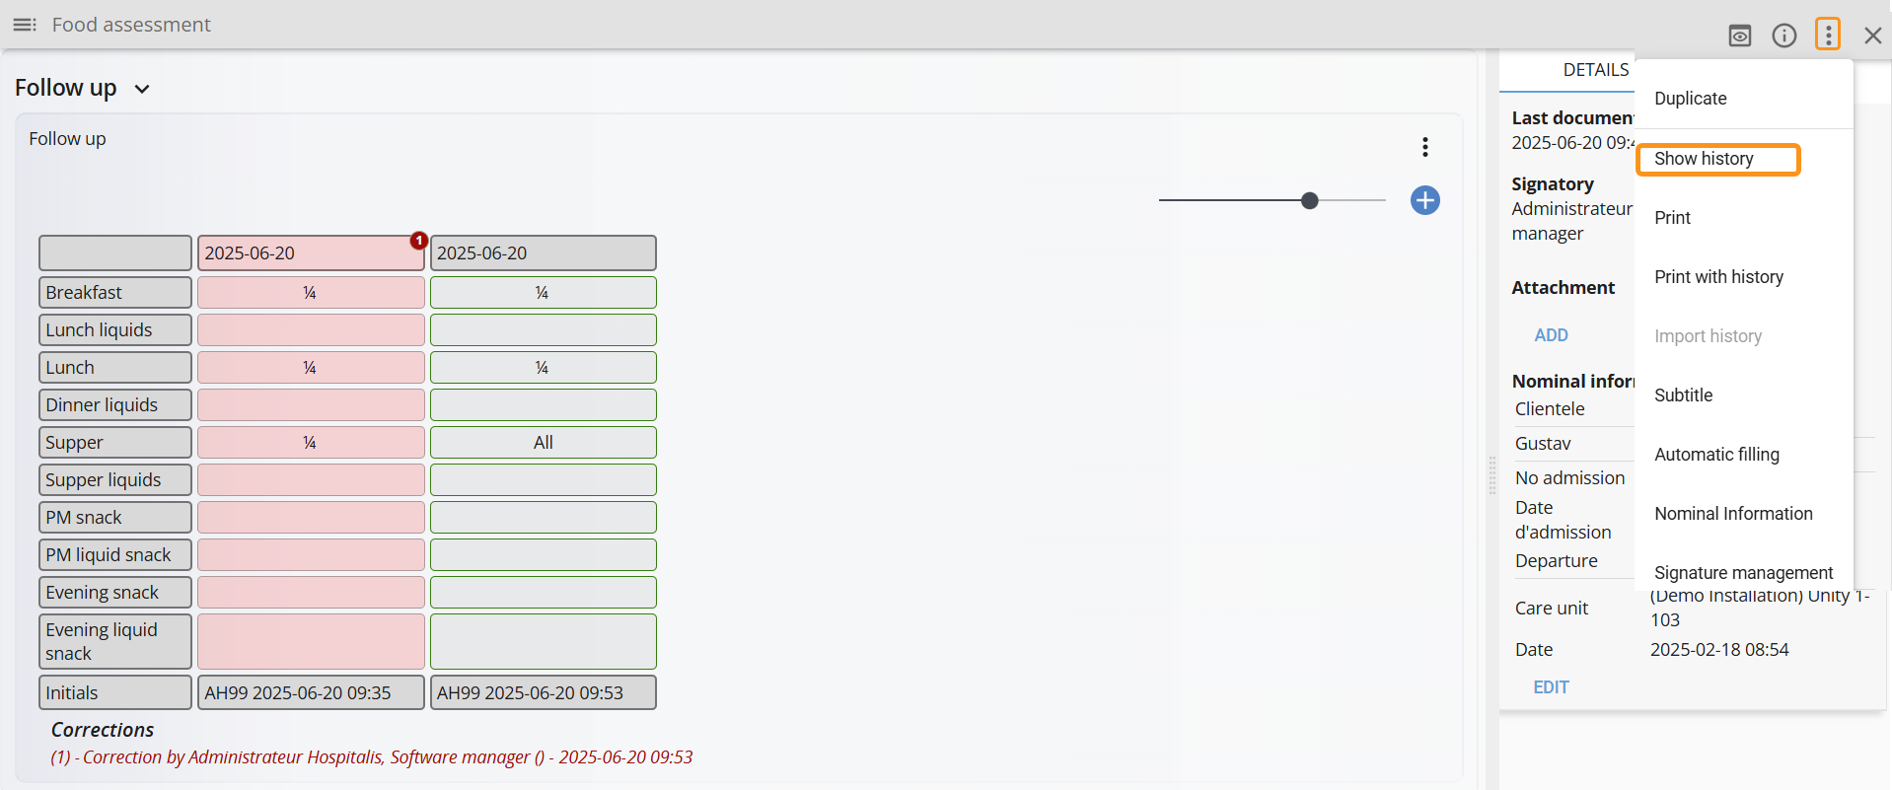

Cancel a column
To cancel a follow-up column:
- From the three dots, click “Cancel”
- Enter a justification
- Click “Confirm”
The cancellation history is available by selecting “View History” from the three-dot menu.

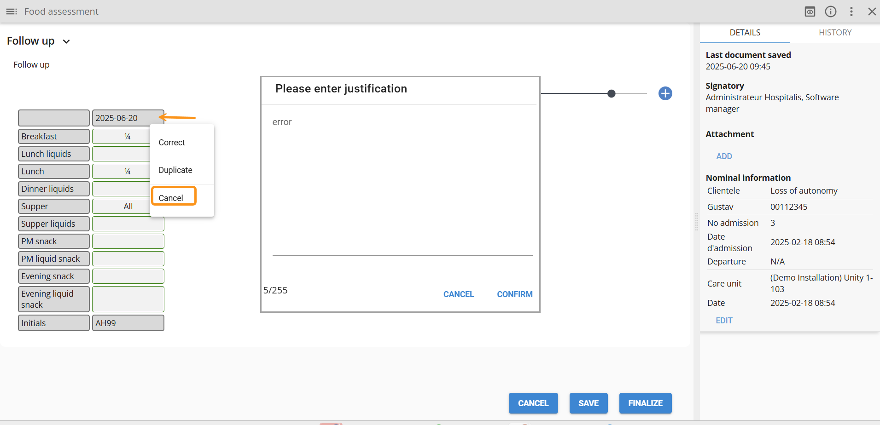

Edit a header title
Depending on the configuration, it is possible to edit a header title:
- Click on the header name
- Enter the modifications and click Ok
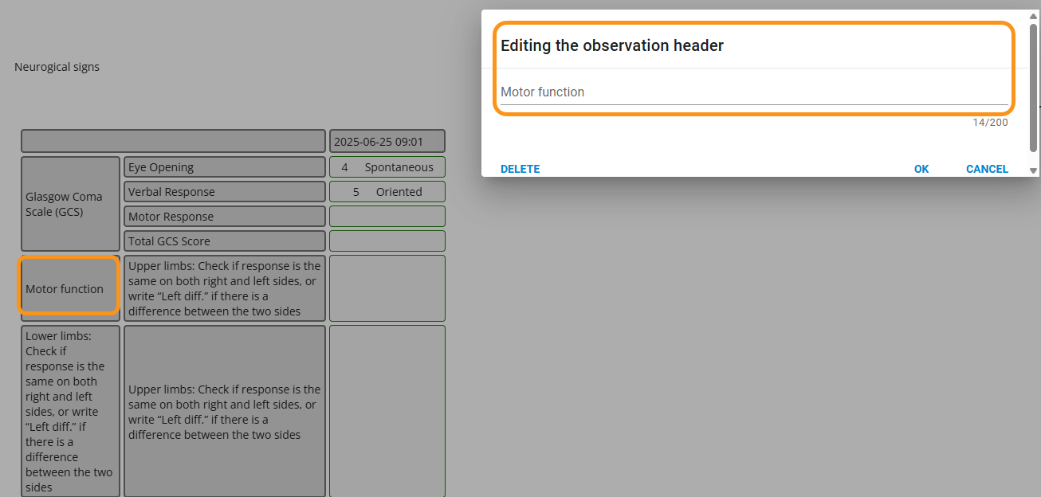

Complete a follow up
This feature is available based on the user's assigned permissions.
A new version of the follow-up can be started once the current one has been finalized.
From the three dots on the finalized follow-up, select “Complete”.
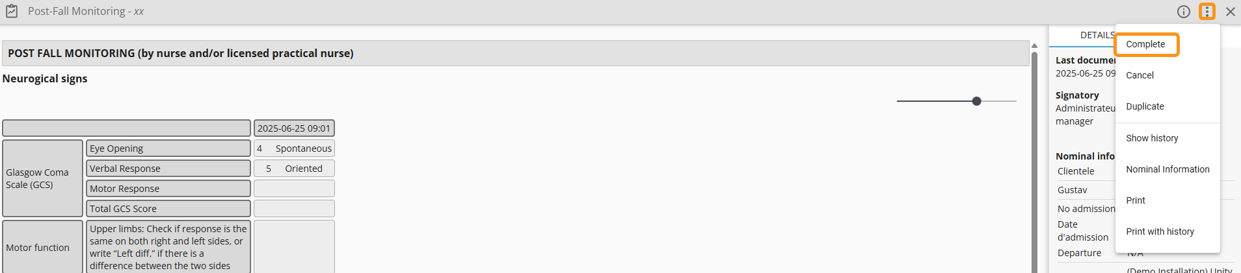

Duplicate
Duplication allows you to create a new version of the document by copying its original version.
From the three dots, click “Duplicate”.
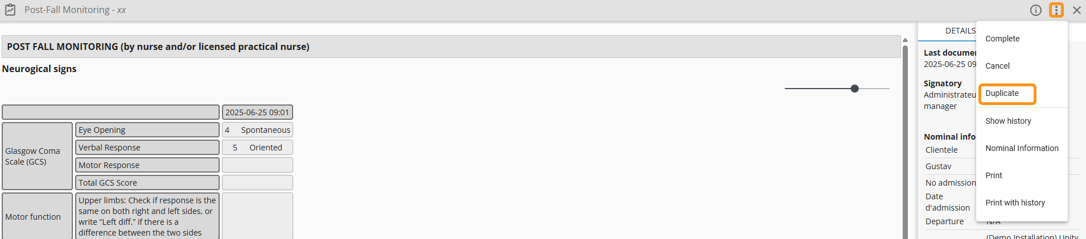

Add a subtitle
Adding a subtitle provides additional context to the document title and will appear in italics when viewed in the chronological view.
- From the three dots, select “Subtitle”
- Enter the subtitle and Confirm

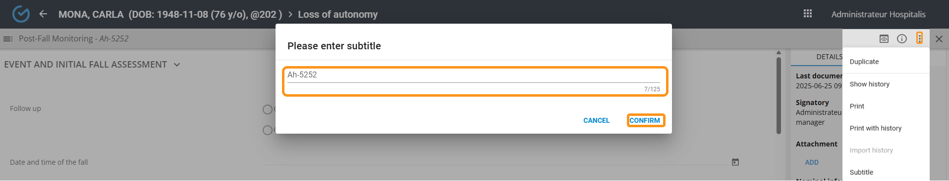

Add an attachment
You can attach one or more files (JPEG, PDF, or PNG format) to documents, with a maximum file size of 45 MB. The attachment can be removed by selecting the (x) icon.

- Click the “Add” button
- Select the attachment
- Click “Open”
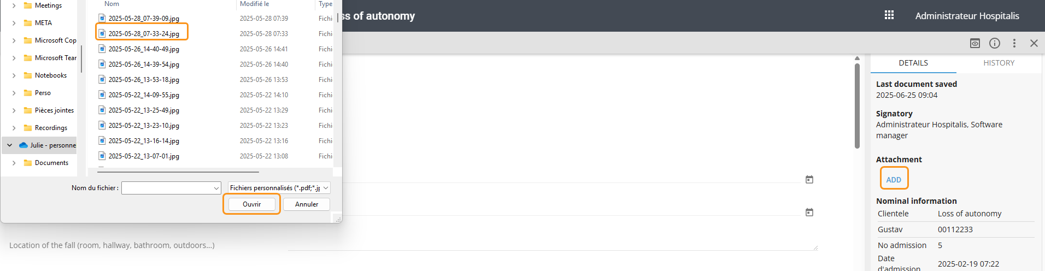
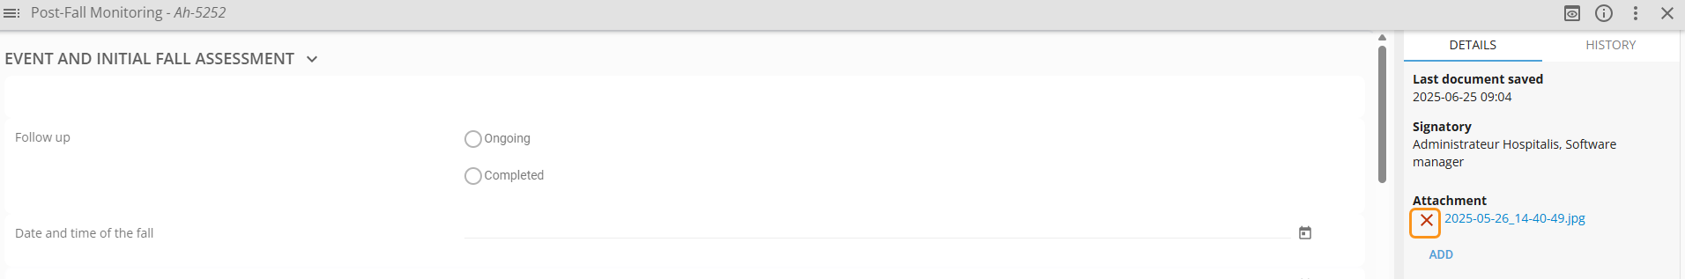

Add a signatory
It is possible to add a contributor’s signature to the document.
- From the three dots, select “Signature Management”
- Click “Add a Signature”
- Enter the user name, password. Facility and confirm
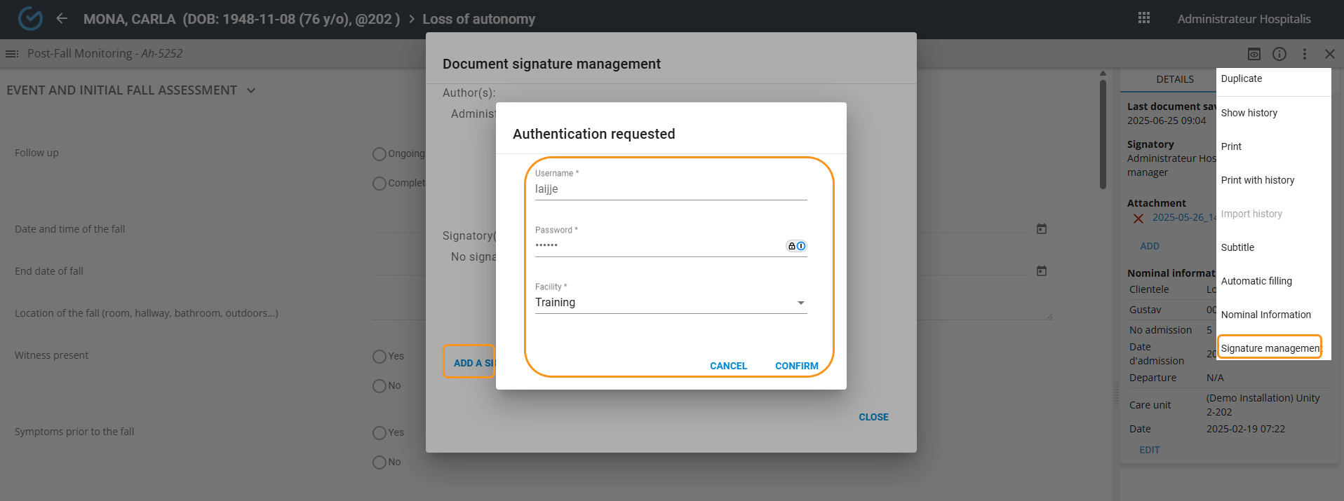

Correct a finalized document
From the three dots, it is possible to correct a finalized document. A justification will be required before making any changes. The correction details are available from the History tab.

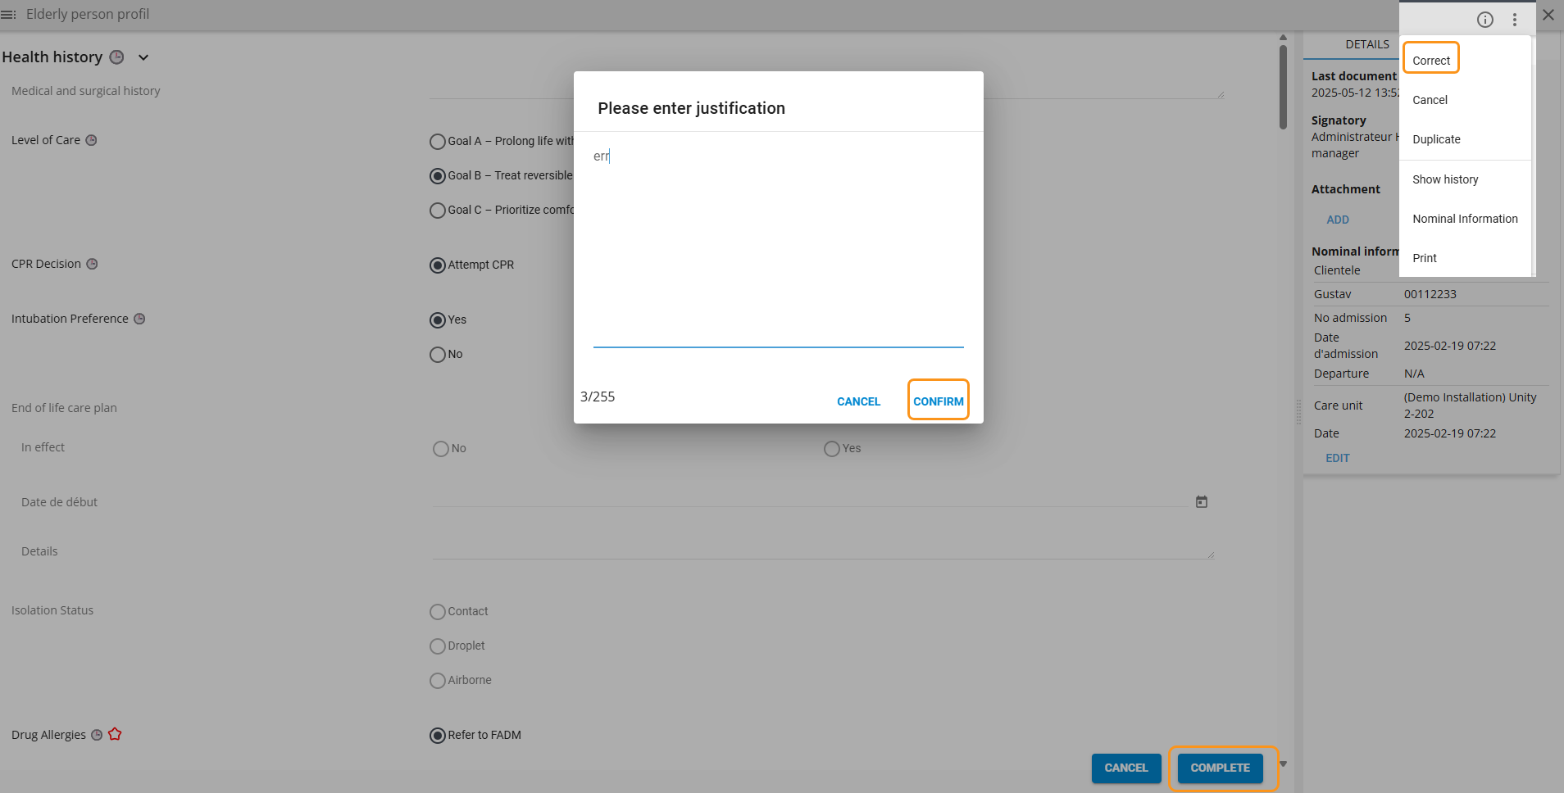
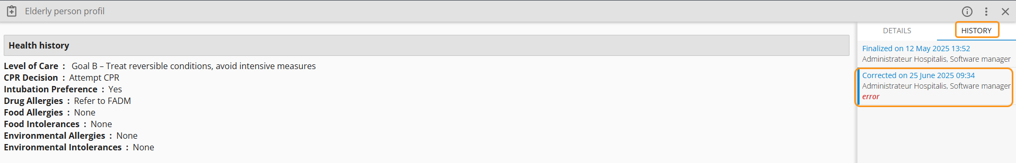

Cancel
Cancelling a request, a non-pharmacological order, a PTI, or a care plan requires special permission.
A user can cancel a document that they have saved as a draft or finalized. The document will no longer appear in the chronological view, but it can still be accessed by selecting “Show Cancelled”.
- From the three dots, select “Cancel”
- Enter a justification and “Confirm”
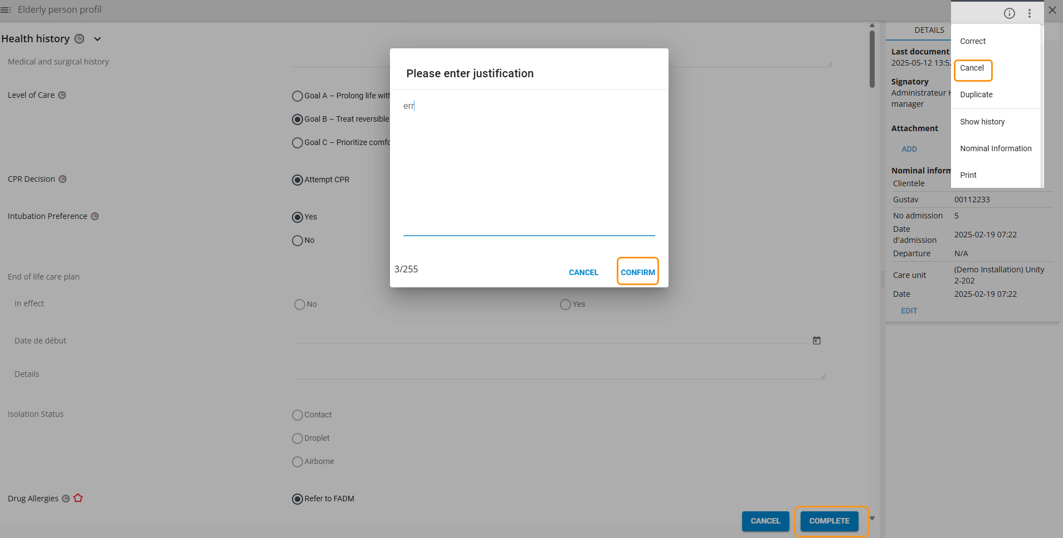
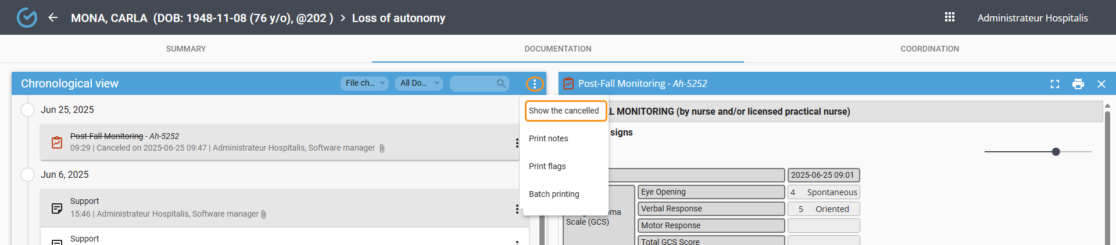

Print
From the three dots, it is possible to print a document in PDF format.
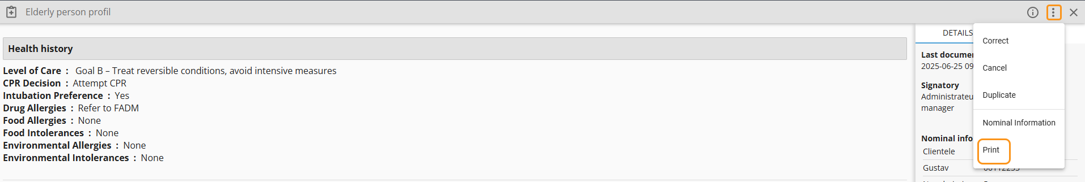

User digital signature
This feature is available depending on the configuration of the facilities.
Using a finger, mouse, or stylus, it is possible to have a user sign a document if needed.
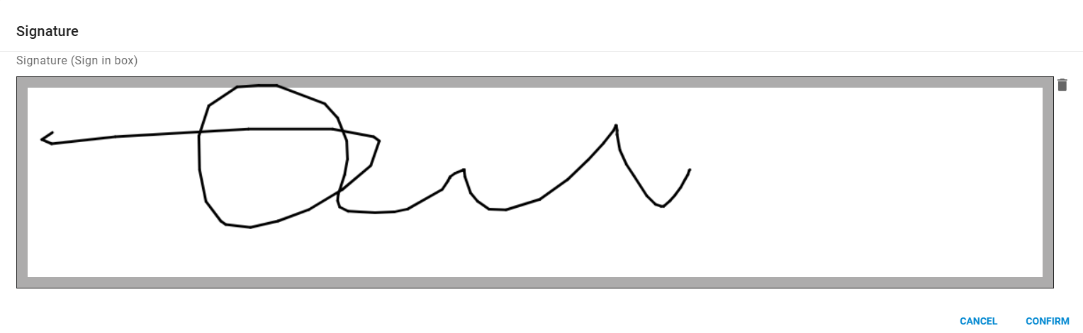

Care plan

The care plan allows the scheduling of the user’s care/services, which are generated in the work routines.
- The user must have been admitted to a room for the care plan to be accessible.
- Only one care plan can be active in the record.
- If the care episode is closed, the care plan will be automatically finalized.

The care plan is divided into three sections:

- The left section allows navigation between the plan’s sections. Bold text indicates that a care/service has been activated in that section.
- The center section allows assigning a schedule and directives associated with the care/service.
- The right section displays the list of care/services that have been activated in the plan.
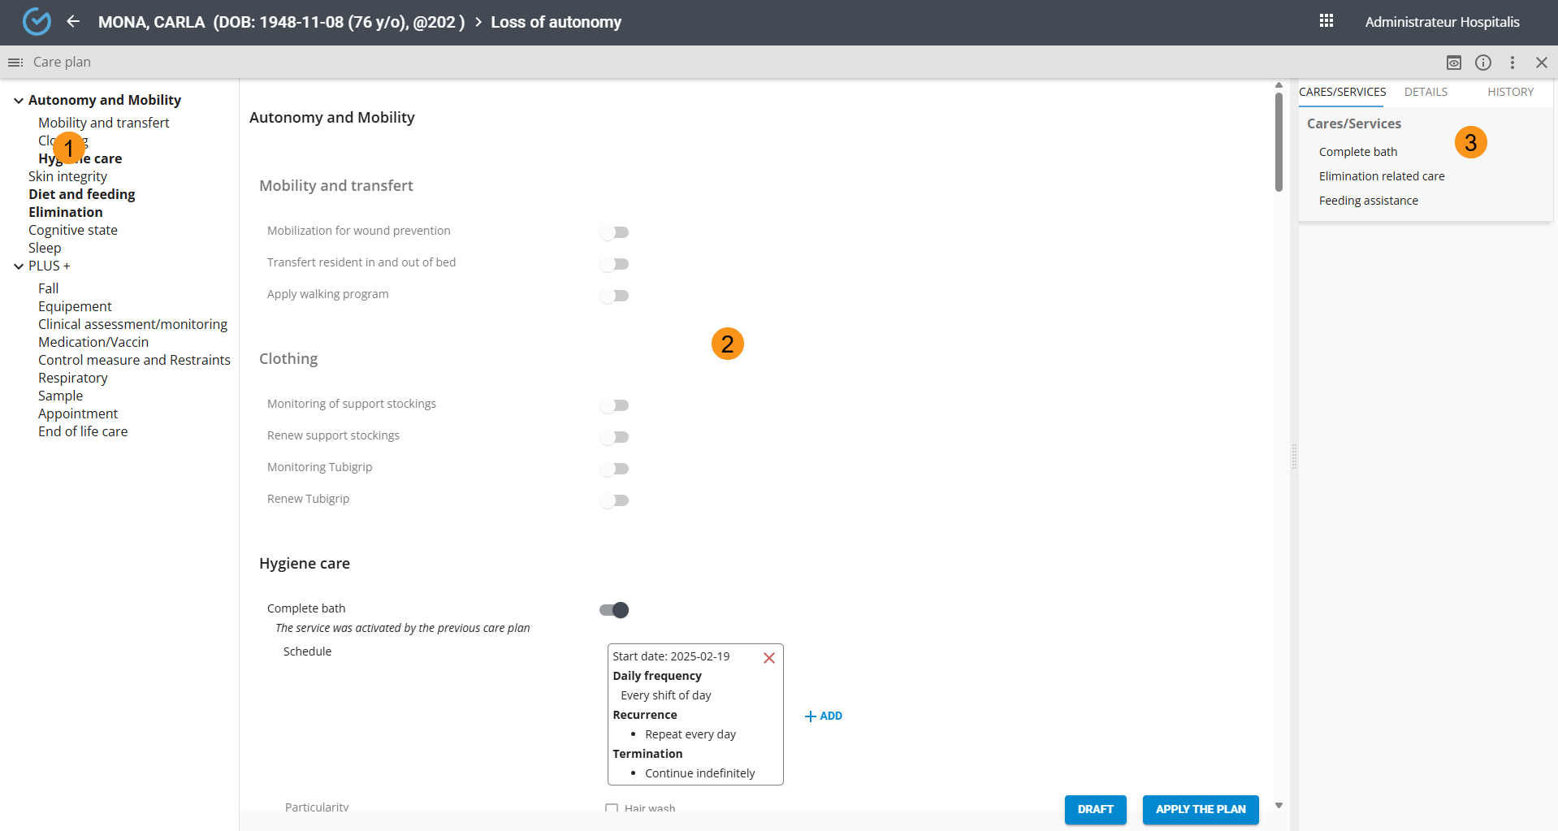

Create a care plan
To create or modify a care plan:
From the chronological view, click the care plan icon and select the plan from the library
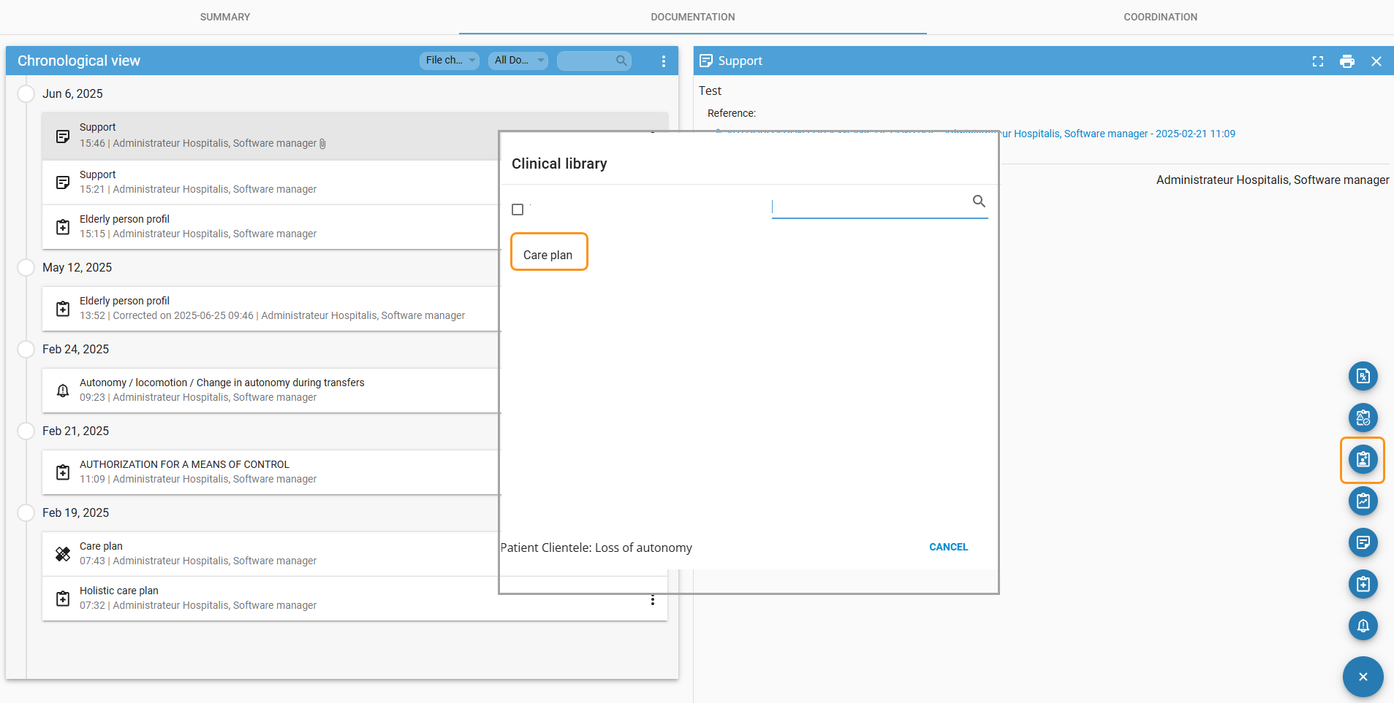

Activate a care/service
- When opening the plan, the activation of a care/service may come from a PTI directive, an initial assessment, or the previous care plan.
- A care plan can be saved as a draft, but it must be applied to generate the services in the work routines.
- If a schedule has not been defined, an error message will appear indicating which care item is missing a schedule.
To activate a care item:
- Slide the toggle button to the right and specific guidelines if needed
- Click the “Add” button to define a schedule
- Enter a title and Set a start date (optional)
- Enter the frequency, recurrence,, end condition and confirm
*** Don’t forget to apply the care plan.
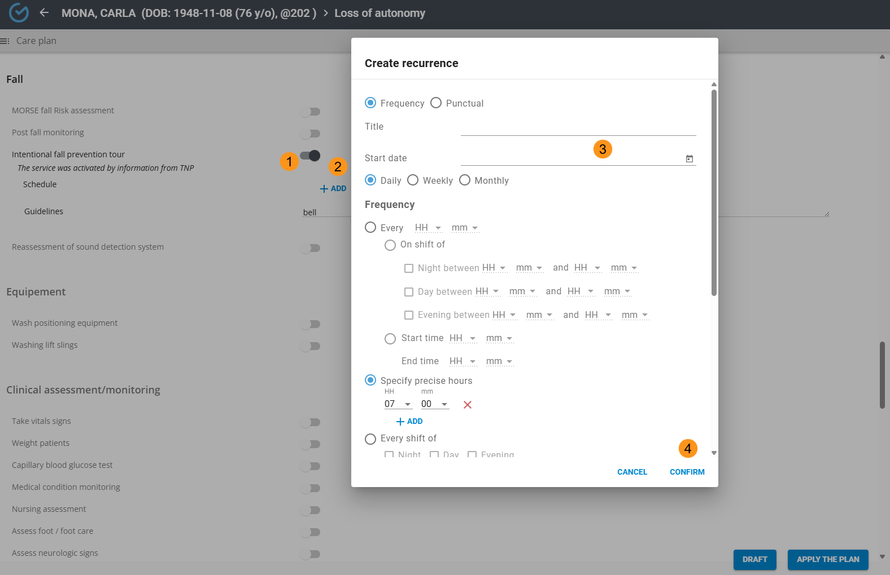
Select the schedule box to make a modification and click the (x) to delete it.
You can add an additional schedule by clicking the “Add” button again, located to the right of the previous schedule.
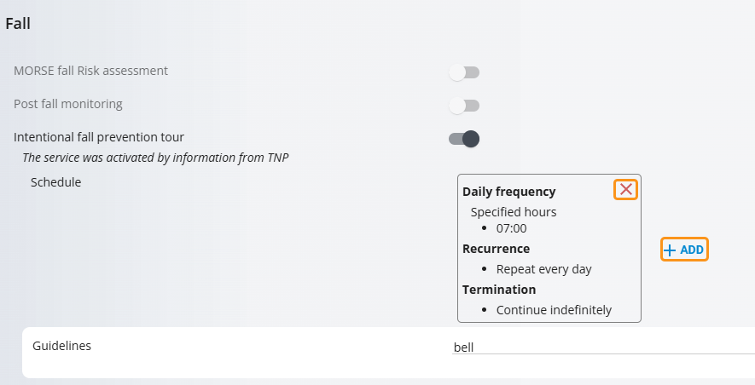
Depending on its configuration, it is possible to duplicate a service if needed.
Entering a subtitle for a multiple-instance service is mandatory in order to distinguish it in both coordination and work routines.
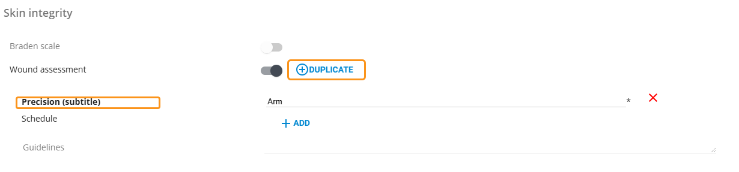

Deactivate a care /service
If the Service has been not terminated by information from TNP, slide the toggle button to the left.

Revise the care plan
Revision allows you to modify the care plan and can be done by selecting the icon from the library or by opening the plan from the chronological view.
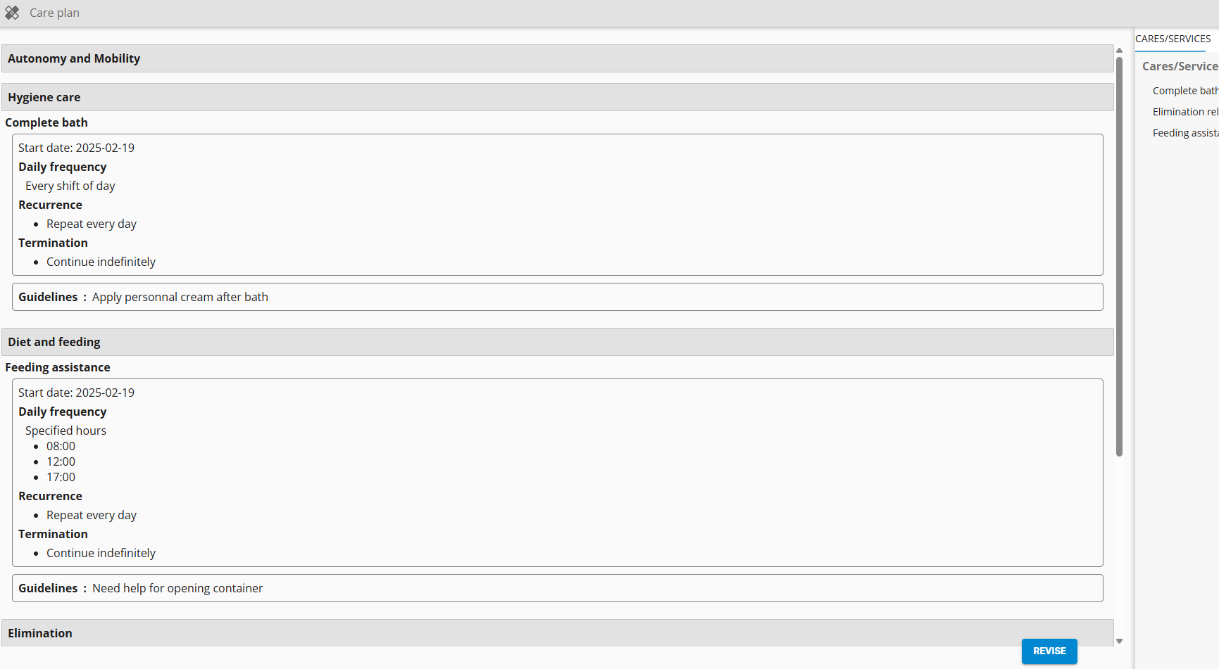

Correct a care plan
Although the correction option is available, it is recommended to use the revision feature to ensure the user benefits from the most recent configuration updates made by the implementation team.

Finish and cancel the care plan
The plan finalization feature is available based on the permissions granted to the user. Finalizing the plan will remove all scheduled activities from both the Coordination tab and work routines.
A finalized plan remains accessible for consultation in the record, but it cannot be reactivated.
The plan cancellation feature is available based on the permissions granted to the user.
This action will automatically suspend all scheduled activities in the work routines and in the Coordination tab.

Therapeutic nursing plan (TNP)

It can be accessed via the library icon or by clicking the “Continue” button when selected from the chronological view
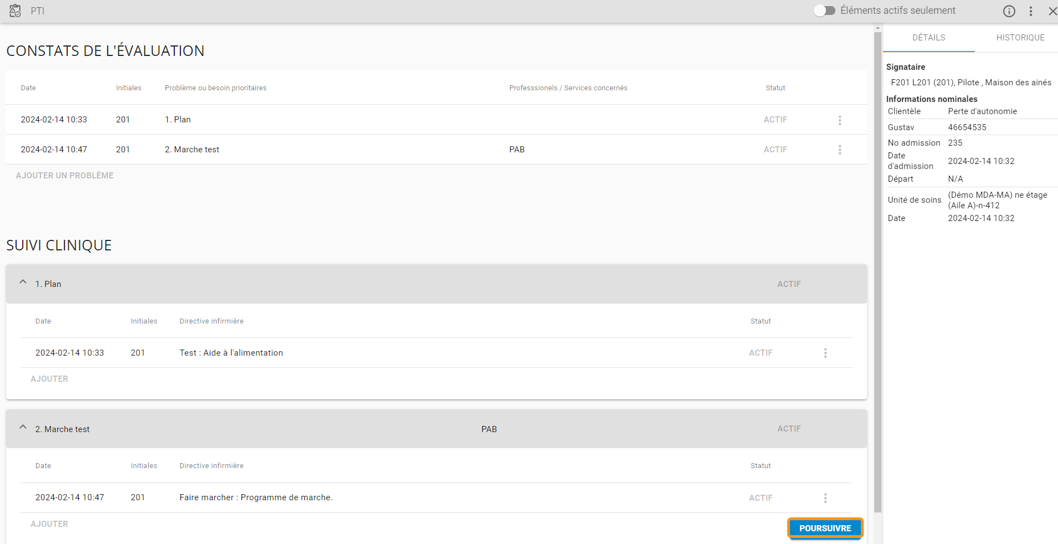

Evaluation findings

Add a priority problem or need
- Select “Add” a problem
- if needed, change the problem number
- Enter the date and time, priority problem or need, profession or services involved and Confirm
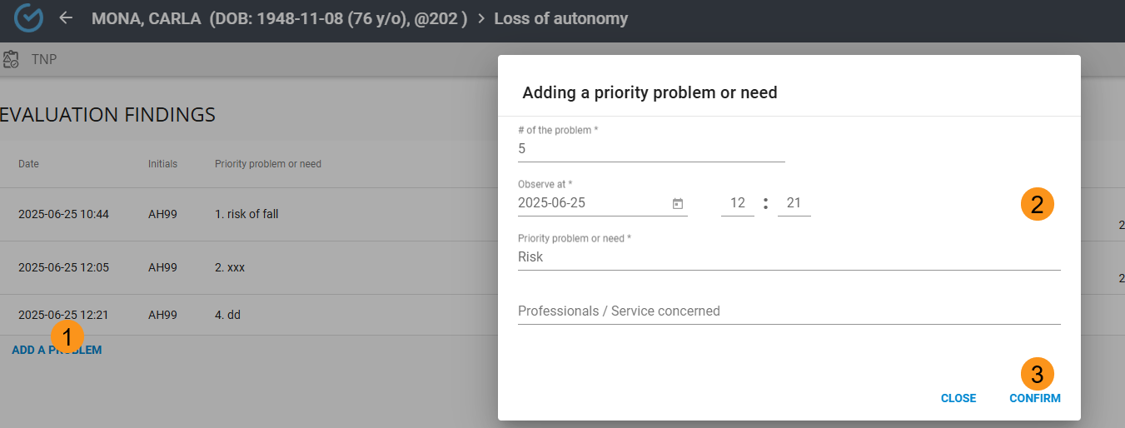

Update/ correct cancel the status of a priority problem or need
To modify the status, select “Status” button, select the new status and confirm
Changing a status to “Resolved/Satisfied” will automatically set the related directives' status to “Discontinued/Completed”, using the same date and time as the problem status update.
Changing the status to “Evolved” opens the problem details and allows you to edit the information, except for the problem number, which is grayed out.
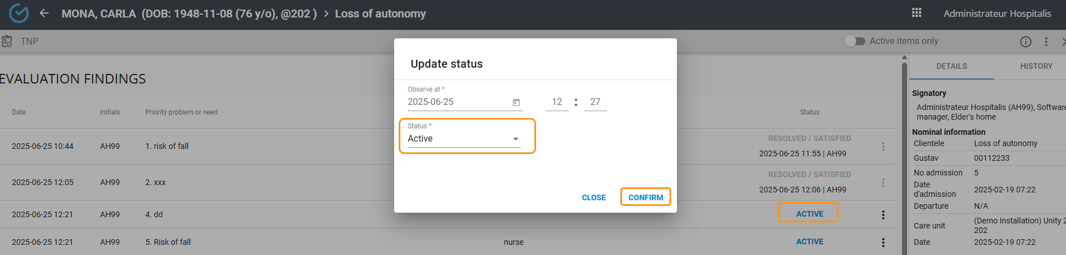

Clinical follow up

Add a directive
Adding a directive associated with a care/service activates a plan revision alert in the inter-shift report.
- Click the “Add” button of the problem in the clinical follow-up section
- Select the date and time and and ad directive
- Search for and select a service in the plan (optional)
- Click the “Edit” button to associate a previously entered problem (optional)
- Confirm, select nominal information and apply
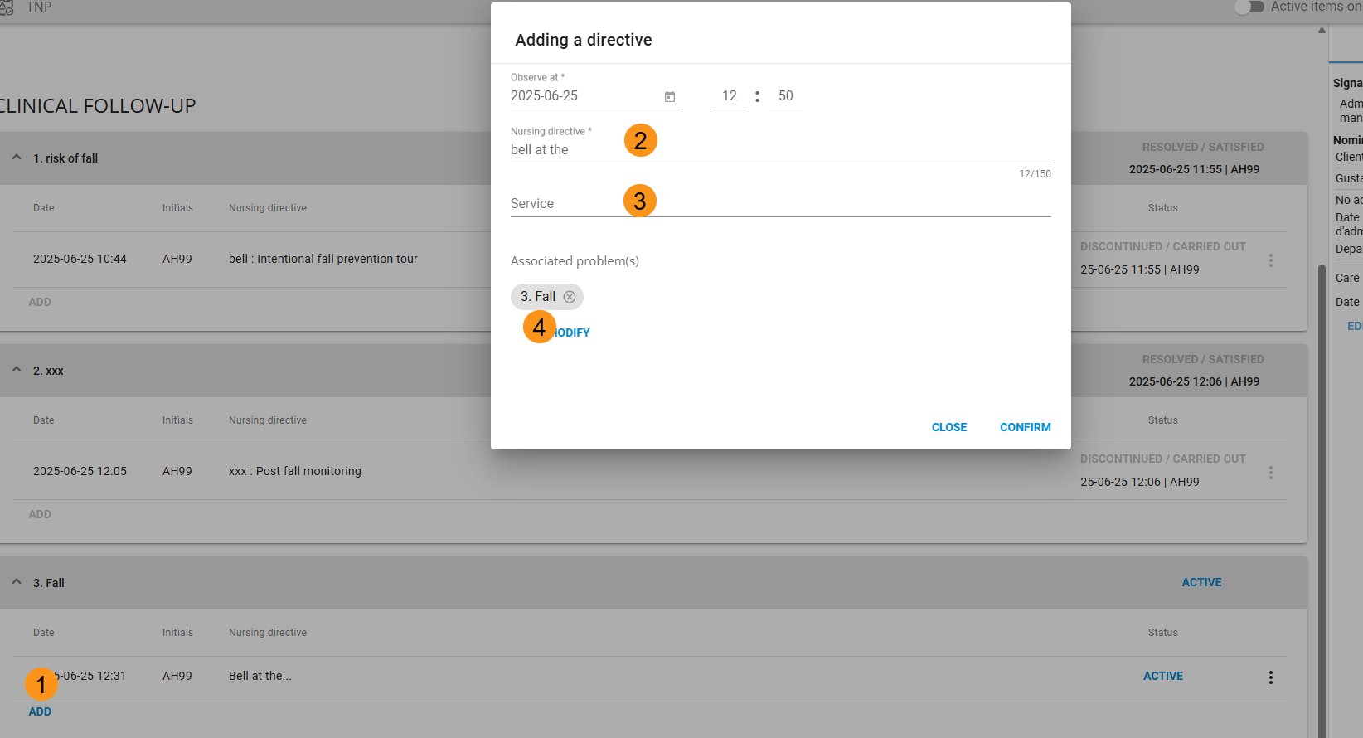

Update, correct or cancel Status of a directive
Select “Status” button, select the new status and confirm
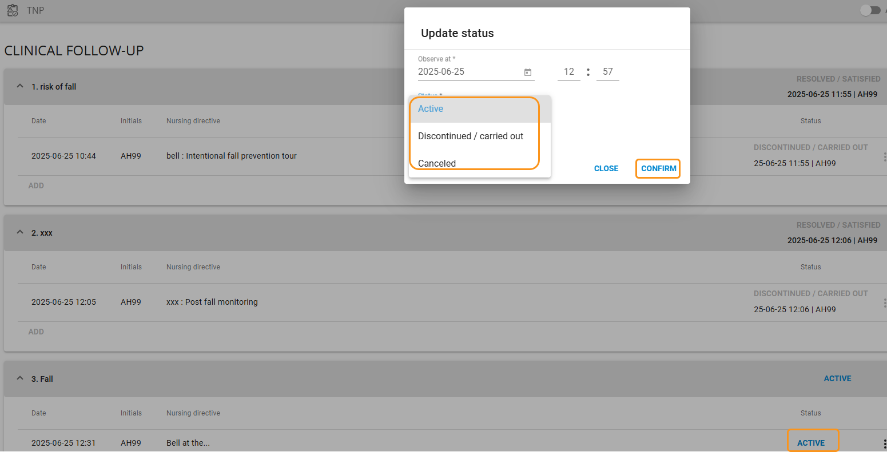

Correct a nursing directive
From the three dots, it is possible to correct a directive, and this action requires the user to provide a justification.
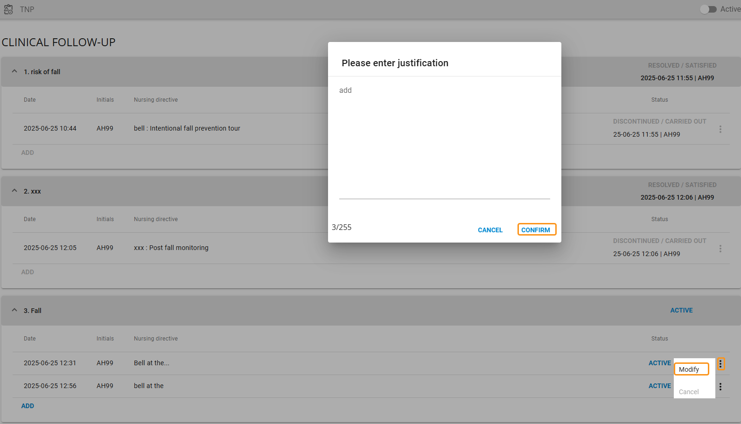

Show active items
It is possible to declutter the PTI view by activating the “Active Items Only” button.
Canceled statuses, Resolved/Satisfied findings, and Discontinued/Completed directives will not be displayed.
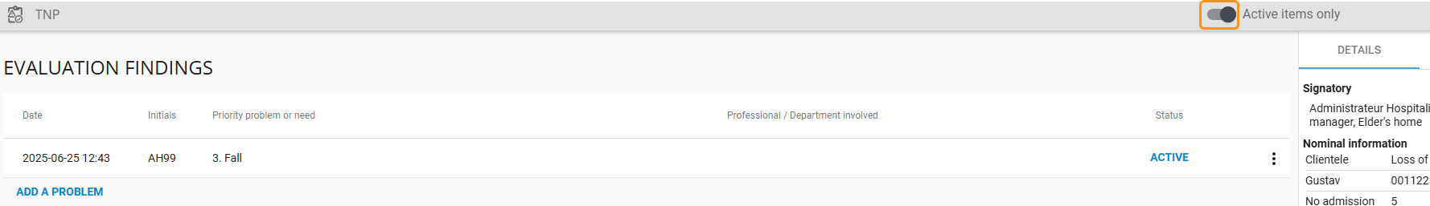

Modifier les informations nominales lors d’un transfert de chambre
During a room transfer, the personal information must be updated to ensure that the new room number appears on the printed PDF.
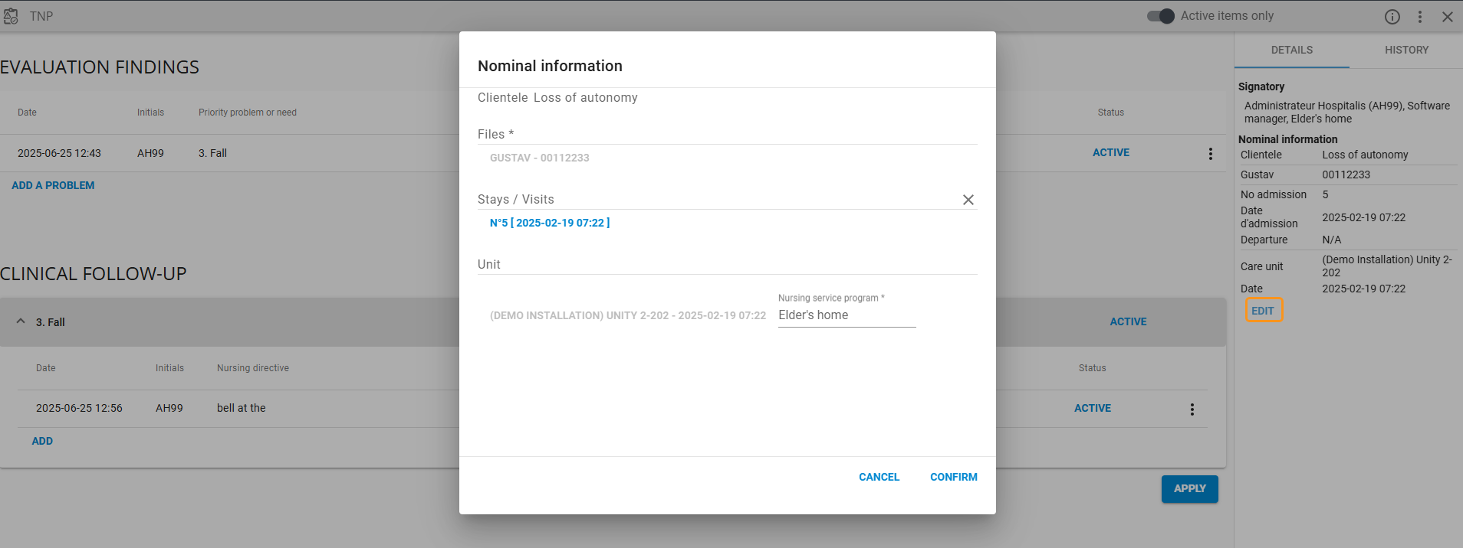

Finish or delete TNP
The finalization and cancellation features of the PTI are available based on granted permissions.
Once finalized, the PTI cannot be reactivated, its elements cannot be imported into a new version, but
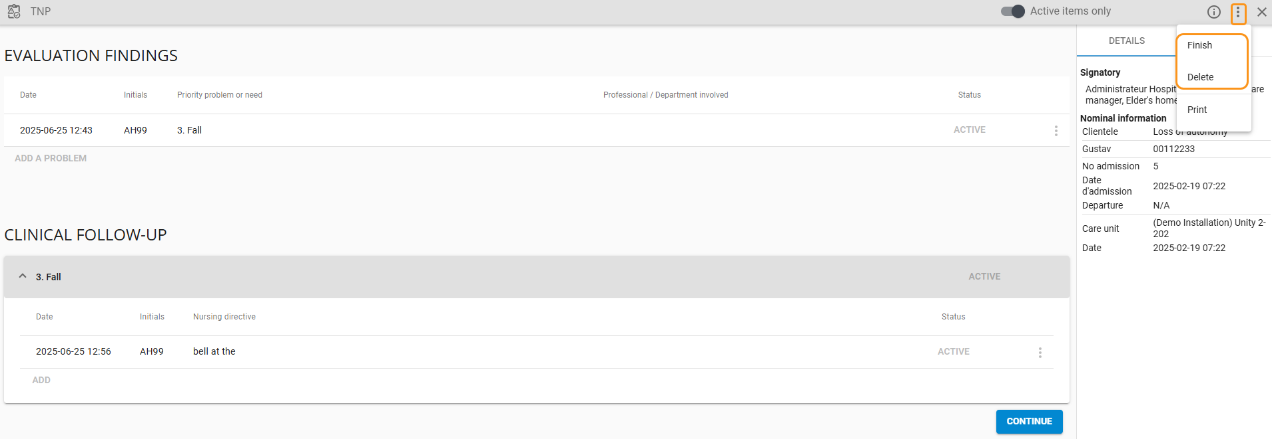

REQUEST

* Available depending on profession and the facility’s configuration
The steps for submitting a request can be performed from the record as well as from the workspace tile.
Entering the priority level and the professions involved in receiving the requests are mandatory to ensure proper processing.
The transmission status as well as the name of the profession/coordinator assigned to the request are displayed in the record.
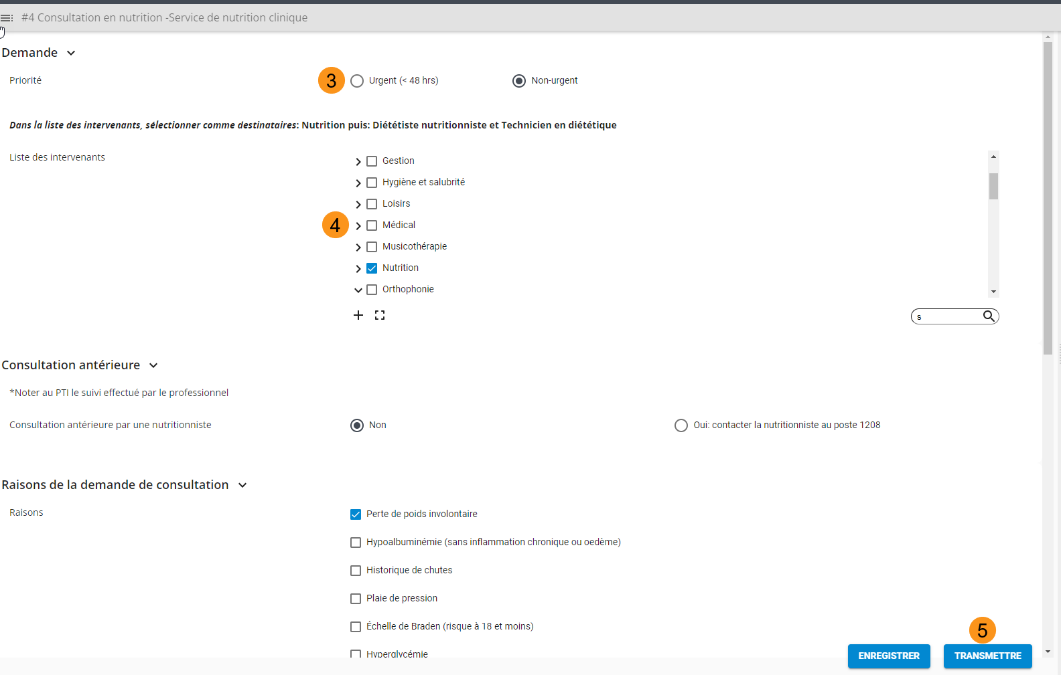
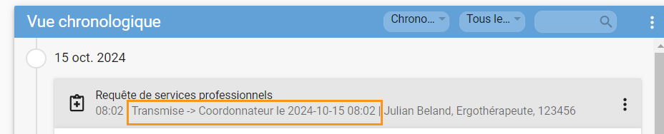

ORDONNANCE NON PHARMACOLOGIQUE
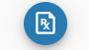
Available depending on profession and the facility’s configuration
Available from the library, the non-pharmacological order must be transmitted to be accessible in the releveur’s tile.
Once transmitted, the order will be available in read-only mode in the initiator’s tile.

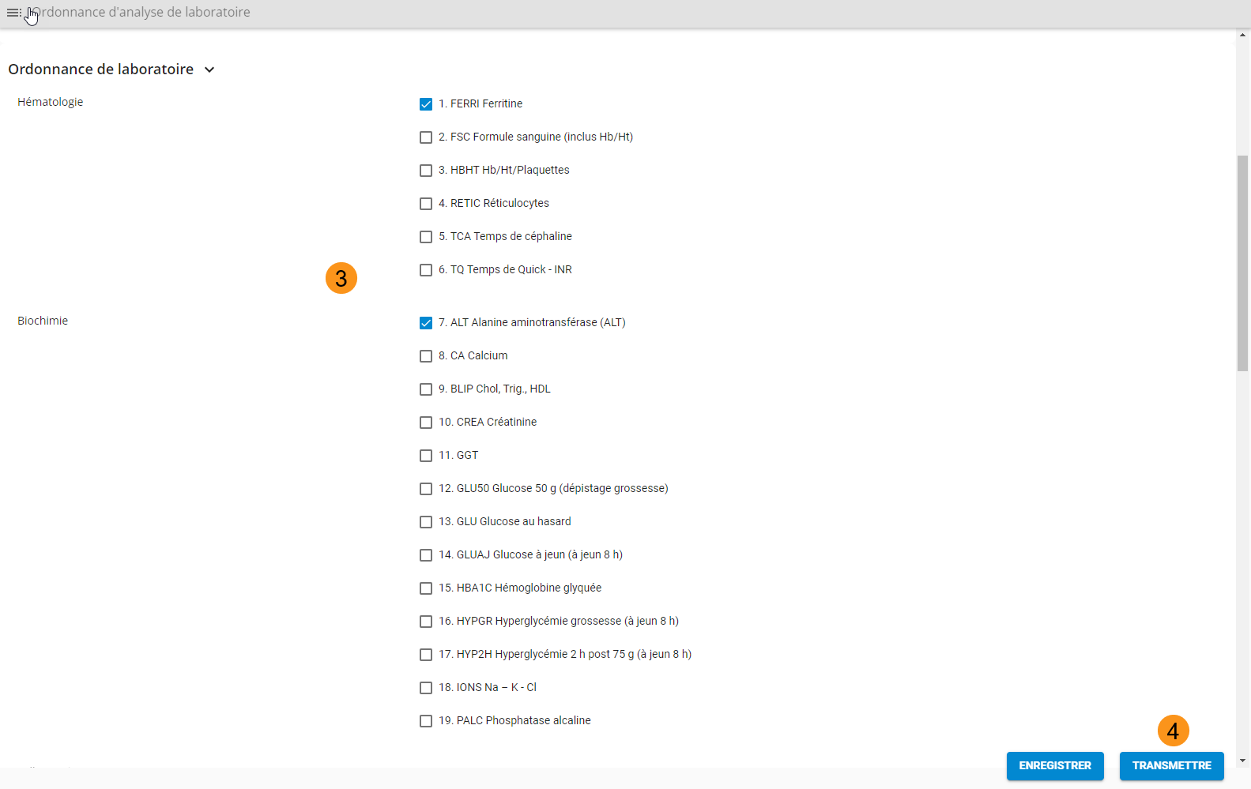

CORDINATION
The Coordination section displays the timeline of activities scheduled in the care plan as well as in the care pathways. From the left menu, it is possible to navigate between activities to be done and those in progress.
- By selecting the date range, it is possible to modify the start and end dates for displaying activities.
- When an item is selected, additional information may be displayed and the “Complete, not completes and postpones`` button is available if the user’s profile has completion rights
- It is possible to view completed activities from the left menu.
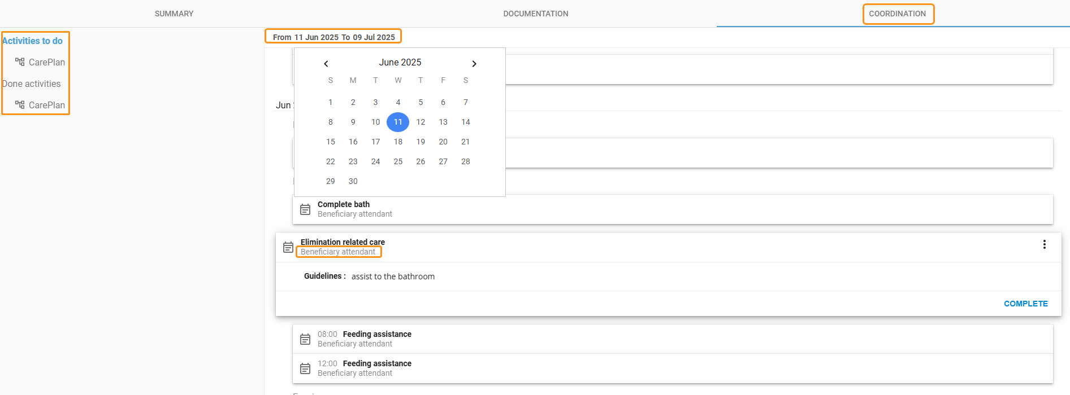

Statrt a care Pathway

Creating a care pathway allows activities to appear in the “Clinical Follow-Ups” card within the workspace. A record can contain multiple active care pathways at the same time.
Steps to start a care pathway:
- Click the “More” button and select “Care Pathway”
- Click “Add”
- Choose the desired pathway
- Select the start date
- Click Confirm

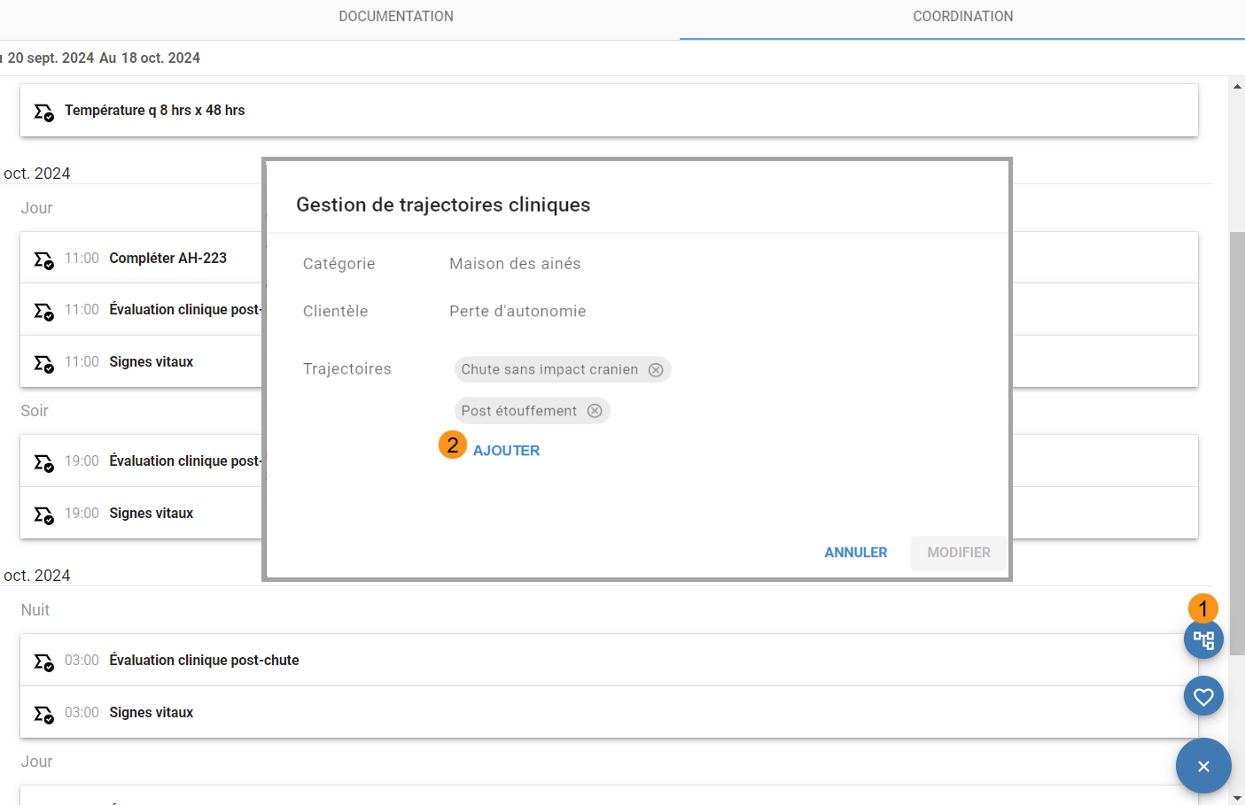
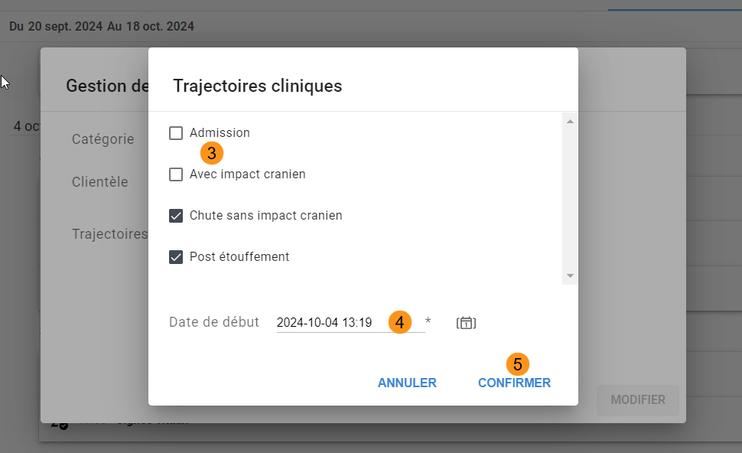
To delete a care pathway, click the (x)
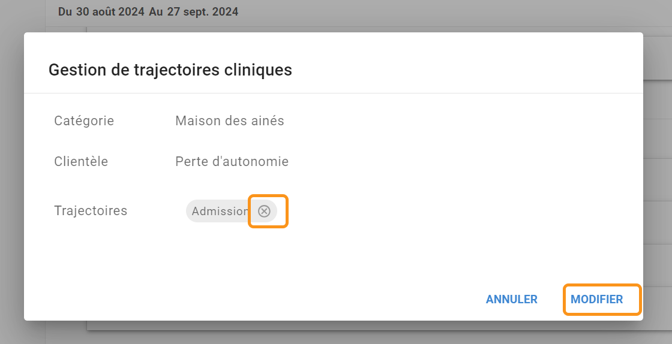
Note: A care pathway with a past end date cannot be deleted.

